**Parish Dates From September 2022**

**Monday 26th Sept. 7.30pm Bible Study in the Lodge.**

**Tuesday 27th Sept. 10.15am Holy Communion.**

**Wednesday 28th Sept. 2.00pm St Michael’s School Harvest Festival Service.**

**Friday 30th Sept. 7.00pm HARVEST SUPPER AND QUIZ NIGHT**

**In the Village Hall.**

**Sunday 2nd Oct. 9.00am Holy Communion**

**10.30am HARVEST FESTIVAL AND GIFT DAY.**

**4.00pm Holy Communion (Old Mill Court)**

**Tuesday 4th Oct. 10.15am Holy Communion.**

**Wednesday 5th Oct. 7.00pm – c8.30pm Alpha Course begins in the Lodge.**

**Sunday 9th Oct. 9.00am Holy Communion**

**10.30am Parish Communion.**

**3.45pm FARM CHURCH AT THE VILLAGE HALL.**

**Tuesday 11th Oct. 10.15am Holy Communion.**

**Wednesday 12th Oct. 7.00pm – c8.30pm Alpha Course in the Lodge.**

**Sunday 16th Oct. 9.00am Holy Communion**

**10.30am All Age Worship.**

**Tuesday 18th Oct. 10.15am Morning Prayer.**

**7.30pm Joint Ladies Group & Men’s Fellowship**

**in the Village Hall.**

**Wednesday 19th Oct. 7.00pm – c8.30pm Alpha Course in the Lodge.**

**Sunday 23rd Oct. 9.00am Holy Communion**

**10.30am Morning Worship with Sunday School.**

**Tuesday 25th Oct. 10.15am Morning Prayer.**

**Wednesday 26th Oct. 7.00pm – c8.30pm Alpha Course in the Lodge.**

**Suggested Bible readings this week.**

Monday 26th Sept. Luke. 9: v 46-50. Tuesday 27th Sept. Luke 9: v 51-56.

Wed. 28th Sept. Luke 9: v 57-end. Thursday 29th Sept. Festival of

St Michael and All Angels. Revelation 12: v 7-12.

Friday 30th Sept. Luke 10: v 13-16. Saturday 1st Oct. Luke 10: v 17-24.

**Website :** **www.hooleparishchurch.com**

Facebook page: **St Michael and All Angels Church, Hoole**,

Rector – Revd Ann Templeman anntempleman@live.co.uk

01772 448515 or 07877659156

**SO***Please take this sheet home with you*

**St. Michael and All Angels –Hoole**

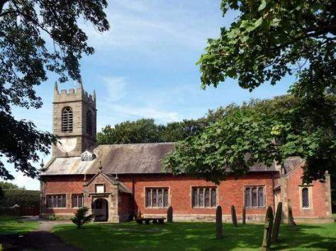

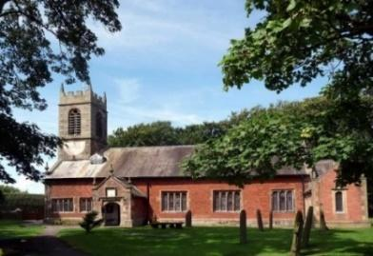

***Welcome to our church this morning. Please stay for a chat and a cup of tea or coffee after the 10.30 service - a great way to meet people***

***Sunday 25th September 2022***

**THE WORK OF THE LORD**

**Always give yourself fully to the work of the Lord.**  *1 Cor. 15: v 58.*

**PRAYER OF THE DAY: Lord God, defend your Church from all false**

**teaching and give to your people knowledge of your truth, that we**

**may enjoy eternal life in Jesus Christ our Lord. Amen.**

**Sunday School today during the service**

There are toys and colouring sheets

for younger children at the back of church.

**

**9.00am. Holy Communion (Book of Common Prayer) begins p237**

**10.30am. Parish Communion with Sunday School.**

**Reading: 1 Corinthians Ch. 15: v 50 – Ch. 16: v 4.**

**Hymns: 474 – Now thank we all our God.**

**Screen – Never be Shaken.**

**625 – Take my life, and let it be.**

**332 – I the Lord of sea and sky.**

**H/C Hymns: 202 – Give thanks with a grateful heart**

**620 – Such love.**

**Reading: 1 Corinthians Ch. 15: v 50 – Ch. 16: v 4.** I declare to you, brothers and sisters, that flesh and blood cannot inherit the kingdom of God, nor does the perishable inherit the imperishable. Listen, I tell you a mystery: we will not all sleep, but we will all be changed – in a flash, in the twinkling of an eye, at the last trumpet. For the trumpet will sound, the dead will be raised imperishable, and we will be changed. For the perishable must clothe itself with the imperishable, and the mortal with immortality. When the perishable has been clothed with the imperishable, and the mortal with immortality, then the saying that is written will come true: ‘Death has been swallowed up in victory.’

‘Where, O death, is your victory?    Where, O death, is your sting?’

The sting of death is sin, and the power of sin is the law. But thanks be to God! He gives us the victory through our Lord Jesus Christ.

Therefore, my dear brothers and sisters, stand firm. Let nothing move you. Always give yourselves fully to the work of the Lord, because you know that your labour in the Lord is not in vain.

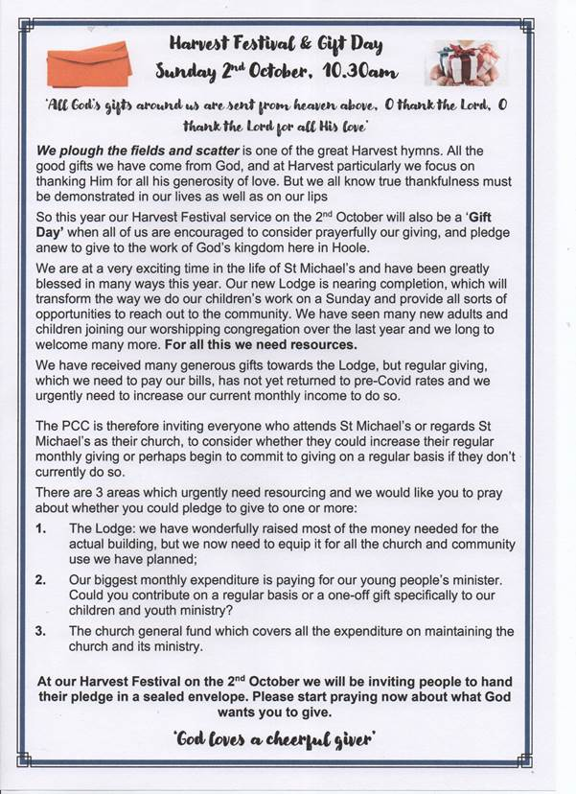

Now about the collection for the Lord’s people: do what I told the Galatian churches to do. On the first day of every week, each one of you should set aside a sum of money in keeping with your income, saving it up, so that when I come no collections will have to be made. Then, when I arrive, I will give letters of introduction to the men you approve and send them with your gift to Jerusalem. If it seems advisable for me to go also, they will accompany me.

**Prayer:** We give thanks for the opening of our Lodge last Sunday, and we continue to ask for wisdom in its equipping and use for service to God and the community. We pray for our Harvest festival service and Gift Day next Sunday. We pray for those who are sick especially Sam Burns, Mona Lewis, Jim Ashcroft, Jim Belshaw, Patricia Edmondson, and Josephine Hodge. We give thanks for the lives of Kate Adams and Isobel Wooldridge and pray for their families and friends.

