Parish Dates October 2021 onwards

Monday Oct 18th 3.30pm Bereavement group tea.
7.30pm Bible Study at the Rectory.
Tuesday Oct 19th 10.15am – 10.45am Prayer time in Church.
7.30pm Ladies Group and Men’s Fellowship
joint meeting in the Village Hall.

Sunday Oct 24th 9.00am Holy Communion
10.30am Morning Worship with Sunday School.
12.00noon Colin Clark – Interment of Ashes
Tuesday Oct 26th 10.15am – 10.45am Prayer time in Church.
7.30pm Bible Study at the Rectory.
Thursday Oct 28th from 11.30am Locals’ Lunch in New Village Hall.
4.30pm Chat and Chocolate group in Church.

Sunday Oct 31st 9.00am Holy Communion
10.30am Parish Communion with Sunday School.
6.00pm SERVICE OF THANKSGIVING
FOR LOVED ONES.
Monday Nov 1st 7.30pm Bible Study at the Rectory.
Tuesday Nov 2nd 10.15am – 10.45am Prayer time in Church.
Thursday Nov 4th 4.30pm Chat and Chocolate group in Church.
Saturday November 6th 10.00am – 2.00pm
PARISH QUIET DAY AT WHALLEY ABBEY
Sunday Nov 7th 9.00am Holy Communion
10.30am Parish Communion with Sunday School.

KEY FUTURE DATES

Sunday Nov 14th 10.10am REMEMBRANCE SUNDAY SERVICE
Sunday Nov 21st 3.45pm Narnia Church at Hoole Village Hall.

Suggested Bible readings this week.
Monday 18th Oct. Luke 10: v 1-9. Tuesday 19th Oct. Luke 12: v 35-38.
Wednesday 20th Oct. Luke 12: v 39-48. Thursday 21st Oct. Luke 12: v 49-53.
Friday 22nd Oct. Luke 12: v 54-end. Saturday 23rd Oct. Luke 13: v 1-9.

Website : www.hooleparishchurch.com
Facebook page: St Michael and All Angels Church, Hoole,
Rector – Revd Ann Templeman anntempleman@live.co.uk 01772 448515The Rectory, 69 Liverpool Old Road Much Hoole PR4 4RB
Please take this sheet home with you
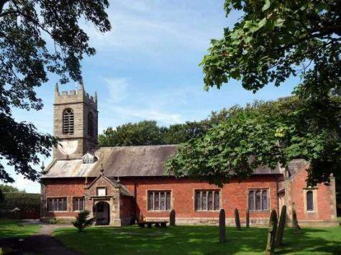
St. Michael and All Angels – Hoole

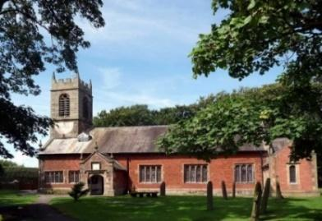

Welcome to our church again this morning. We continue to welcome new friends and welcome back others, please stay for a chat and a cup of tea or coffee after the 10.30 service, a great way to meet people.

Sunday 17th October 2021 Trinity 20

THE GLORY OF JESUS – THE TRANSFIGURATION

He was transfigured before them. His clothes became dazzling white.
Mark 9 v 2-3.

PRAYER OF THE DAY: God, our light and our salvation: illuminate
our lives, that we may see your goodness in the land of the living,
and looking on your beauty may be changed into the likeness of
Jesus Christ our Lord. Amen.

No Sunday School today during the service
Pokemon Family Church
in the Village Hall at 3.45pm.
There are toys for younger children
at the back of church.

9.00am. Holy Communion (Book of Common Prayer) begins p237

10.30am. Parish Communion.

Readings: 2 Peter 1: v 16-18. Mark 9: v 1-13.
Hymns: 428 – Love divine all loves excelling.
Screen/video – Glory of God we exalt your Name.
Supp. 3 – Before the throne of God above.
205 – Glorious things of Thee are spoken.
H/C Hymns: 285 – Holy is the Lord. 436 – Majesty, worship His majesty.

3.45pm. Pokemon Family Church in the Village Hall.
BIBLE READINGS: 2 Peter 1: v 16-18. For we did not follow cleverly devised stories when we told you about the coming of our Lord Jesus Christ in power, but we were eye-witnesses of his majesty. He received honour and glory from God the Father when the voice came to him from the Majestic Glory, saying, ‘This is my Son, whom I love; with him I am well pleased.’ We ourselves heard this voice that came from heaven when we were with him on the sacred mountain.

Mark 9: v 1-13. And he said to them, ‘Truly I tell you, some who are standing here will not taste death before they see that the kingdom of God has come with power.’
After six days Jesus took Peter, James and John with him and led them up a high mountain, where they were all alone. There he was transfigured before them. His clothes became dazzling white, whiter than anyone in the world could bleach them. And there appeared before them Elijah and Moses, who were talking with Jesus.
Peter said to Jesus, ‘Rabbi, it is good for us to be here. Let us put up three shelters – one for you, one for Moses and one for Elijah.’ (He did not know what to say, they were so frightened.) Then a cloud appeared and covered them, and a voice came from the cloud: ‘This is my Son, whom I love. Listen to him!’ Suddenly, when they looked around, they no longer saw anyone with them except Jesus.

As they were coming down the mountain, Jesus gave them orders not to tell anyone what they had seen until the Son of Man had risen from the dead. They kept the matter to themselves, discussing what ‘rising from the dead’ meant. And they asked him, ‘Why do the teachers of the law say that Elijah must come first?’

Jesus replied, ‘To be sure, Elijah does come first, and restores all things. Why then is it written that the Son of Man must suffer much and be rejected? But I tell you, Elijah has come, and they have done to him everything they wished, just as it is written about him.’

Prayer. We give thanks for the safe return of Ann and Peter from their Holiday and pray for Peter recovering from his accident. We pray for those who are sick, especially Baby Erica Ivy, Patricia Mortimer, Bill and Beryl Carr, Rose Wood, Nicola Middleton, Tom Parkinson and Josephine Hodge. We give thanks for the life of Harriet Mitcheson, and pray for Barbara and all of her family.

Ladies Group and Men’s Fellowship Joint Meeting in the Village Hall on Tuesday Oct 19th at 7.30pm. ‘The Humorous & Bizarre side of the Police Force’

BIBLE STUDIES AND PRAYER TIMES
Join us for Prayer time 10.15am -10.45am in church each Tuesday morning. Why not try out Bible study this autumn. We will be looking at the Parables of Jesus, and continue tomorrow evening October 18th at the Rectory.
