Parish Dates August 2021 onwards

Tuesday August 3rd 10.15am – 10.45am. Prayer time in Church
Friday August 6th 2.00pm Funeral of Victor Marsh
Sunday August 8th 09.00am Holy Communion in Church
10.30am Morning Worship in Church
Tuesday August 10th 10.15am – 10.45am. Prayer time in Church.
Thursday August 12th from 11.30am Locals’ Lunch in New Village Hall
Sunday August 15th 09.00am Holy Communion in Church
10.30am Parish Communion in Church
Tuesday August 17th 10.15am – 10.45am. Prayer time in Church.
Saturday August 21st Marriage of Liam Greenwood and Amy Woollam.
Sunday August 22nd 09.00am Holy Communion in Church
10.30am Morning Worship in Church
Tuesday August 24th 10.15am – 10.45am. Prayer time in Church.
Thursday August 26th from 11.30am Locals’ Lunch in New Village Hall
Sunday August 29th 09.00am Holy Communion in Church
10.30am Parish Communion in Church
Tuesday August 31st 10.15am – 10.45am. Prayer time in Church.
Sunday Sept 5th 09.00am Holy Communion in Church
10.30am Parish Communion in Church
Monday Sept 6th 7.30pm PCC meeting at the Rectory
Sunday Sept 12th 09.00am Holy Communion in Church
10.30am Morning Worship in Church
3.45pm Minecraft Church in School.
Key Future Dates SAVE THE DATE Harvest Festival and Social
Friday Oct 1st 7.00pm Harvest Supper & Parish Social with Quiz
and Entertainment in the New Village Hall.
Sunday Oct 3rd 10.30am HARVEST FESTIVAL

All the above services are ‘Live’ in church
We will aim to have audio recordings of all 10.30 services on the website www.hooleparishchurch.com by Sunday lunch time.
The Zoom link for all church Zoom activities is on the front of website.
Our Facebook page: St Michael and All Angels Church, Hoole,
Rector – Revd Ann Templeman anntempleman@live.co.uk 01772 448515
The Rectory, 69 Liverpool Old Road Much Hoole PR4 4RB
Please take this sheet home with you
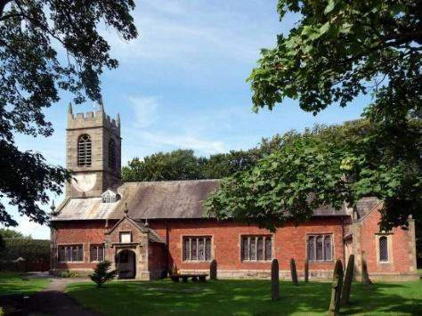
St. Michael and All Angels – Hoole

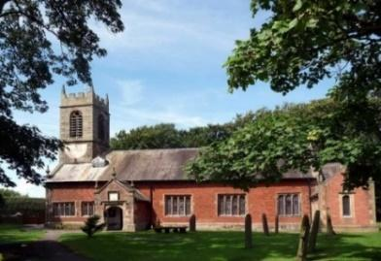

Welcome to our church again this morning. We continue to welcome new friends and welcome back others.

Sunday 1st August 2021 Trinity 9

HE WAS PIERCED FOR OUR TRANSGRESSIONS

“We all, like sheep, have gone astray, each of us has turned to his own
way; and the Lord has laid on Him the iniquity of us all.” Isaiah 53: v6.

PRAYER OF THE DAY: Gracious Father, revive your Church in
our day, and make her holy, strong and faithful, for your glory’s sake
in Jesus Christ our Lord. Amen.
No Sunday School as such today during the service but Mandy Hughes will be taking any children out for a bible story and activity.
There are also toys and colouring sheets for younger children at the back of church.

9.00am. Holy Communion (Book of Common Prayer) begins p237

10.30am. Parish Communion.

Reading: Isaiah 53: v 1-10a.

Hymns: 511 – O Lord my God. (How great Thou art)
738 – When I survey the wondrous cross.
Suppl. 4 – O to see the dawn.
463 – My song is love unknown (omit vs 2 & 5)

H/C Hymn: 87 – Broken for me.

BIBLE READING: Isaiah 53: v 1-10a.
Who has believed our message and to whom has the arm of the Lord been revealed? He grew up before him like a tender shoot, and like a root out of dry ground. He had no beauty or majesty to attract us to him, nothing in his appearance that we should desire him. He was despised and rejected by mankind, a man of suffering, and familiar with pain. Like one from whom people hide their faces he was despised, and we held him in low esteem.
Surely he took up our pain and bore our suffering, yet we considered him punished by God, stricken by him, and afflicted.
But he was pierced for our transgressions, he was crushed for our iniquities; the punishment that brought us peace was on him, and by his wounds we are healed. We all, like sheep, have gone astray, each of us has turned to our own way; and the Lord has laid on him the iniquity of us all.
He was oppressed and afflicted, yet he did not open his mouth; he was led like a lamb to the slaughter, and as a sheep before its shearers is silent, so he did not open his mouth. By oppression and judgment he was taken away.
Yet who of his generation protested? For he was cut off from the land of the living; for the transgression of my people he was punished. He was assigned a grave with the wicked, and with the rich in his death, though he had done no violence, nor was any deceit in his mouth.
Yet it was the Lord’s will to crush him and cause him to suffer, and though the Lord makes his life an offering for sin, he will see his offspring and prolong his days.
Prayer. We give thanks for the planning permission for our much needed Lodge in the churchyard and pray that we will be able to find the money for this exciting new venture which is essential for the growth of our church. We pray for all who are on holiday at this time thinking especially of Liz as she leads the special two weeks summer Beach Mission in Lincolnshire
We pray for those who are sick, especially Baby Erica Ivy, Patricia Mortimer, Bill and Beryl Carr, Alan Fleetwood, Nicola Middleton, Anthony Brogden and Josephine Hodge. We give thanks for the life of Victor Ernest Marsh and pray for his family and friends.
REFRESHMENTS AFTER 10.30 SERVICE
Volunteers needed for rota. Please let Barbara Wood know if you can help. bw12252@hotmail.com

BIBLE STUDIES AND PRAYER TIMES
Join us for Prayer time 10.15am -10.45am in church
each Tuesday morning throughout August.
There will be a short Summer break in our series of Bible Study.
These will however resume in September on Mondays and on Tuesdays.

Village Hall. Following the Grand Opening yesterday, many of the regular activities can now resume, the next “Locals’ Lunch” will be held on Thursday 12th from 11.30am..

