PARISH DIARY
nb No Tuesday Holy Communion Services at present.

Monday 7th Sept 7.30pm PCC meeting (by Zoom)
Tuesday 8th Sept 7.30pm Bible Study-Just10: Don’t Covet
Sunday Sept. 13th 9.00am. Holy Communion (Book of Common Prayer )
10.30am. Morning Worship (no Sunday School).
3.45pm HOGWARTS FAMILY CHURCH IN St Michael’s Church

Monday 14th Sept 7.30pm Bible Study-Just10: Don’t Covet
Sunday Sept 20th 9.00am. Holy Communion (Book of Common Prayer )
10.30am. Parish Communion with Sunday School.
Tuesday 22nd Sept 7.30pm Bible Study-Just 10: Don’t Lie
Sunday Sept. 27th 9.00am. Holy Communion (Book of Common Prayer )
10.30am. Morning Worship with Sunday School.
Monday 28th Sept 7.30pm Bible Study- Just 10: Don’t Lie
Sunday Oct. 4th 9.00am Holy Communion
10.30am Harvest Festival.
Sunday Oct 11th 9.00am. Holy Communion (Book of Common Prayer )
10.30am. Morning Worship with Sunday School.
Sunday Oct 18th 9.00am. Holy Communion (Book of Common Prayer )
10.30am. Parish Communion with Sunday School.

FUTURE DATES
Sunday Nov 1st 4.00pm Service of Thanksgiving for loved ones.
Friday Nov. 6th VE Day Celebration Social in Walmer Bridge
Village Hall (if permitted)
Sunday Nov. 8th 10.00am Remembrance Sunday Service with
Bishop of Blackburn.
Please Note. Our church is open daily throughout the week from
9.30am to 4.30pm for visiting and private prayer.
Our Facebook page: St Michael and All Angels Church, Hoole, our website is www.hooleparishchurch.com

Rector – Revd Ann Templeman anntempleman@live.co.uk 01772 448515
The Rectory, 69 Liverpool Old Road Much Hoole PR4 4RB

Please take this sheet home with you
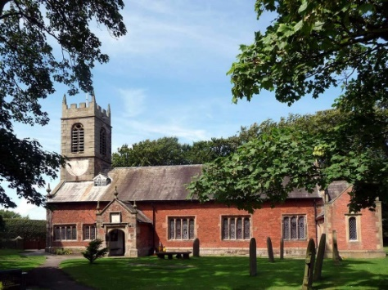
St. Michael and All Angels – Hoole

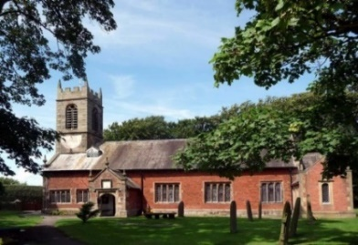

A special welcome to our church again this morning.
Please observe social distancing, but stay close to Christ.

Sunday 6th September 2020

A NEW START – GOD, MOSES AND THE BURNING BUSH

‘God called to him, “Moses! Moses!” and Moses said “Here I am” . . .
and God said, “So now go”’ from Exodus 3:v 1-15.

PRAYER OF THE DAY: Almighty God, you search us and know us:
may we rely on you in strength and rest on you in weakness,
now and in all our days; through Jesus Christ our Lord. Amen.

Sunday School today during the service
There are toys for younger children at the back of church. Sunday School for ages 3-11 meets outside today in the marquee during the sermon and prayers.

9.00am. Holy Communion (Book of Common Prayer) begins p237

10.30am. Parish Communion with Sunday School.
Reading: Exodus 3: v 1-15.
Hymns : 201 Sing Hosanna
Great Big God-Children’s hymn –
67 Be still for the presence of the Lord
332 I the Lord of sea and sky.
H/C Hymns: 285 Holy is the Lord 374 Just as I am
BIBLE READING: Exodus 3 v 1-15.
1. Now Moses was tending the flock of Jethro his father-in-law, the priest of Midian, and he led the flock to the far side of the wilderness and came to Horeb, the mountain of God. There the angel of the Lord appeared to him in flames of fire from within a bush. Moses saw that though the bush was on fire it did not burn up. So Moses thought, ‘I will go over and see this strange sight – why the bush does not burn up.’
When the Lord saw that he had gone over to look, God called to him from within the bush, ‘Moses! Moses!’ And Moses said, ‘Here I am.’
‘Do not come any closer,’ God said. ‘Take off your sandals, for the place where you are standing is holy ground.’ Then he said, ‘I am the God of your father, the God of Abraham, the God of Isaac and the God of Jacob.’ At this, Moses hid his face, because he was afraid to look at God.
2.
The Lord said, ‘I have indeed seen the misery of my people in Egypt. I have heard them crying out because of their slave drivers, and I am concerned about their suffering. So I have come down to rescue them from the hand of the Egyptians and to bring them up out of that land into a good and spacious land, a land flowing with milk and honey – the home of the Canaanites, Hittites, Amorites, Perizzites, Hivites and Jebusites. And now the cry of the Israelites has reached me, and I have seen the way the Egyptians are oppressing them. So now, go. I am sending you to Pharaoh to bring my people the Israelites out of Egypt.’ But Moses said to God, ‘Who am I that I should go to Pharaoh and bring the Israelites out of Egypt?’
And God said, ‘I will be with you. And this will be the sign to you that it is I who have sent you: when you have brought the people out of Egypt, you will worship God on this mountain.’ Moses said to God, ‘Suppose I go to the Israelites and say to them, “The God of your fathers has sent me to you,” and they ask me, “What is his name?” Then what shall I tell them?’
God said to Moses, ‘I am who I am. This is what you are to say to the Israelites: “I am has sent me to you.” ’God also said to Moses, ‘Say to the Israelites, “The Lord, the God of your fathers – the God of Abraham, the God of Isaac and the God of Jacob – has sent me to you.” ‘This is my name for ever, the name you shall call me from generation to generation.

Prayer:. We pray for all the children and young people of our parish as they begin a new term and pray for their teachers and school governors. We pray for all those suffering physically mentally or economically from the pandemic. We pray for those who are sick especially Beryl Cotton, Jane Slinger, Michael Harrison and baby Schultz, and for Mona Lewis recovering from an operation.
Suggested Bible readings for this week.
Mon. Sept 7th Luke 6: v 6-11. Lord of the Sabbath.
Tues. Sept 8th Luke 6: v 12-19. The Twelve Apostles.
Wed. Sept 9th Luke 6: v 20-26. Blessings and Woes.
Thur. Sept 10th Luke 6: v 27-38. Love for Enemies.
Fri. Sept 11th Luke 6: v 39-42. Judging Others.
Sat Sept 12th Luke 6: v 43-end. The Wise and Foolish Builders.
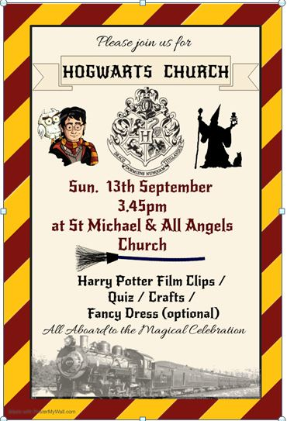
BIBLE STUDIES/GROWTH GROUPS begin Tues 8th Sept
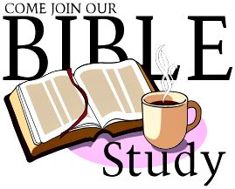
JUST 10 –Session 1: DON’T COVET
This Autumn we are going to look at the 10 Commandments. Meetings will take place on Mondays and Tuesdays at 7.30pm on alternate weeks –choose Zoom or in person – if there is room or in church if not. Please let Ann know if you can come.
HARVEST QUIZ postponed till 22nd Jan

