PARISH DIARY
nb No Tuesday Holy Communion Services at present.

Sunday Sept. 6th 9.00am. Holy Communion (Book of Common Prayer )
10.30am. Parish Communion with Sunday School.
Monday 7th Sept 7.30pm PCC meeting (by Zoom)
Tuesday 8th Sept 7.30pm Bible Study-Just10: Don’t Covet
Sunday Sept. 13th 9.00am. Holy Communion (Book of Common Prayer )
10.30am. Morning Worship (no Sunday School).
3.45pm HOGWARTS FAMILY CHURCH IN St Michael’s Church

Monday 14th Sept 7.30pm Bible Study-Just10: Don’t Covet
Sunday Sept 20th 9.00am. Holy Communion (Book of Common Prayer )
10.30am. Parish Communion with Sunday School.
Tuesday 22nd Sept 7.30pm Bible Study-Just 10: Don’t Lie
Friday Sept. 25th 7.00pm Harvest Quiz Night in Hoole Village Hall
(if permitted)
Sunday Sept. 27th 9.00am. Holy Communion (Book of Common Prayer )
10.30am. Morning Worship with Sunday School.
Monday 28th Sept 7.30pm Bible Study- Just 10: Don’t Lie
Sunday Oct. 4th 9.00am Holy Communion
10.30am Harvest Festival.
Sunday Oct 11th 9.00am. Holy Communion (Book of Common Prayer )
10.30am. Morning Worship with Sunday School.

FUTURE DATES
Sunday Nov 1st 4.00pm Service of Thanksgiving for loved ones.
Friday Nov. 6th VE Day Celebration Social in Walmer Bridge
Village Hall (if permitted)
Sunday Nov. 8th 10.00am Remembrance Sunday Service with
Bishop of Blackburn.
Please Note. Our church is open daily throughout the week from
9.30am to 4.30pm for visiting and private prayer.
Our Facebook page: St Michael and All Angels Church, Hoole, our website is www.hooleparishchurch.com

Rector – Revd Ann Templeman anntempleman@live.co.uk 01772 448515
The Rectory, 69 Liverpool Old Road Much Hoole PR4 4RB
Please take this sheet home with you
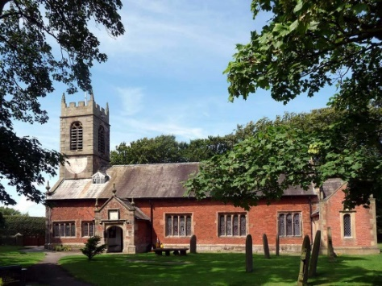
St. Michael and All Angels – Hoole

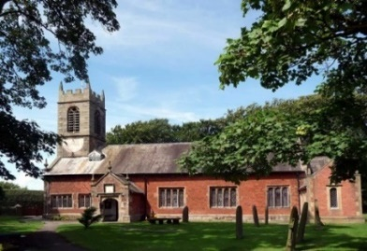

A special welcome to our church again this morning.
Please observe social distancing, but stay close to Christ.

Sunday 30th August 2020 12th Sunday after Trinity.

LIVING SACRIFICES
“Do not conform to the pattern of this world, but be transformed
by the renewing of your mind….Do not be overcome with evil, but overcome evil with good. Romans 12.

PRAYER OF THE DAY: God of constant mercy,
who sent your Son to save us: remind us of your goodness,
increase your grace within us, that our thankfulness may grow,
through Jesus Christ our Lord. Amen.

Sunday School today during the service
There are toys for younger children at the back of church. Sunday School for ages 3-11 meets outside today during the sermon and prayers.

9.00am. Holy Communion (Book of Common Prayer) begins p237

10.30am. Parish Communion with Sunday School.
Reading: Romans 12: v 1,2 & 9-end.
Hymns : 463 My Song is Love Unknown verses 1,2,6
Children’s hymn – King of Me
625 Take my Life
428 Love divine
H/C Hymns: 658 There is a Redeemer 620 Such Love
BIBLE READING: Romans 12 v 1,2 and 9 to end
Therefore, I urge you, brothers and sisters, in view of God’s mercy, to offer your bodies as a living sacrifice, holy and pleasing to God – this is your true and proper worship. Do not conform to the pattern of this world, but be transformed by the renewing of your mind. Then you will be able to test and approve what God’s will is – his good, pleasing and perfect will.
Love must be sincere. Hate what is evil; cling to what is good. Be devoted to one another in love. Honour one another above yourselves. Never be lacking in zeal, but keep your spiritual fervour, serving the Lord. Be joyful in hope, patient in affliction, faithful in prayer. Share with the Lord’s people who are in need. Practise hospitality.
Bless those who persecute you; bless and do not curse. Rejoice with those who rejoice; mourn with those who mourn. Live in harmony with one another. Do not be proud, but be willing to associate with people of low position. Do not be conceited.
Do not repay anyone evil for evil. Be careful to do what is right in the eyes of everyone. If it is possible, as far as it depends on you, live at peace with everyone. Do not take revenge, my dear friends, but leave room for God’s wrath, for it is written: ‘It is mine to avenge; I will repay,’ says the Lord. On the contrary: ‘If your enemy is hungry, feed him; if he is thirsty, give him something to drink. In doing this, you will heap burning coals on his head.’ Do not be overcome by evil, but overcome evil with good.

Prayer:. We pray for all the children and young people of our parish preparing to go back to school this week and pray for their teachers and school governors. We pray for all those suffering physically mentally or economically from the pandemic. We pray for who are in special need at this time, we pray for those who are sick and include in our prayers Beryl Cotton, Jane Slinger, Michael Harrison and baby Schultz, and for Mona Lewis recovering from an operation.
Suggested Bible readings for this week.
Mon. Aug 31st Luke 4: v 16-30. Jesus rejected at Nazareth.
Tues. Sept 1st Luke 4: v 31-37. Jesus drives out an evil spirit.
Wed. Sept 2nd Luke 4: v 38-end. Jesus heals many.
Thur. Sept 3rd Luke 5: v 1-11. The calling of the first Disciples.
Fri. Sept 4th Luke 5: v 33-end. Jesus questioned about fasting.
Sat Sept 5th Luke 6: v 1-5. Lord of the Sabbath.
BIBLE STUDIES/GROWTH GROUPS begin Tues 8th Sept
JUST 10 –Session 1: DON’T COVET
This Autumn we are going to look at the 10 Commandments. Meetings will take place on Mondays and Tuesdays at 7.30pm on alternate weeks –choose the Rectory in person
or Zoom. Please let Ann know if you can come.

