PARISH DIARY
nb No Tuesday Holy Communion Services at present.

Sunday August 30th 9.00am. Holy Communion (Book of Common Prayer )
10.30am. Parish Communion with Sunday School.
Sunday Sept. 6th 9.00am. Holy Communion (Book of Common Prayer )
10.30am. Parish Communion with Sunday School.
Monday 7th Sept 7.30pm PCC meeting
Tuesday 8th Sept 7.30pm Bible Study/Growth Group
Sunday Sept. 13th 9.00am. Holy Communion (Book of Common Prayer )
10.30am. Morning Worship (no Sunday School).
3.45pm HOGWARTS FAMILY CHURCH IN ST Michael’s church

Sunday Sept 20th 9.00am. Holy Communion (Book of Common Prayer )
10.30am. Parish Communion with Sunday School.
Sunday Sept. 27th 9.00am. Holy Communion (Book of Common Prayer )
10.30am. Morning Worship with Sunday School.
Tuesday Sept 29th St Michael and All Angels
Sunday Oct. 4th 10.30am Harvest Festival.

FUTURE DATES
Friday Sept. 25th 7.00pm Harvest Quiz Night in Hoole Village Hall
(if permitted)
Sunday Oct. 4th 10.30am Harvest Festival.
Sunday Nov 1st 4.00pm Service of Thanksgiving for loved ones.
Friday Nov. 6th VE Day Celebration Social in Walmer Bridge
Village Hall (if permitted)
Sunday Nov. 8th 10.00am Remembrance Sunday Service with
Bishop of Blackburn.
Please Note. Our church is open daily throughout the week from
9.30am to 4.30pm for visiting and private prayer.
Our Facebook page: St Michael and All Angels Church, Hoole, our website is www.hooleparishchurch.com

Rector – Revd Ann Templeman anntempleman@live.co.uk 01772 448515
The Rectory, 69 Liverpool Old Road Much Hoole PR4 4RB
Please take this sheet home with you
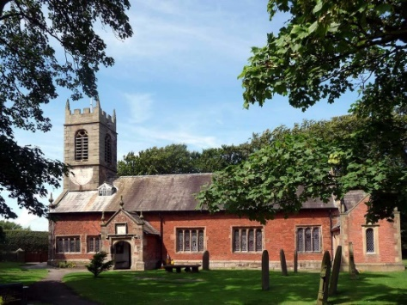
St. Michael and All Angels – Hoole

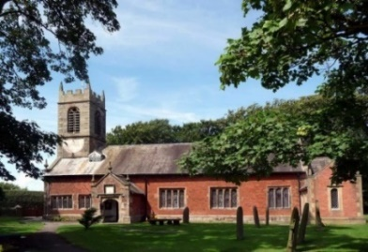

A special welcome to our church again this morning.
Please observe social distancing, but stay close to Christ.

Sunday 23rd August 2020 11th Sunday after Trinity.

RECOGNISING GOD’S VOICE

“I am the God Shepherd: I know my sheep and my sheep know me”
John 10: v 14.

PRAYER OF THE DAY: God of glory, the end of our searching,
help us to lay aside all that prevents us from seeking your kingdom,
and to give all that we have to gain the pearl beyond all price,
through our Saviour Jesus Christ. Amen.

Sunday School joins with All Age Worship today
There are toys for younger children
at the back of church.
.

9.00am. Holy Communion (Book of Common Prayer) begins p237

10.30am. All Age Morning Worship Sunday.
Reading: John 10: v 1-18.
Hymns : 552 – O worship the Lord in the beauty of holiness.
Supplement 4 (Children’s) – My Lighthouse.
195 – The Servant King.
503 – O Jesus I have promised.

BIBLE READING: John 10: v 1-18.
‘Very truly I tell you Pharisees, anyone who does not enter the sheepfold by the gate, but climbs in by some other way, is a thief and a robber. The one who enters by the gate is the shepherd of the sheep. The gatekeeper opens the gate for him, and the sheep listen to his voice. He calls his own sheep by name and leads them out. When he has brought out all his own, he goes on ahead of them, and his sheep follow him because they know his voice. But they will never follow a stranger; in fact, they will run away from him because they do not recognise a stranger’s voice.’ Jesus used this figure of speech, but the Pharisees did not understand what he was telling them.
Therefore Jesus said again, ‘Very truly I tell you, I am the gate for the sheep. All who have come before me are thieves and robbers, but the sheep have not listened to them. I am the gate; whoever enters through me will be saved.^{[a]} They will come in and go out, and find pasture. The thief comes only to steal and kill and destroy; I have come that they may have life, and have it to the full.
‘I am the good shepherd. The good shepherd lays down his life for the sheep. The hired hand is not the shepherd and does not own the sheep. So when he sees the wolf coming, he abandons the sheep and runs away. Then the wolf attacks the flock and scatters it. The man runs away because he is a hired hand and cares nothing for the sheep.
‘I am the good shepherd; I know my sheep and my sheep know me – just as the Father knows me and I know the Father – and I lay down my life for the sheep. I have other sheep that are not of this sheepfold. I must bring them also. They too will listen to my voice, and there shall be one flock and one shepherd. The reason my Father loves me is that I lay down my life – only to take it up again. No one takes it from me, but I lay it down of my own accord. I have authority to lay it down and authority to take it up again. This command I received from my Father.’

Prayer: We pray for all those suffering physically mentally or economically from the pandemic.
We pray for all who are on holiday at this time and pray for their safety. We pray for who are in special need at this time, we pray for those who are sick and include in our prayers Martin Hesketh, Althea Slater, Beryl Carr, Jane Slinger and Michael Harrison. We pray for the people of Lebanon following the recent disaster in Beirut.

Suggested Bible readings for this week.
Mon. Aug 24th Luke 22: v 24-30. Bartholomew - Apostle.
Tues. Aug 25th Matthew 23: v 23-26. Seven Woes.
Wed. Aug 26th Matthew 23: v 27-32. Seven Woes. (continued)
Thur. Aug 27th Matthew 24: v 42-end. The Day and Hour Unknown.
Fri. Aug 28th Matthew 25: v 1-13. Parable - The Ten Virgins.
Sat. Aug 22nd Matthew 14: v 1-12. John the Baptist Beheaded.

