PARISH DIARY
nb No Tuesday Holy Communion Services at present.

Sunday August 23rd 9.00am. Holy Communion (Book of Common Prayer )
10.30am. All Age Morning Worship Sunday Sunday August 30th 9.00am. Holy Communion (Book of Common Prayer )
10.30am. Parish Communion with Sunday School.
Sunday Sept. 6th 9.00am. Holy Communion (Book of Common Prayer )
10.30am. Parish Communion with Sunday School.
Monday 7th Sept 7.30pm PCC meeting
Tuesday 8th Sept 7.30pm Bible Study/Growth Group
Sunday Sept. 13th 9.00am. Holy Communion (Book of Common Prayer )
10.30am. Morning Worship with Sunday School.
3.45pm HOGWARTS FAMILY CHURCH IN ST Michael’s church

Sunday Sept 20th 9.00am. Holy Communion (Book of Common Prayer )
10.30am. Parish Communion with Sunday School.
Sunday Sept. 27th 9.00am. Holy Communion (Book of Common Prayer )
10.30am. Morning Worship with Sunday School.
Tuesday Sept 29th St Michael and All Angels

FUTURE DATES
Friday Sept. 25th 7.00pm Harvest Quiz Night in Hoole Village Hall
(if permitted)
Sunday Oct. 4th 10.30am Harvest Festival.
Sunday Nov 1st 4.00pm Service of Thanksgiving for loved ones.
Friday Nov. 6th VE Day Celebration Social in Walmer Bridge
Village Hall (if permitted)
Sunday Nov. 8th 10.00am Remembrance Sunday Service with
Bishop of Blackburn.
Please Note. Our church is open daily throughout the week from
9.30am to 4.30pm for visiting and private prayer.
Our Facebook page: St Michael and All Angels Church, Hoole, our website is www.hooleparishchurch.com

Rector – Revd Ann Templeman anntempleman@live.co.uk 01772 448515
The Rectory, 69 Liverpool Old Road Much Hoole PR4 4RB
Please take this sheet home with you
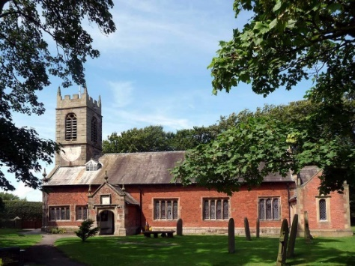
St. Michael and All Angels – Hoole

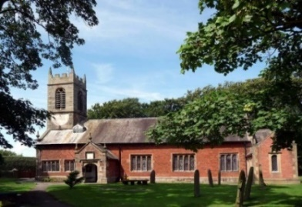

A special welcome to our church again this morning.
Please observe social distancing, but stay close to Christ.

Sunday 16th August 2020 10th Sunday after Trinity.

TESTING FAITH

“You have great faith! Your request is granted” Matthew 15: v 28.

PRAYER OF THE DAY: Lord of heaven and earth, as Jesus
taught his disciples to be persistent in prayer, give us patience and
courage never to lose hope, but always to bring our prayers before
you; through Jesus Christ our Lord. Amen.

Sunday School today during the service
There are toys for younger children at the back of church. Sunday School for ages 3-11 meets outside today during the sermon and prayers.

.

9.00am. Holy Communion (Book of Common Prayer) begins p237

10.30am. Parish Communion with Sunday School.
Reading: Matthew 15: v 21-28.
Hymns : 70 – Be thou my vision.
Supplement 1 (Children’s) - Our God is a great big God.
662 – There’s a wideness in God’s mercy.
382 – Let all the world in every corner sing.
H/C Hymns: 658 – There is a Redeemer.
66 – Be still and know that I am God.
BIBLE READING: Matthew 15: v 21-28.
Leaving that place, Jesus withdrew to the region of Tyre and Sidon. A Canaanite woman from that vicinity came to him, crying out, ‘Lord, Son of David, have mercy on me! My daughter is demon-possessed and suffering terribly.’
Jesus did not answer a word. So his disciples came to him and urged him, ‘Send her away, for she keeps crying out after us.’
He answered, ‘I was sent only to the lost sheep of Israel.’
The woman came and knelt before him. ‘Lord, help me!’ she said.
He replied, ‘It is not right to take the children’s bread and toss it to the dogs.’
‘Yes it is, Lord,’ she said. ‘Even the dogs eat the crumbs that fall from their master’s table.’
Then Jesus said to her, ‘Woman, you have great faith! Your request is granted.’ And her daughter was healed at that moment.

Prayer: We pray for all those suffering physically mentally or economically from the pandemic.
We pray for all who are on holiday at this time and pray for their safety. We pray for who are in special need at this time, we pray for those who are sick and include in our prayers Martin Hesketh, Althea Slater, Beryl Carr, Jane Slinger and Michael Harrison. We pray for the people of Lebanon following the recent disaster in Beirut.

Foodbank: Thanks are due to all who have contributed to the food bank during recent months. Can we urge you to continue with this much needed help. The foodbank is being used much more than before lock down

Suggested Bible readings for this week.
Mon. Aug 17th Matthew 19: v 16-22. The Rich Young Man.
Tues. Aug 18th Matthew 19: v 23-end. With God, all things are possible.
Wed. Aug 19th Matthew 20: v 1-16. Parable - The Workers in the Vineyard.
Thur. Aug 20th Matthew 22: v 1-14. Parable - The Wedding Banquet.
Fri. Aug 21st Matthew 22: v 34-40. The Great Commandment.
Sat. Aug 22nd Matthew 23: v 1-12. Seven Woes.

