FATHER’’S DAY JUNE 21st 2020

Join in our Sunday Service on
www.hooleparishchurch.com or Facebook
A FATHER’S LOVE

‘How much more will your Father in heaven give good gifts to those who ask him!’ Matthew7:v 11

Welcome to our Father’s Day Service today. As we give thanks to God for our own fathers, we worship our generous loving Heavenly Father who is the source and inspiration of all good human fathers.
HYMN: Our first hymn praises God for His love for us–‘Father-like he tends and spares us: Praise my Soul the King of Heaven: https://youtu.be/bIpf8rSJtn4
1 Praise, my soul, the King of heaven,
to his feet your tribute bring;
ransomed, healed, restored, forgiven,
who like you his praise should sing?
Alleluia, alleluia!
praise the everlasting King.
2 Praise him for his grace and favour
to our fathers in distress;
praise him, still the same as ever,
slow to blame and swift to bless;
Alleluia, alleluia!
glorious in his faithfulness.
3 Father-like, he tends and spares us,
All our hopes and fears he knows;
in his hands he gently bears us,
rescues us from all our foes:
Alleluia, alleluia!
widely as his mercy flows.
4 Angels, help us to adore him;
you behold him face to face;
sun and moon, bow down before him,
praise him all in time and space.
Alleluia, alleluia!
praise with us the God of grace.
As it is Father’s Day, I have asked some of our children to take part in this service.
Listen and watch as they say thank you to God for their dads and follow that with poems about fathers and then prayers.
Thank you God for my Dad because he built me toy houses
Thank you God for my Dad because he buys me sweeties
Thank you God for my Grandad because he is now fit and healthy
Thank you God for my Dad because he bought me a rainbow Barbie
Thank you God for my Dad because he is very kind and very helpful
Thank you God for my Dad because he is very funny and makes me laugh
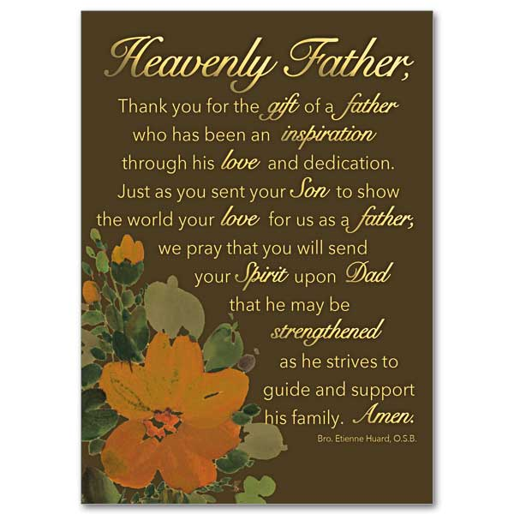
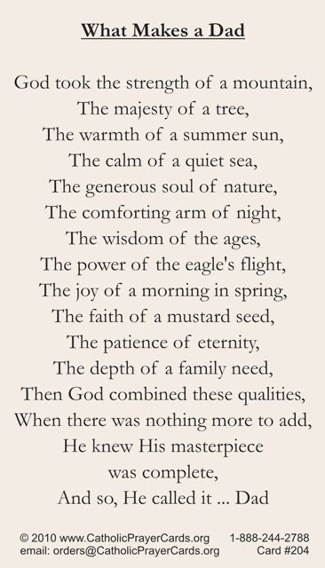
Dear God
Thank you for all the Daddies in the world. Please look after them all, especially at the moment when some people may not be able to see their Daddies very much.
Amen

A time now to say sorry to God:
Jesus says, ‘Repent, for the kingdom of heaven is close at hand.’
A short time of silence
All: Heavenly Father, have mercy upon us, forgive us where we have gone wrong and sinned, and help us to walk from now on in your way. Amen.
May our Father God, the God of love and power, bring you back to Himself, forgive you through the death of His Son Jesus, free you from your sins, and restore you to newness of life by His Spirit

PRAYER OF THE WEEK:

Lord God our Heavenly Father whose love and mercy for us never fails:
deepen our faithfulness to you and to your living Word,
Through Jesus Christ our Lord. Amen.

READINGS:

Romans 8: v14-16 & 26-27.
For those who are led by the Spirit of God are children of God. The Spirit you received does not make you slaves, so that you live in fear again; rather, the Spirit you received brought about your adoption to sonship. And by him we cry, “Abba, Father.” The Spirit Himself testifies with our spirit that we are God’s children.
In the same way, the Spirit helps us in our weakness. We do not know what we ought to pray for, but the Spirit Himself intercedes for us through wordless groans. And He who searches our hearts knows the mind of the Spirit, because the Spirit intercedes for God’s people in accordance with the will of God.
SONG: Father God, I wonder how I managed to exist without the knowledge of your Fatherhood.
https://youtu.be/pMuvGb7KDE8
Father God, I wonder how I managed to exist
Without the knowledge of Your parenthood and Your loving
Care
But now I am Your son, I am adopted in Your family
And I can never be alone
'Cause Father God, You're there beside me
I will sing Your praises
I will sing Your praises
I will sing Your praises
Forever more
I will sing Your praises
I will sing Your praises
I will sing Your praises
Forever more

Our next Bible reading will be read by Charlie

Matthew 7: v 7-11.
Ask and it will be given to you; seek and you will find; knock and the door will be opened to you. For everyone who asks receives; the one who seeks finds; and to the one who knocks, the door will be opened.
‘Which of you, if your son asks for bread, will give him a stone? Or if he asks for a fish, will give him a snake? If you, then, though you are evil, know how to give good gifts to your children, how much more will your Father in heaven give good gifts to those who ask him!

SERMON
I tried googling best father’s day jokes. They appear to be harder to find than good mother’s day jokes but let me share these 2:
Do fathers always snore?
No - only when they are asleep
One evening a little girl and her parents were sitting around the table eating supper. The little girl said, "Daddy, you're the boss, aren't you?" Her Daddy smiled, pleased, and said yes. The little girl continued "That's because Mummy put you in charge, right?"
Peter’s present from our daughter Rachel is perhaps better:
An apron with the slogan ‘Stand back! Dad is cooking’:
The jokes all hinge on what you reckon to be the role of fathers.
Last week Peter and I watched on TV the film Goodbye Christopher Robin. It told the story of how the Winnie the Pooh books came to be written; it happened like this: AA Milne found himself in his house in the Ashdown forest without the nanny or his wife to look after his son Billy Moon. For 2 weeks AA Milne spent time alone with his son. They went walking together through the woods every day playing games together like Pooh sticks and always took with them Billy Moon’s toy animals – Winne the Pooh ,Tigger, Piglet etc
Later when the Winnie the Pooh books became world famous Billy Moon was dragged round the world like a child prodigy being shown off as the ‘real’ Christopher Robin. There is a very poignant and sobering part in the film where a teenaged Billy Moon tells his father how he felt about being used as publicity for the famous books. AA Milne is accused by his son as not being a proper father as he did not love Billy Moon for who he was.
For that of course is what real love is – loving someone for who they are -unconditionally, selflessly. That is the essential, non- negotiable characteristic of being a good father .
We all know many people who never know their father or who had a bad father. But interestingly there is an impressive consensus of what a good father looks like even if you did not have one - someone who loves his child self-sacrificially.
Jesus begins His teaching on prayer with the special Christian family prayer …Our Father. For Christians God is not some remote all powerful, impersonal spirit who we cannot know; He is like the very best human father who loves us more than we can begin to imagine. God the Father is the source and inspiration of all good human fatherhood. We are going to sing after this sermon the beautiful song How deep the Father’s Love. God’s love for us is so deep that He was prepared to send His only Son to die for us on a cross that we might be saved.
And through that great act of self-sacrificial love Jesus won for us the possibility of entering into God’s family, of becoming His children and enjoying all the family privileges.
Look back at our second Bible reading Jesus says: ‘Which of you, if your son asks for bread, will give him a stone? Or if he asks for a fish, will give him a snake? If you, then, though you are evil, know how to give good gifts to your children, how much more will your Father in heaven give good gifts to those who ask him!
A good father is one who loves to give good gifts to his children – but things they really need not just things they want, says Jesus- not necessarily the latest I-phone or computer game And that’s right isn’t it? If you love your children you will love to give them good things they need .And you want to have a relationship with your children where they can ask.
And so Jesus teaches us about prayer. At the heart of the family privileges Jesus has won for us on the cross is the ability to go to God our Father and ask for whatever we need. This is a deeply personal relationship we are given. Paul in his letter to Christians in Rome says that we can call God Abba, Father. But this word is more intimate than father; this is the equivalent of Daddy.
But does Jesus really mean here that God is going to answer every request we make, that he is really like a father longing to give his children what they want and need? Can we truly take him up on such remarkably open-ended promises? I suspect many people have an instinctive reluctance not to ask God for things. They feel it’s selfish or God has better things to do with his time than to provide us with whatever we want. But maybe it is not selfish to ask for things, maybe it is just the natural thing that children are supposed to do with parents. Maybe when we refuse to ask it makes God sad or puzzled; why aren’t his children talking to him and telling him what they would like him to do for them. Of course we shouldn’t ask for wrong things out of selfishness but for most of us it is not that we are too eager to ask for the wrong things but that we are not nearly eager enough to ask for the right things
But the right things does not simply mean good moral qualities like kindness or patience but it means the things we need day by day which our Heavenly Father is just as concerned about. After all in the Lord’s prayer he taught us to ask for our daily bread. God is our Father not a tyrant or bureaucrat who wouldn’t want to be bothered by our trivial concerns. God loves you, He cares for you. He wants you to tell Him your daily needs. He wants to be part of your daily life as all good fathers long to be part of their children’s lives.
As we become mature children, we will increasingly share His concern for His suffering and sorrowing world. We will want to pray for it more than for ourselves. But as well as praying the kingdom prayer that Jesus taught us, as well as praying for God’s will to be done on earth, we are told here very clearly to pray for what we ourselves need here and now. So what is stopping us?
We may well say we have tried it and it doesn’t work. But we are not told God’s timing. All Christians can tell stories of when God answered prayer, but after a long period of time. There is much we cannot understand. But as Archbishop William Temples famously said, ‘When I pray coincidences happen and when I don’t they don’t’.
So treat God as your Father and let Him know how things are with you. And keep telling him and keep trusting. God will never let you down.
We will turn to prayer in a moment to pray for our needs but first we are going to sing a hymn focussing on God’s unconditional love for each one of us.
HYMN: How Deep the Father’s Love for us
https://youtu.be/sjDh4yuil9w
How deep the Father's love for us
How vast beyond all measure
That He should give His only Son
To make a wretch His treasure

How great the pain of searing loss
The Father turns His face away
As wounds which mar the Chosen One
Bring many sons to glory

Behold the man upon a cross
My sin upon His shoulders
Ashamed, I hear my mocking voice
Call out among the scoffers

It was my sin that held Him there
Until it was accomplished
His dying breath has brought me life
I know that it is finished

I will not boast in anything
No gifts, no power, no wisdom
But I will boast in Jesus Christ
His death and resurrection

Why should I gain from His reward?
I cannot give an answer
But this I know with all my heart
His wounds have paid my ransom

PRAYERS:
Heavenly Father,
We come before you in humility and with reverence. As we open our hearts and minds in prayer we know that you will understand our muddled words and minds. We thank you that you will always be there to listen to us and that you will give all good things to those who ask. We rejoice in the fact that we are your children and your heirs and will one day celebrate with you in glory
Keep your people safe…. And guide them in all that they do.
We pray for our beautiful country. We thank you for the sunshine and the showers that help our crops to grow and make our parks and fields look so green and pleasant. We pray for our farmers as they struggle to provide us with the food we need in these uncertain times. We pray for all businesses as they work hard to try to cope with and overcome the strictures that Covid 19 has placed upon them. We pray for the wider world that has to cope with famine, flood and other natural disasters as well as the virus, and especially for those areas of racial tension. Guide us we pray to put into effect the truth that all lives matter, and help us to treat all as brothers and sisters.
Keep your people safe ………and guide them in all that they do.
We pray for our government as it faces the difficult task of balancing the needs of the health of the nation against the economic recession that we are facing. We pray for those involved in the continuing Brexit negotiations. We pray for countries across the globe as they face making the same decisions as to whether to ease or restrict lockdown and as we all keep alert against a second spike of the virus
Keep your people safe……… and guide them in all that they do
We pray for our congregation and our friends and families as they begin to cope with the new normal and in some cases begin to venture out for the first time. We thank you for the fact that we are gradually able to see more people as time goes on. We pray especially for the housebound, and the lonely for whom the world is often a narrow and constrictive space. We pray for Beryl Carr and Michael Harrison and all others known to us …………..Extend your love and care using us to all those who have need of it.
Keep your people safe………. and guide them in all that they do
We give thanks for the lives of all those who we have loved and who are now with you. We think particularly at this time of Pearl Read, Austin Spencer. Dorothy Watkinson and Bernice Hesketh. We ask for your love, support and comfort for their friends and families as they face the difficult times ahead.
Keep your people safe……….. And guide them in all that they do
Merciful Father, accept these prayers for the sake of your Son our Saviour Jesus Christ. Amen

We join now in the Family prayer Jesus taught His followers to pray:
Our Father who art in heaven
Hallowed be thy name
Thy kingdom come, thy will be done
On earth as it is in heaven.
Give us this day our daily bread and forgive us our trespasses
As we forgive those who trespass against us
And lead us not into temptation
But deliver us from evil;
For thine is the kingdom, the power and the glory, for ever and ever. Amen

NOTICES
It is great news indeed that St Michael’s church is now open for private prayer (and funerals) from 9.30 – 4.30 every day. Prayer materials are in the church for use inside the church and to take away.
We held Pearl Read’s Funeral and Thanksgiving service in church on Thursday. It was lovely to see so many of you outside the church. We realise that sometthan of you could not hear much of the service so we are planning to print the tribute and sermon in the next parish magazine.
HYMN; Our final hymn focuses on the faithfulness of our generous Heavenly Father who provides us with all we need: Great is thy Faithfulness O God our Father. https://youtu.be/X3dQX469ylk
"Great is Thy faithfulness, " O God my Father,
There is no shadow of turning with Thee;
Thou changest not, Thy compassions, they fail not
As Thou hast been Thou forever wilt be.
"Great is Thy faithfulness!" "Great is Thy faithfulness!"
Morning by morning new mercies I see;
All I have needed Thy hand hath provided—
"Great is Thy faithfulness, " Lord, unto me!
Summer and winter, and springtime and harvest,
Sun, moon and stars in their courses above,
Join with all nature in manifold witness
To Thy great faithfulness, mercy and love.
"Great is Thy faithfulness!" "Great is Thy faithfulness!"
Pardon for sin and a peace that endureth,
Thine own dear presence to cheer and to guide;
Strength for today and bright hope for tomorrow,
Blessings all mine, with ten thousand beside!
"Great is Thy faithfulness!" "Great is Thy faithfulness!"
BLESSING
May the Love of the Lord Jesus draw you to Himself
May the Power of the Lord Jesus strengthen you to serve Him
And may the Joy of the Lord Jesus fill your hearts
And so may the blessing of God Almighty, the Father, the Son and the Holy Spirit be with you and all those whom you love, now and for ever more. Amen

Rev Ann Templeman 01772 448515 or 07877659156, anntempleman@live.co.uk

