Welcome to Week 3 of Virtual Sunday School.

I hope you and your family are OK and not too bored yet.
This week, I have recorded the session again, as well as sending this, so hopefully you can see that too.

Make a Cross
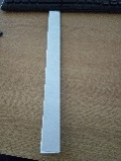
Usually, we get a Palm Cross from church today. We won’t get one this year, so let’s make our own. Here are the instructions, with a few helpful photos:
- Take a piece of A4 paper. Fold it in half 3 times length ways

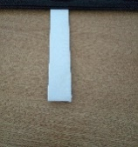

- Fold it in half

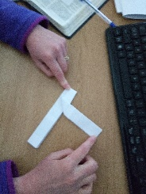
- Fold the top bit along a diagonal to leave the top bit of the cross

- Bend the long bit behind the vertical bit of the cross, and tuck it in if you want. You might want to add a piece of Sellotape to the back to hold it in place.

Keep this for the whole year in place of your palm cross. Display it somewhere to remind you about Palm Sunday and Easter.

Story
Do one or more of these:
- Read Matthew 21v1-11 about Jesus’ triumphal entry into Jerusalem on a donkey.
- Watch the video of me reading the story
- Watch one of these videos
- https://www.youtube.com/watch?v=lTmbTuutBgg
- https://www.youtube.com/watch?v=z-39h0xYqdE
Think about it
- What was the most surprising part of the story and why?
- Have you ever been part of a big crowd watching an event?
- If you saw Jesus on the street, what word might you shout and why?

Activity
Make a flag for Jesus. The crowd who saw Jesus ride into Jerusalem waved Palm leaves and laid down their cloaks. We don’t have access to Palm leaves, but we can make a flag. Think about what happened and what word you might shout and put it on your flag. If you can, attach it to a stick or straw so that you can wave it. Maybe you can act out the story with your family.

Song
Today, we have 3 songs which all remind us of the events of Palm Sunday. The first is a very old classic song and the other two are more modern.
- https://www.youtube.com/watch?v=gSbEEwik2hs
- https://www.youtube.com/watch?v=RrXtnk2eCrg
- https://www.youtube.com/watch?v=kyFZ93k_0AU&feature=youtu.be&fbclid=IwAR1aSYV9QdetXQg73BL3BUgJsArC4xznj7a2UkSapZfTQJzutA9A1tnfcF8

Prayer
What do you want to thank God for this week?
What do want to say sorry for?
What do you want to ask God for?

Now pray this prayer with your family:
Jesus, our King,
we offer you the praise of our hands,
(wave hands)
we offer you the praise of our voices,
(shout ‘Hosanna!’)
we offer you the praise of our feet,
(stamp feet)
we offer you the praise of
our minds and our hearts.
(place hands on hearts)
Hosanna to the Son of David!
Amen.

