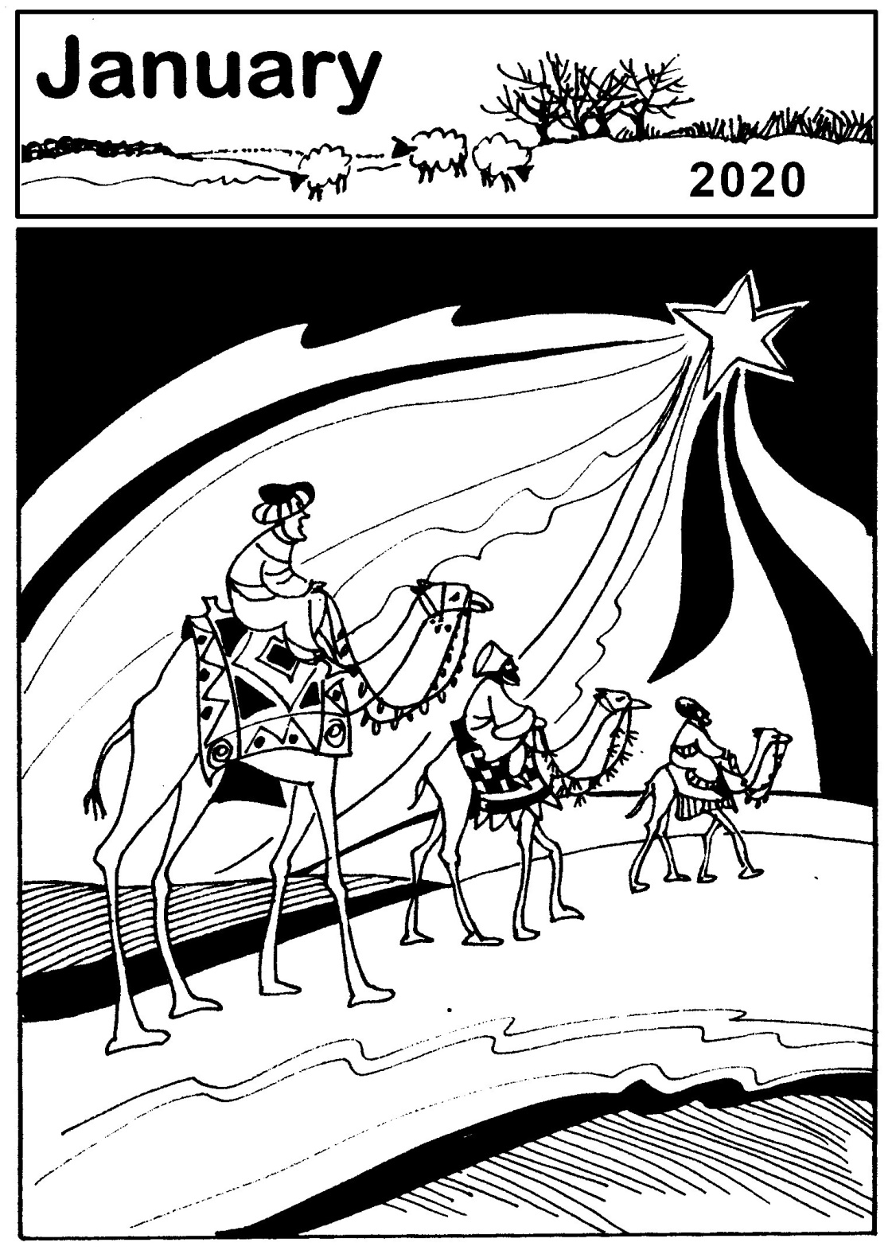
CHURCH OFFICERS
Rector: The Reverend Ann Templeman
The Rectory, 69 Liverpool Road, Much Hoole, PR4 4RB
Tel: 01772 448515 and mob: 07877 659156;
E: anntempleman@live.co.uk
Associate Minister: The Reverend Peter Templeman
Churchwarden:
Mr Jock Davidson – Tel: 617918; E: sgtmajor@talktalk.net
Occasional Preacher:
Mrs Margaret Kirkman – Tel: 01772 379219. Mob: 07786543581.
E: margk1946@gmail.com
Churchwarden Emeritus:
Mr William G Carr. Tel: 01772 615321. E: billcarr1935@btinternet.com
PCC Secretary:
Mrs Andrea Susnik – Tel: 615336. E: familysusnik@live.co.uk
PCC Treasurer:
Mrs Barbara Wood – Tel: 01772 287404. Mobile: 07745 208617. E: bw12252@sky.com
Deanery Synod Representatives: Mrs Jane Elphick, Mrs Jean Dewhurst and Mrs Kathleen Leigh.
Parish Safeguarding Officer: Mrs Jean Dewhurst, Tel: 616106.
Magazine Editor
Mrs Erika Penrose – Tel: 613816. E: jandepenrose@btinternet.com
Magazine Secretary:
Mrs Elsie Kirkham – Tel: 615832.
Magazine Advert Co-ordinator:
Position vacant
Flower Secretaries:
Mrs Lisa Redshaw – Tel 614428 and Mrs Pearl Read – Tel: 614367.
Electoral Roll Officers:
Mrs Jean Dewhurst, Tel: 616106 and Mrs Jane Elphick, Tel: 601495.
Verger: Mrs Irene Pickles – Tel: 615708
Assistant Verger: Mr Stuart Tighe – Tel: 612963
Weekly Giving Envelopes: Please contact the Treasurer or Churchwarden.
Parish Administrator: Mrs Amanda Gibson – Tel: 07735 961620.
ORGANISATIONS
Sunday School
Sunday School – St Michael’s Club – begins at 10.30 in church and usually happens every Sunday.
Leader: Mrs Kathleen Leigh – Tel: 612196. Email: katleigh@live.co.uk
Hoole Church Ladies’ Group – meets 7.30pm, 3rd Tuesday, in School. Leader: Mrs Erika Penrose.
Tel: 613816. E: jandepenrose@btinternet.com
St Michael’s Men’s Fellowship – meets 7.30pm, 2nd Tuesday, in Hoole Village Memorial Hall.
Secretary: Mr Stuart Tighe – Tel: 612963.
Friends of St Michael – Caring for the fabric of our ancient church.
Chair: Mrs Jane Elphick, Tel: 601495.
Secretary: Mr David Turner, Tel: 01772 383344.
Social Committee – Contact: Mrs Sheila Taylor, Tel: 616850
Hoole St Michael C E Primary School
Head Teacher: Mrs Juliet Price – Tel: 613219.
1st St. Michael’s Hoole Scout & Guide Groups – Contact:
Rebecca Catterall
Church Website: http://www.hooleparishchurch.com.

CHURCH OPENING TIMES
St Michael’s Church is open every day. Opening times are:
Monday to Saturday inclusive: 9.30am to 4.30pm.
Sunday: 8.00am to 4.30pm.
Jock Davidson, Churchwarden

Do take a look at our church website – http://www.hooleparishchurch.com
You’ll find the parish magazine in colour there!
We also have a Facebook page with our news – St Michael’s Church, Much Hoole. Please “like” us!

FROM THE RECTORY

Mary did you know?
It's a brilliant song. The children from St Michael's School sung it beautifully at the Toy and Christingle Service. It gets right to the heart of Christmas focusing on who Jesus is and what He came to do.
'Mary did you know that the child who you delivered will soon deliver you?' What a stupendous line!- that tiny human baby is none other than the Lord of all creation breaking into our world on the greatest rescue operation of all time - the salvation of the world, the conquest of sin and death.
For of course it's not just about Christmas - it's a song for every part of the year and it is particularly helpful for January when you have taken down the decorations, all the visitors have gone and you are left taking stock and wondering what the new year with its new government will bring.
And it's immensely personal: ' He came to deliver/to save you'. The first step for all of us is to recognise we need help, we need rescuing from our selfishness, our sin, our preoccupations with our own needs and desires.
A group of 50 young people who had recently become Christians were asked to write one word about what difference their new faith had made. 48 of them wrote the word 'purpose'. Becoming a follower of Jesus had given them the purpose their lives so badly lacked.
We will only find purpose and true peace which lasts throughout the ordinariness of January and beyond, in Jesus Christ - the one who was born in a stable but yet is the Lord of all creation, the Saviour of the World.
There is no better New Year resolution than resolve to get to know Jesus better.
Rev Ann Templeman
January 2020
Mary, Did You Know?
Mary did you know that your baby boy would one day walk on water?
Mary did you know that your baby boy would save our sons and daughters?
Did you know that your baby boy has come to make you new?
This child that you've delivered, will soon deliver you?
Mary did you know that your baby boy will give sight to a blind man?
Mary did you know that your baby boy will calm a storm with his hand?
Did you know that your baby boy has walked where angels trod?
When you kiss your little baby, you kiss the face of God?
Mary did you know? Mary did you know? Mary did you know?
Mary did you know? Mary did you know? Mary did you know?
The blind will see, the deaf will hear, the dead will live again
The lame will leap, the dumb will speak, the praises of the lamb
~~~~
Growth groups/ Bible study groups 2020
You are warmly invited to the Rectory for the continuing Growth and Bible Study groups for the New Year when we will be exploring various Bible passages and themes. The first two sessions at 7.30pm on Monday 6th and Tuesday 14th January will be on the story of the visit of the Wise Men to the Infant Jesus from Matthew Chapter 2.
ST MICHAEL AND ALL ANGELS CHURCH, HOOLE
SUNDAY SCHOOL – Michael’s Club for children (ages 3 to 12), usually every Sunday during the 10.30 service.
10.30am – Starts in church; children leave for their own teaching in the school after a children’s song and return after the sermon and prayers.
Parish Diary to February
Sunday 5th Jan 09.00 Holy Communion (Book of Common Prayer)
10.30 Parish Communion with Sunday School
4.00 Holy Communion at Old Mill Court
Monday 6th Jan 7.30 Growth Group at the Rectory
Tuesday 7th Jan 10.15 Holy Communion (said)
Sunday 12th Jan 09.00 Holy Communion (Book of Common Prayer)
10.30 Morning Worship with Sunday School
Monday 13th Jan 7.30 PCC meeting at the Rectory
Tuesday 14th Jan 10.15 Holy Communion (said)
7.30 Growth Group at the Rectory
Sunday 19th Jan 09.00 Holy Communion (Book of Common Prayer)
10.30 Parish Communion
3.45 FROZEN CHURCH IN ST MICHAEL’S SCHOOL
Tuesday 21st Jan 10.15 Holy Communion (said)
Sunday 26th January 09.00 Holy Communion (Book of Common Prayer)
10.30 Morning Worship with Sunday School
Tuesday 28th January 10.15 Holy Communion (said)
Sunday 2nd February 09.00 Holy Communion (Book of Common Prayer)
10.30 Parish Communion with Sunday School
4.00 Holy Communion at Old Mill Court
Monday 3rd February 7.30 Growth Group at the Rectory
Tuesday 4th February 10.15 Holy Communion (said)
Sunday 9th February 09.00 Holy Communion (Book of Common Prayer)
10.30 Morning Worship with Sunday School
Tuesday 11th Feb 10.15 Holy Communion (said)
7.30 Growth Group at the Rectory
Sunday 16th February 09.00 Holy Communion (Book of Common Prayer)
10.30 Parish Communion with Sunday School
Tuesday 18th Feb 10.15 Holy Communion (said)

Sunday 23rd Feb 09.00 Holy Communion (Book of Common Prayer)
10.30 Morning Worship
3.45 PANCAKE CHURCH IN THE VILLAGE HALL
Tuesday 25th Feb 10.15 Holy Communion (said)
ASH WEDNESDAY 26th 7:30 Holy Communion

Intercessions: Please let the Rector or Margaret Kirkman know of anyone you would like including on our prayer list, by text or 07786 543581.

KEY FUTURE DATES

- PANCAKE CHURCH
In the Village Hall at 3.45pm

- MOTHERING SUNDAY SERVICE
Sunday 22nd March at 10.30am

- PALM SUNDAY SERVICE
Sunday 5th April at 10.30am
Meet at St Michael’s School at 10.00am to process with donkey

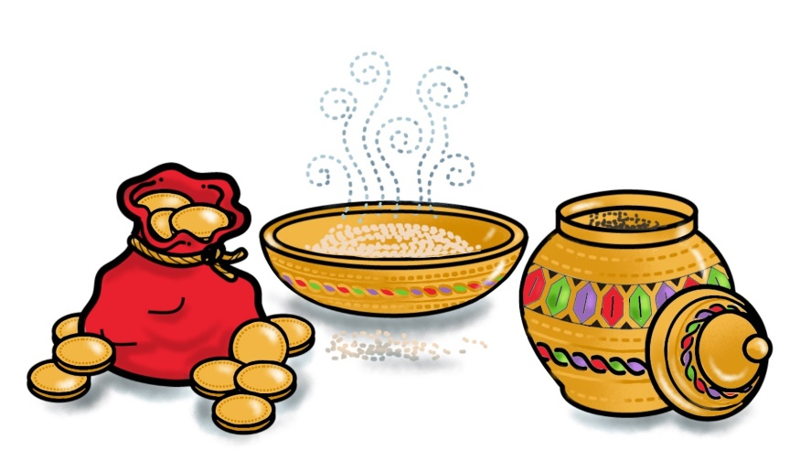

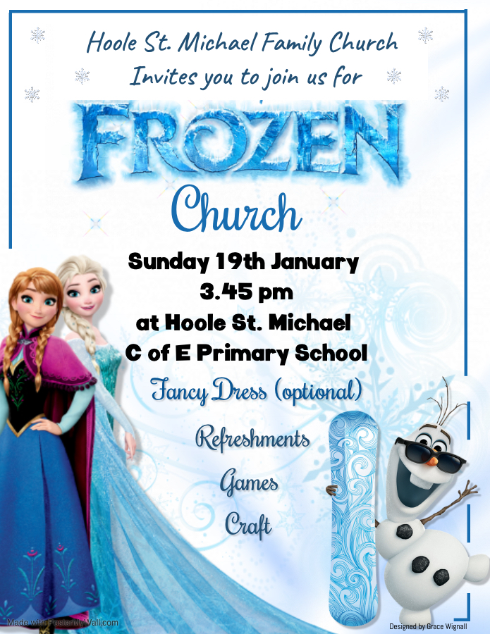
TOY AND CHRISTINGLE SERVICE
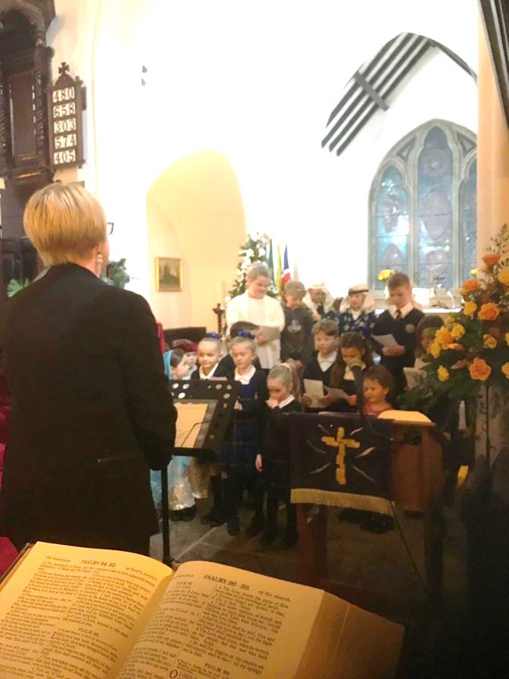
The church was full of 100 children and their parents for the Toy and Christingle service.
Children from St Michael's school acted out part of the nativity and sang a beautiful and profound carol called Mary did you know? – see the 'From the Rectory’ article for some of the words.
At the end of the service the Christingles were lit and the lights turned off; it was an amazing way of worshipping Jesus, the light of the world, as we sang ‘Shine Jesus shine’.

Report from Penny:
I went to the Christingle service at church on Sunday with my family and we all really enjoyed it. I especially enjoyed singing the Christmas Carols! It was lovely watching the children perform their songs and Nativity scene and it was really moving to see how many people had brought presents to donate to Derian House – it’s such a worthy cause.
The atmosphere in church on Sunday was really warm and welcoming and the tea and the amazing Christingle cake at the end was a perfect end to a lovely service!
~~~~

Ladies’ Group
The committee and I would like to wish a Happy New Year to all our members and friends.
Our Christmas Coffee Evening last month went extremely well and we all thoroughly enjoyed the entertainment provided by Katy Bradley and her choir, “KTB Voice”. The proceeds from this event of £484 – the best for several years – have been donated to the NW Air Ambulance. Many thanks to everyone who contributed.
This month it is of course our AGM and social evening, taking place on Tuesday 21st January in the village hall at 7.30pm. We look forward to seeing as many members as can make it: annual subs of £10.00 are payable and the new 2020 programme will be available. Added attraction – we will all be able to enjoy another session of a Beetle Drive!
Don’t forget it’s our 45th anniversary lunch on Tuesday 18th February at the Fat Italian Restaurant, Burscough, 12.45 for 1.00pm (the third Tuesday as usual except in the daytime). The cost is £20 for two courses including tea/coffee. You can choose either a starter and main course or a main course and dessert; if you would like a third course you will pay the extra cost on the day. A £5 deposit is due. Menus have been distributed and if you would like one, please call Sheila on 616850 or ask her at the AGM. Lifts, if required, will be arranged nearer the event.
We would like to encourage any ladies who are thinking they might like a regular evening out, to join our group – or at least to come along and try us! You would find us a very warm and friendly group. Call me (contact details at the beginning of the magazine) for more details or just come along.
Erika
~~~~
Men’s Fellowship
The Men’s Fellowship will be meeting at the village hall on Tuesday 14th January at 7.30pm. The talk by Malcolm Tranter is entitled “Going up in the World”. All men welcome.

Prayer of the Month
Father, we dedicate ourselves
to serve you faithfully
and to follow Christ
To face the future with him,
seeking his special purpose for our lives.
Send us out now to work
and to witness
freely, gratefully and hopefully,
in the power
of the Holy Spirit,
and for the honour and glory
of your Son
Jesus Christ our Lord. Amen.

From the Parish Registers
Holy Baptism “We welcome into the Lord’s Family”
Henry Thomas Baron was baptised on 8th December.
The Departed “Rest eternal grant unto them”
The ashes of Shirley Holme were interred in the churchyard on 22nd November.
We give thanks for the life of Anne Valerie Harrison, aged 79, of Walmer Bridge, whose funeral took place on 10th December. Interment followed in the churchyard.
~~~~
From the Register of Services
Date |  | Attendance | Communicants | Amount
November | 24th | 88 | 26 | £276.60
December | 1st | 84 | 69 | £360.90
 | 8th | 159 | 27 | £284.30
Standing Order total for November: £546.50
Standing Order projection for December: £3,500
Donations from Baptisms: £67.21.
~~~~

Your 2020 giving to church

Envelopes:
Please look for your 2020 giving envelopes in church, if you haven’t already collected it. The new box of envelopes will usually be near the font.
Some of you will have new numbers as the number of people giving via the regular envelope system is decreasing: therefore we have ordered fewer this year.
Please check your name first, then the number on the box.

Standing Orders:
The number of people giving by monthly standing order or annual donation is increasing. However, you may recall that in the envelope scheme there were options to just “give that bit extra” at Easter, Harvest, Christmas.
Could you take that into account in your giving perhaps on those special occasions?

Thank You:
Many thanks to everyone who gives: big or small, regular or ad hoc; all is appreciated.
But like inflation, our needs keep growing with the growth of our Church.
Can you please consider giving just a teensy weensy little bit more this next year??

Consider this:
- An increase of just 50p per week raises your donation by £26 per annum.
- If everyone did it, it would be a massive boost of £2,106!!

All enquiries are welcome whether it is about giving by envelope or standing order or anything else finance related.
Please do not hesitate to give me a call, drop me an email, pop round my house or collar me on a Sunday.

Barbara Wood - Treasurer to the PCC

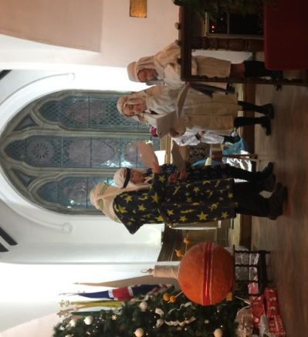
Hoole St Michael CE Primary School – December
The children at Hoole St Michael CE Primary made Christingles with the help of our parents. We really enjoyed the Christingle service led by Rev Ann. Morgan sang a beautiful solo - ‘Once in Royal David’s City’ to begin our worship. Our children performed ‘Mary Did You Know’ which Mrs Mesghali taught us. Some of the children also performed an entertaining shepherd sketch for us. A wonderful time was had by everyone. Juliet Price, Headteacher
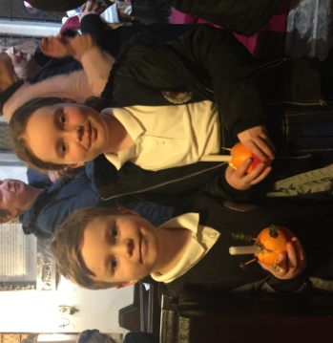
Our Prayer Circle
As Christians we know that one of the main things that Jesus taught us was the words of The Lord’s Prayer and very often in the Bible we are told that He went to a quiet place and prayed. Our hymns tell us to “Take it to the Lord in prayer” and that “the voice of prayer is never silent”. There is no doubt of the need for prayer for our own spiritual needs as well as the knowledge of the comfort and support that it gives to both the person praying and the people being prayed for.
To that end we have set up a Prayer Circle at St Michael’s.... ‘What’s one of those then?’ you may ask. It is simply a group of people who when called upon will pray at home separately and quietly for whatever you ask.
If you have a concern of any sort that you want us to pray for all you need to do is to ring any of the numbers and simply say what or who is in need of prayer, and whilst a minimum of explanation might be an advantage for us to focus the prayer, ou don’t even have to say who you are! The person taking the call will pass it round the circle and you will know that we, on behalf of the church, are taking your worry to the Lord. If you would like your particular concern added into the intercessions on a Sunday morning then we can do that too.
We are happy to welcome others into the circle, just let us know and you will be added on.
Prayer is an essential part of our Christian life to keep us walking in the footsteps of our Saviour... so... the lines are open right now, we are waiting to take your call which is very important to us because it matters to you... just ring and your prayer will be increased seven-fold (at least).
Our circle consists of Ted (01772 617002), Margaret (01772 379219), Carole Bamber (01772 610670 or mobile 07989 145963), Gill Slinger (07729 121248), Barbara Wood (07745 208617) and Bill Carr (01772 615321).
Ted, Margaret, Carole, Gill, Barbara and Bill

There was no space for “Uncle Eustace” in last month’s issue, so by popular request we’re catching up this month:

St James the Least of All
Parish Pump Editor: The Rev Dr Gary Bowness continues his tongue-in-cheek letters from ‘Uncle Eustace’…

On the best ways for a vicar to disrupt Christmas

My dear Nephew Darren
I am sorry I was not alive during that wonderful four-year period when Oliver Cromwell abolished Christmas. Just think! No Christmas parties, no carol services, no cards to send and no frantic last-minute shopping. That man was a hero.
Planning for Christmas at St James’ normally starts on 2nd January. By Easter, the flowers for church have been colour coordinated, the seating plans and table decorations for the Christmas party have been allocated (with nominated reserves in case someone should inconveniently die in the intervening eight months). Long before Summer is over, the tree lights have been tested, music for the 9 Lessons and Carols Service has been chosen and the service sheets printed. Way before the dark nights set in, car parking attendants will have been found, those who are to light all the candles will have been rehearsed to perfection and the brass lectern has had its annual polish.
We do not do spontaneity at St James the Least of All. If ever there was a service when time for something unexpected was allowed, its place would be announced in the order of service; how long it would happen unexpectedly would have been decided by a committee and who was to be spontaneous would have been allocated on a rota.
The one person none of these well-meaning, efficient, committed organisers can control is the Rector. You could call it a staff perk.
Carols will (accidentally, of course) be announced in the wrong order; if verse 3 was to be omitted, I announce it will be verse 4. This keeps the organist on his toes while the choir hovers on the point of a collective nervous breakdown. At the Christmas supper, my introductory welcome speech and extensive grace make those in the kitchen wonder if the vegetables being boiled should better be served as thick soup.
I offer the helpful suggestion that the tree, having been installed and decorated in the chancel, may perhaps look better in the sanctuary and I turn all the heating off throughout the season, explaining that it will help the flowers to last. All Services will start five minutes early (was my watch rather fast?) so I can look disapprovingly at those still coming in while we are singing the first carol and making it clear that I think they had spent too long in the pub next door.
And so we all reach Christmas morning, with 12 months of planning having gone yet again slightly awry, with parishioners exhausted and I exhilarated at the chaos that has been created with such ease. Mr Cromwell, your spirit lives on.
Your loving uncle,
Eustace

On how to mix town and country – or not

The Rectory
St James the Least of All

My dear Nephew Darren
Your idea for our two churches to hold a combined New Year’s Day walk was an admirable one, although I could sense a certain clash of cultures when your party arrived at the starting point with boots, waterproofs and GPS equipment. Our own group, rather anticipating tottering between tea shops, with a little light shopping in between, sported tweed suits, shopping bags and furled umbrellas.
Even the two sets of dogs seemed bemused with one another, with your Westies and King Charles spaniels making enough noise to scare all the wildlife in the county, and our Retrievers puzzled why the pheasants were not dropping from the sky. Dear Miss Mill’s miniature poodle, with the painted toenails, will probably need life-long counselling; the furthest she had walked previously was from her bed to beside the dining room table.
The electronic navigation equipment brought by members of your group made me think that if only the wise men had had these blessings, they wouldn’t have had to follow anything as unreliable as a star. Although I suppose that instead of gold, frankincense and myrrh, they would then have arrived with an MP3 player, a mobile phone which would have been obsolete before Jesus’ first birthday and a CD of Madonna’s greatest hits.
I do concede that our two congregations learned much from one another. Our ladies were most interested to hear about the latest in personal trainers, while yours discovered how to bring a pan of jam to a rolling boil. Your men seemed impressed to hear of squirrel shooting while ours gathered useful tips for caravanning abroad. And poor Miss Mill’s poodle learned that the great outdoors was a parallel and hostile universe.
By mid-afternoon, however, the balance of power shifted. When the leader of the walk from your group lost his Sat Nav, our members felt the need to assert themselves. The gentlemen navigated using wind direction, moss on trees and angles of the sun, while our ladies, with tweed skirts furled somewhat higher than one would have wished, showed yours how to wade through peat bog without complaining.
Perhaps town and country really can learn from one another. But if Major Bullock’s wife arrives for Matins next Sunday sporting the latest gym gear, you will have much to answer for.
Your loving uncle,
Eustace

. Miscellaneous observations on our Christian pilgrimage…
Conduct is an unspoken sermon. - Henri Amiel
No amount of falls will really undo us if we keep picking ourselves up each time. - CS Lewis
Though our feelings for (God) come and go, His love for us does not. It is not wearied by our sins, or our indifference; and, therefore, it is quite relentless in its determination that we shall be cured of those sins, at whatever cost to us, at whatever cost to Him. - CS Lewis.
In helping others, we benefit ourselves; we heal our own wounds in binding up those of others. – Ambrose
Don't talk about the cold hand of death. It is the hand of Christ. - Mary Slessor
Miscellaneous observations on daily life…
Experience is not always the kindest of teachers, but it is the best.
The greatest failure is the failure to try. - William A Ward
Dost thou love life? Then do not squander time, for that is the stuff life is made of. - Benjamin Franklin
Worry is like a treadmill - it wears you out and gets you nowhere.
Nothing is more powerful than hope. One little nibble will keep a person fishing all day. - H V Prochnow
If you tell the truth, you don't have to remember anything
Good judgement comes from bad experience, and a lot of that comes from bad judgement.
A closed mouth gathers no foot.
Generally speaking, you aren't learning much when your lips are moving.
Experience is something you don't get until just after you need it.
Some days you are the bug; some days you are the windscreen.
I’ll sing to that…
There was a church where the new minister and the organist were not getting along. As time went by this began to spill over into the worship service.
One week the minister preached on commitment and how we all should dedicate ourselves to the service of God. The organist played: ‘We shall not be moved’.
The next week the minister preached on tithing and how we all should gladly give to the work of the Lord. The organist responded with: ‘Jesus Paid it All’.
The third week the minister preached on gossiping and how we should all watch our tongues. The organist played all verses of: ‘I Love to Tell the Story’.
By now the minister had become very discouraged with the situation, and the following Sunday told his congregation that he was considering resigning. The organist closed the service with: ‘O Why Not Tonight?
As it came to pass, the minister did indeed resign. The following Sunday he informed the church that it was Jesus who had led him there and it was Jesus who was taking him away. The organist then outdid himself with: ‘What a Friend We Have in Jesus.’
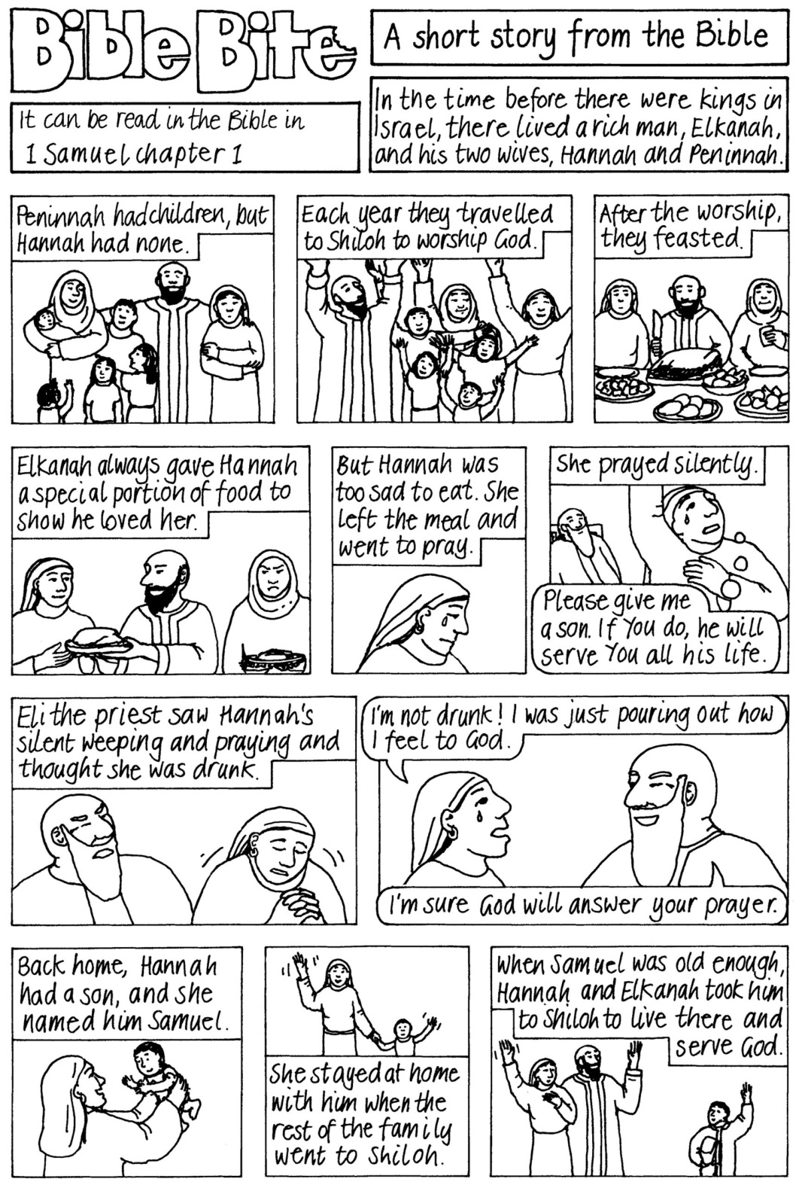
Word Search clues - Samuel part 1 of 2

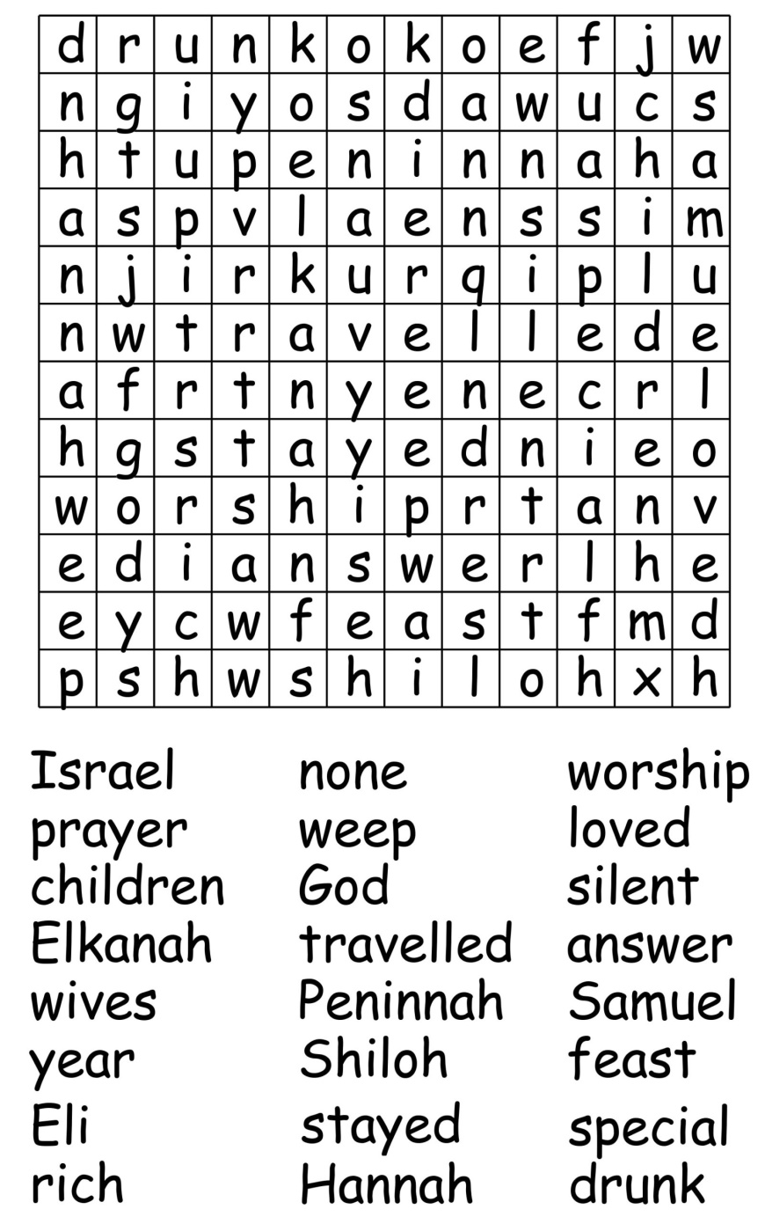
Crossword Clues for January 2020. Answers on page 24.

Across
1 ‘Again Peter denied it, and at that moment a — began to crow’ (John 18:27) (4)
3 Fetters (Job 33:11) (8)
8 Perform on a musical instrument (1 Samuel 16:23) (4)
9 Paul describes it as ‘the third heaven’ (2 Corinthians 12:2–4) (8)
11 Loyally (Deuteronomy 11:13) (10)
14 Hens? Me? (anag.) (6)
15 Not visible (Matthew 6:6) (6)
17 Predicted site of the final great battle (Revelation 16:16) (10)
20 Jacob’s youngest son (Genesis 35:18) (8)
21 One of Zophar’s eleven sons (1 Chronicles 7:36) (4)
22 For example, London, Paris, Rome (8)
23 United Society for the Propagation of the Gospel (1,1,1,1)

Down
1 Favourite church activity: Fellowship round a — — — (3,2,3)
2 Divinely bestowed powers or talents (8)
4 Pile together (1 Thessalonians 2:16) (4,2)
5 Commanded to justify (John 8:13) (10)
6 Timothy’s grandmother (2 Timothy 1:5) (4)
7 Killed (Psalm 78:34) (4)
10 One of Graham Kendrick’s best-known songs, — — King (3,7)
12 Indecency (Mark 7:22) (8)
13 Unceasing (Jeremiah 15:18) (8)
16 He prophesied ‘the abomination that causes desolation’ (Matthew 24:15) (6)
18 British Board of Film Classification (1,1,1,1)
19 Pans (anag.) (4)

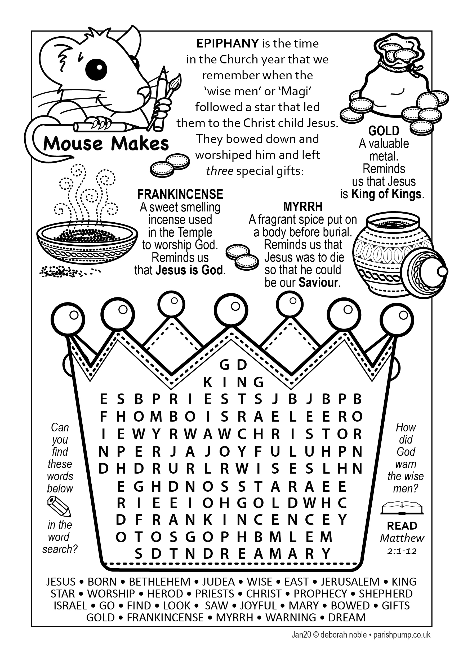
Crossword Answers from page 22

ACROSS: 1, Cock. 3, Shackles. 8, Play. 9, Paradise. 11, Faithfully. 14, Enmesh. 15, Unseen. 17, Armageddon. 20, Benjamin. 21, Beri. 22, Capitals. 23, USPG.

DOWN: 1, Cup of tea. 2, Charisma. 4, Heap up. 5, Challenged. 6, Lois. 7, Slew. 10, The Servant. 12, Lewdness. 13, Unending. 16, Daniel. 18, BBFC. 19, Snap.

Sudoku – Medium
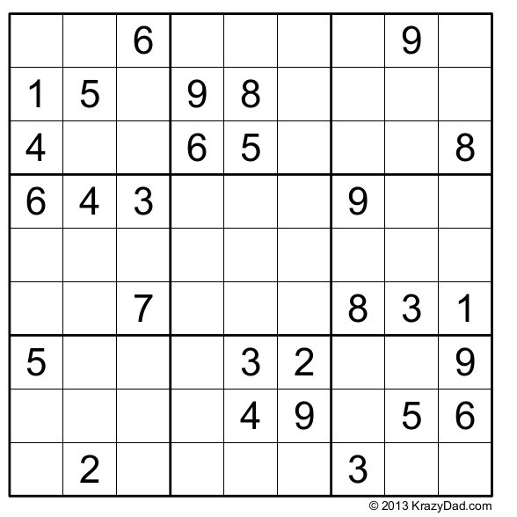

And try this Maze!

CHURCH ROTAS FOR JANUARY

Readers’ Rota
If you cannot read as specified on this rota, please find a substitute and inform a churchwarden of any changes.

Jan 5th 9.00 Peter Templeman
10.30 Lynn Smith and Carole Bamber
12th 9.00 Val Simpson
10.30 Scott Eckersley and Peter Templeman
19th 9.00 Ann Templeman
10.30 Gill Slinger and Jane Elphick
26th 9.00 Mike Redshaw
10.30 Jean Dewhurst and Barbara Wood
Feb 2nd 9.00 Kathleen Leigh
10.30 Emma Cairns and Lillie Holmes-Evans
Sidespersons’ Rota
Jan 5th 9.00 Mike Redshaw
10.30 Jean Aughton, Colin Brown & Julie Brown
12th 9.00 Ken Bishop
10.30 Ted Hopkins & Robert Hawthornthwaite
19th 9.00 Rob McMurray
10.30 Norman Skellorn, Geoff Demack & Eunice Houghton
26th 9.00 Jeremy Leigh
10.30 Bill Carr, Scott Eckersley & Beryl Blakeley
Feb 2nd 9.00 John Simpson
10.30 Jean Aughton, Colin Brown & Julie Brown

Flower Rota
Date Arranger(s) Sponsor(s):
Jan 5th Lisa & Julie
12th Jean & Jean Mr Les Short (Children’s Corner)
19th Betty & Averil Mr & Mrs J Leigh
26th Pearl & Claire Men’s Fellowship
Feb 2nd Elsie & Althea No sponsor
9th Gillian, Angela, Lisa Redshaw
Lisa and Julie

Tea/Coffee Rota following our 10.30 Service
Jan 5th Erika
12th Carole & Gill
19th Beryl & Erika
26th Pauline & Barbara
Feb 2nd Carole & Gill
If you wish to change the date assigned to you, please find a replacement or arrange a swap.

