CHURCH OFFICERS
Rector: The Reverend Ann Templeman – Tel: 01772 448515 and mob: 07877 659156; E: anntempleman@live.co.uk
Associate Minister: The Reverend Peter Templeman
Churchwarden
Mr Jock Davidson – Tel: 617918; E: sgtmajor@talktalk.net
Occasional Preacher
Mrs Margaret Kirkman – Tel: 01772 379219. Mob: 07786543581.
E: margk1946@gmail.com
Reader in Training
Mr Alan Johnson – Tel: 01704 822179; E: alanmarie55@gmail.com
Churchwarden Emeritus
Mr William G Carr. Tel: 01772 615321. E: billcarr1935@btinternet.com
PCC Secretary
Mrs Andrea Susnik – Tel: 615336. E: familysusnik@live.co.uk
PCC Treasurer
Mrs Barbara Wood – Tel: 617679. E: bw12252@sky.com
Deanery Synod Representatives: Mrs Jane Elphick, Mrs Jean Dewhurst and Mrs Kathleen Leigh
Magazine Editor
Mrs Erika Penrose – Tel: 613816. E: jandepenrose@btinternet.com
Magazine Secretary
Mrs Elsie Kirkham – Tel: 615832.
Magazine Advert Co-ordinator
Mrs Margaret Clark – Tel: 616990. E: mic0802@live.co.uk
Flower Secretaries
Mrs Lisa Redshaw – Tel 614428 and Mrs Pearl Read – Tel: 614367.
Electoral Roll Officers
Mrs Jean Dewhurst, Tel: 616106 and Mrs Jane Elphick, Tel: 601495.
Verger: Mrs Irene Pickles – Tel: 615708
Assistant Verger: Mr Stuart Tighe – Tel: 612963
Weekly Giving Envelopes: Pleas
e contact the Churchwarden.
Parish Administrator: Mrs Amanda Gibson – Tel: 07735 961620.

ORGANISATIONS
Sunday School
Sunday School – St Michael’s Club – now begins at 10.30 in church and happens every Sunday.
Leader: Mrs Kathleen Leigh – Tel: 612196. Email: katleigh@live.co.uk
Hoole Church Ladies’ Group – meets 7.30pm, 3rd Tuesday, in School. Leader: Mrs Erika Penrose.
Tel: 613816. E: jandepenrose@btinternet.com
St Michael’s Men’s Fellowship – meets 7.30pm, 2nd Tuesday, in Hoole Village Memorial Hall.
Secretary: Mr Stuart Tighe – Tel: 612963.
Friends of St Michael – Caring for the fabric of our ancient church.
Chair: Mrs Jane Elphick, Tel: 601495.
Secretary: Mr David Turner, Tel: 01772 383344.
Social Committee – Contact: Mrs Sheila Taylor, Tel: 616850
Hoole St Michael C E Primary School
Head Teacher: Mrs Juliet Price – Tel: 613219.
1st St. Michael’s Hoole Scout & Guide Groups – Group Scout Leader: Mandy Clark – Tel: 01772 305452; E:gmjbclark@yahoo.co.uk.
Church Website: Our new church website is now live; the address is
http://www.hooleparishchurch.com. WHY NOT TAKE A LOOK!

Please note: All adverts are at the back of the magazine.
Church Rotas are to be found on pages 26 & 27.

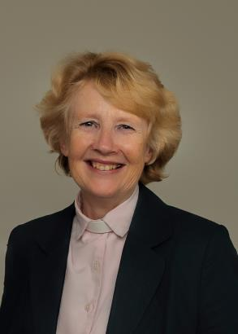
From the Rectory
‘They went to the tomb and found it empty.’
Usually when you find something empty it’s bad news. If you go to the fridge when you’re hungry and find it empty it's bad news. If you get online and find your bank account is empty it’s very bad news indeed.
On the first day of the week Jesus’ friends came to the tomb and found it empty. At first they thought it was bad news as they assumed someone had stolen Jesus’ body but then it became the best possible news; they discovered that his body was not there because Jesus had risen from the dead. And Mary had met him.
I hope you enjoyed the Easter edition of this magazine: those headlines DEAD MAN LIVES! spell out the earth shattering events of the Passover festival in Jerusalem in 30AD – Jesus of Nazareth executed by the Roman authorities and buried in a guarded stone tomb but just two days later an empty tomb and numerous sightings of him by his followers.
If you were in St Michael's on Easter Sunday you watched the daffodil sketch. One of the two daffodils is ridiculed by her friend for believing in an afterlife. She represents that deep longing in all of us for immortality, for eternal life. The claim of Easter witnessed by over 500 people in 11 separate sightings and supported by the testimony of literally billions of Christians ever since is precisely that the first witnesses to the resurrection of Jesus spoke the truth, that Jesus really did rise from the dead and He is alive now. That yearning inside all of us can be satisfied.
I hope very much that many of you will consider going deeper into the Bible and the Christian faith over the summer months by coming along to some of our six Bible discussion group meetings on Mark's Gospel (see details below). These sessions will take place fortnightly on Monday and Tuesday evenings from May to July, from 7.30pm to about 8.45pm, in the Rectory with refreshments (See “What Next” below for the dates). Each session will be stand-alone and will be held twice so people can come along on a different day if they wish. This is an opportunity to get to grips with Mark's Gospel as a whole and some key passages in detail and hence familiarise yourself with more of Jesus’ teaching and the some of the most significant events of His three-year public ministry.
Watch out too for information about how to join in the great national and international wave of prayer launched by our Archbishops from Ascension to Pentecost (30th April till 11th June) to pray as Jesus commanded THY KINGDOM COME and discover that prayer works.
Ann
The Rev Ann Templeman
The Rectory, 69 Liverpool Old Road
Much Hoole, PR4 4RB.
Tel no 01772 448515; mobile 07877 659156.

THY KINGDOM COME – Please pick up the free resources at the back of the church to help you pray and read the Bible as part of this global wave of prayer.

WHAT NEXT?
Do you want to know more about the Bible and the Christian Faith?
Why not come along to the 6 sessions on Mark’s Gospel which we
are running fortnightly from May to July on Monday and then
repeated on Tuesday evenings. Each session will be at the Rectory,
69 Liverpool Old Rd, starting at 7.30 and finishing c 8.45pm.
Session 1: Tues 14th & Mon 20th May Session 2: Tues 28th May & Mon 3rd June
Session 3: Tues 11th and Mon 17th June Session 4: Tues 25th May & Mon 1st July
Session 5: Tues 9th and Mon 15th July Session 6: Tues 23rd & Mon 29th July
Please contact Rev Ann: anntempleman@live.co.uk or tel: 017723 448515 for more info.

Sunday School – Michael’s Club for children (ages 3 to 12), every Sunday during the 10.30 service.
10.30am – Starts in church; children leave for their own teaching in the school after a children’s song and return after the sermon and prayers.
Parish Diary for May and June 2019
Thursday 2nd May 6.00 Parish Amble starting from The Dolphin Inn
Saturday 4th May 2.00-3.00 Help required to clean church after building
works in readiness for Sunday services.
Sunday 5th May 09.00 Holy Communion (Book of Common Prayer)
10.30 Parish Communion with Sunday School
12.00 Baptism of Ronnie Arthur Davidson
4.00 Holy Communion (Old Mill Court)
Tuesday 7th May 10.15 Holy Communion (said)
Sunday 12th May 09.00 Holy Communion (Book of Common Prayer)
10.30 Morning Worship with Sunday School
Monday 13th May 7.00 PCC meeting at the Rectory (beginning with buffet meal)
Tuesday 14th May 10.15 Holy Communion (said)
7.00 Men’s Fellowship meeting at MH Village Hall
7.30pm House group/Bible Study at the Rectory - Mark session 1
Sunday 19th May 09.00 Holy Communion (Book of Common Prayer)
10.30 Parish Communion with Sunday School
12.00 Baptism of Billie Jane Curley
4.00 LEGO FAMILY CHURCH at Much Hoole Village Hall
Monday 20th May 7.30 House group/Bible Study at the Rectory – Mark session 1
Tuesday 21st May 10.15 Holy Communion (said)
Ladies’ Group Day Trip to Barton Grange Garden Centre
Saturday 25th May 1.00 Wedding of Donna Harrison & Andrew Crabtree
Sunday 26th May 09.00 Holy Communion (Book of Common Prayer)
10.30 Morning Worship with Sunday School
12.00 Baptism of Elsie Louise Williams
Tuesday 28th May 10.15 Holy Communion (said)
7.30 House group/Bible Study at the Rectory – Mark session 2
THY KINGDOM COME NATIONAL CALL TO PRAYER –
ASCENSION DAY TO PENTECOST
ASCENSION DAY Thursday 30th May
7.30 Holy Communion

Monday 3rd June 7.30 House group/Bible Study at the Rectory – Mark session 2
Sunday 2nd June 09.00 Holy Communion (Book of Common Prayer)
10.30 Parish Communion with Sunday School
12.00 Baptism of Rory George Thomas
Tuesday 4th June 10.15 Holy Communion (said)
Saturday 8th June 2.00 Ladies’ Group Summer Fete at Hoole Village Hall
PENTECOST
Sunday 9th June 09.00 Holy Communion (Book of Common Prayer)
10.30 Morning Worship with Sunday School
12.00 Baptism of Benjamin Toby Alan Wheatley
4.00 LIFT OFF FAMILY CHURCH at Much Hoole Village Hall
Tuesday 11th June 10.15 Holy Communion (said)
7.30 House group/Bible Study at the Rectory – Mark session 3
TRINITY SUNDAY
16th June 09.00 Holy Communion (Book of Common Prayer)
10.30 Parish Communion with Sunday School
Monday 17th June 7.30 House group/Bible Study at the Rectory – Mark session 3
Tuesday 18th June 10.15 Holy Communion (said)
7.30 Ladies’ Group meeting at St Michael’s School
Sunday 23rd June 09.00 Holy Communion (Book of Common Prayer)
10.30 Morning Worship with Sunday School
Tuesday 25th June 10.15 Holy Communion (said)
7.30 House group/Bible Study at the Rectory – Mark session 4
Sunday 30th June 09.00 Holy Communion (Book of Common Prayer)
Have you seen our new church website for church news, photos, etc?
Go to http://www.hooleparishchurch.com

10.30 Parish Communion with Sunday School
10.30 Confirmation Service at St James’ Church, Leyland
12.00 Baptism of Joshua Thomas John Bradley

KEY FUTURE DATES
- LEGO FAMILY CHURCH
Sunday 19th May at 4.00pm in the Village Hall

- LIFT OFF CHURCH
Sunday 9th June at 4.00pm in the Village Hall

- CREAM TEA CHURCH
Sunday 7th July at 3.00pm in St Michael's School

- HARVEST FESTIVAL
Sunday 6th October

From the Parish Registers
Holy Baptism
“We welcome into the Lord’s Family”
Charlie Christopher Davison was baptised on 10th March.
George Davison Stillwell was baptised on 10th March.
Evelyn Cerys Jones was baptised on 7th April.
Funerals
We give thanks for the life of Charles Henry Wells, aged 91 years, of Longton, whose funeral took place on 29th March. Interment followed in the churchyard.
The ashes of the Reverend Steven Hughes were interred in the churchyard on 20th April.
We pray for their family and friends.
~~~~
From the Register of Services
Date |  | Attendance | Communicants | Amount
March | 24th | 80 | 32 | £305.70
March | 31st | 111 | 86 | £331.31
April | 7th | 81 | 68 | £342.45
April | 14th | 113 | 28 | £321.75
Donations from Weddings, Funerals and Baptisms: £268.23.
Have you had a look at our new church website for church news, photos, etc?
Go to http://www.hooleparishchurch.com

PALM SUNDAY AND ANNUAL CHURCH MEETING – 24th April
The morning began with the donkey procession from the school to the church with our two visiting donkeys, Jack and Jenny, and the enthusiastic waving of palm branches by children and adults. During the service the children were invited outside to have donkey rides which they thoroughly enjoyed.
In Church we celebrated Jesus’s entry into Jerusalem riding on a donkey – the long awaited King who would bring peace.
Then followed St Michael’s Annual Church Meeting in school, and a Jacob’s Join which was much appreciated by all.
At the Annual Meeting the following were elected to the Parochial Church Council:
Chair: Revd Ann Templeman
Warden: Jock Davidson
Warden: Vacant
Associate Minister: Revd Peter Templeman
Treasurer: Barbara Wood
Secretary: Andrea Susnik
Synod Rep/ER: Jane Elphick
Synod Rep/ER: Jean Dewhurst
Synod Rep: Kathleen Leigh
Reader in Training: Alan Johnson
Member: Bill Carr
Member: Mike Redshaw
Member: Gillian Slinger
Member: Eunice Houghton
Member: Margaret Kirkman
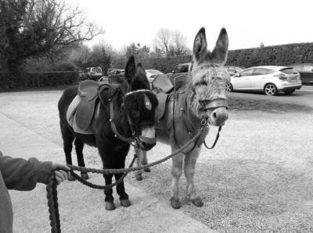
Member: Carole Bamber
Member: Emily Wignall

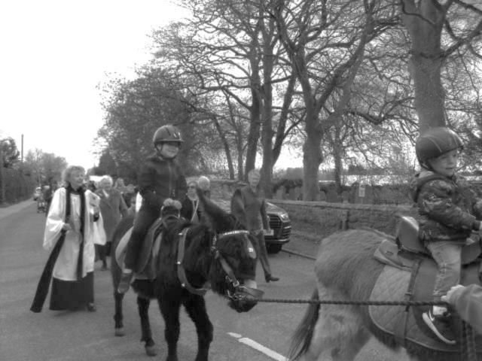
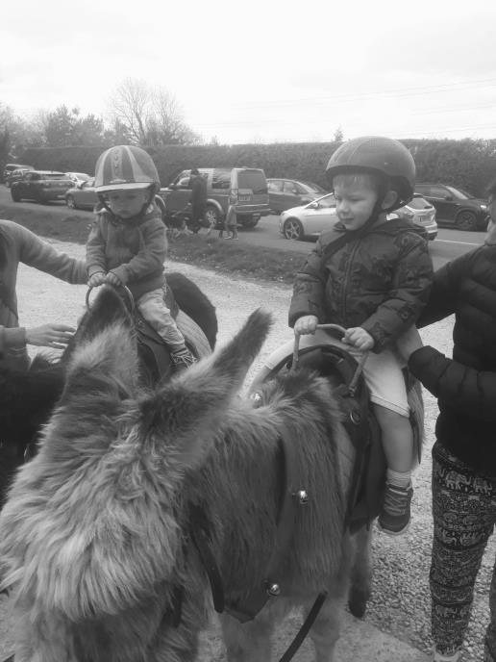
A few photos from Palm Sunday
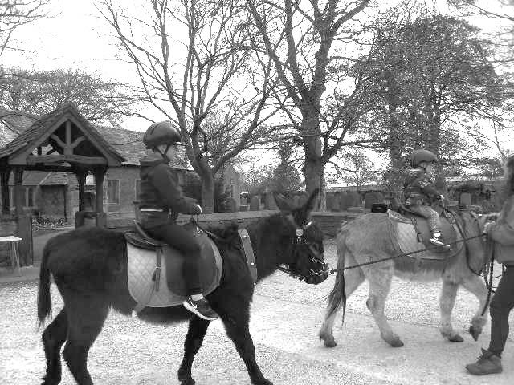
Men’s Fellowship
Our meeting this month is on Tuesday 14th May at 7.30pm at Hoole Village Hall, when the AGM will be held. All welcome.
~~~~
Ladies’ Group
Last month a good turnout of members listened to Nicola Sheard telling us all about the environmentally friendly “Tropic” skin treatments.
This month it is of course our trip to Barton Grange Garden Centre, with the coach picking up from the church at 10.00am on the 21st..
Our Summer Fete is fast approaching on Saturday 8th June, and we would be grateful if you could start to think about donating cakes for the cake stall, small cakes for refreshments, plants for the plant stall, and raffle and tombola prizes. Please bring anything for the raffle and tombola to the trip on 21st May; also the large plastic box is, as usual, in church ready to receive your generous donations – you might perhaps have unwanted gifts which would be ideal for prizes! All will be gratefully received.
Erika
~~~~
Church Flower Group
A huge thank you to all who came to the Flower Ladies AGM and coffee morning on the 30th March; this year a charity fund raiser on behalf of St Catherine’s Hospice in memory of Janet Coxhead. £367.36 was raised, and hopefully and the event was enjoyed by all.
Thank you again for all the kind donations – cakes, lemon curd, jam, plants; all donations – and the support from all at St. Michael’s.
Important subjects were discussed at the meeting – type of Christmas tree, rota, and how to tie the daffodils for Mothering Sunday!
Daffodils were also provided for the Family Church Event.
All the ladies agreed for the flower fund to pay for a garden waste bin for the church, from the council, currently £30.00 per year. This has been agreed by Jock and will hopefully remind us to recycle greenery where possible.
We hope everyone enjoyed the decorated church at Easter and many thanks again to all the sponsors.
Julie
Thanks to the Flower Group
Thank you all so much for making the church so beautiful for Easter Sunday – and it’s lovely to see flowers in the church again!

CHURCH OPENING TIMES
The church is open during the day as follows:

Day | Open | Close
Monday | 9.30am | 4.30pm
Tuesday | 9.30am | 4.30pm
Wednesday | 9.30am | 4.30pm
Thursday | 9.30am | 4.30pm
Friday | Closed
Saturday | 9.30am | 4.30pm
Sunday | 8.00am | 4.30pm

Jock Davidson, Churchwarden

Water Aid is at an end for the 2018/2019 year – Harvest through to Easter
…but I will not be doing the paperwork until the end of May, so if you have any bottles of change (or any type of change for that matter) lurking about, I will be very pleased to relieve you of it.
Don’t forget, if you are a tax payer, I will need a WATER AID Gift Aid Form completing with your donation if you wish to gift aid it. These can be found in the Church porch on the left as you walk in. Spare jars as well.
Bring your bottle/jar/loose coinage to Church marked up for Water Aid and hand to:
- Elaine Lawrence who attends the 9 am service – usually
- Me – I attend the 1030 service – usually
- Jock – who is there at just about everything – usually!
- Or leave it on the window ledge behind the font and it will be collected that very same Sunday afternoon by Mike or Elaine Lawrence who have the tedious task of counting, bagging and banking it.
Our total has improved quite a bit since last month – at the time of writing (22nd April) it has now reached the giddy heights of £268.34 – still well behind previous years though – so far…
Many thanks
Barbara Wood
~~~~
FOMO Malawi
Friends of Mulanje Orphans, (Malawi)
UK Charity No 1090727
A PLEA ON BEHALF OF FOMO
As you know we (the PCC on your behalf) support FOMO as part of our regular charitable giving. However, the Malawi people have suffered grievous flooding causing a great amount of suffering resulting in loss of life, crops, homes and basic household equipment. You will more than likely have received an email from me with the latest FOMO newsletter attached to it – this will provide you with some background on what they have achieved and what they hope to achieve despite these setbacks.
Because of this recent natural disaster in the region, FOMO are looking to send out a container soon and a plea will go out for donations of various items of need which you may have hanging around your home and no longer really need. Watch out for further details to follow.
In the meantime, they desperately, desperately need blankets. Each blanket costs £3. Are you able to add an extra £3 to one of your weekly donations to church during the month of May? If so, just mark the envelope FOMO and put it on the collection plate.
I will make sure it is passed onto Mary Woodworth who is not only a member of our choir, but one of the leading lights of the FOMO organisation (her husband Keith being the other).
Many thanks in anticipation.
Barbara Wood – Treasurer to the PCC
~~~~
THERE IS A GREEN HILL FAR AWAY HYMN NO. 657
Words: Cecil Frances Alexander (1818 – 1895) Music: William Horsley (1784 – 1858) Horsley
Easter has come and gone once more, the story of the death and resurrection of Christ. But the story it tells us should never be forgotten. The message should be engraved in our hearts and memories forever. But if ever you wanted a hymn with a direct message and a direct story, then this is it. It tells you everything you need to know in the first verse.
There is a green hill far away,
Without a city wall, Where the dear Lord was crucified.
Who died to save us all.
There you go, end of message. It is written in a very childlike way, but immediately gets to the heart of the story. The author was Cecil Frances Alexander who wrote it for her godson. He had been complaining about learning the catechism and how difficult and dull it could be. But Cecil Frances understood children and was involved in their religious education. She set about writing a group of hymns to help him and other pupils learn the truth about such writings as “The Apostles’ Creed” in a simpler and more interesting way. ‘Suffered under Pontius Pilate, was crucified, dead and buried’ became ‘where the dear Lord was crucified, who died to save us all’. What a talented lady she was with a wonderful way with words. Cecil Frances was involved most of her adult life in charitable work and helped to build a deaf and dumb institute and also develop a District Nurses Service.
Though crystal clear in its meaning, the first line of the hymn can be puzzling. Where is this distant hill? Why would it need a city wall in the first place? Some modern hymn books (such as ours) have changed the words ‘without a city wall’ to ‘outside a city wall’. (I think if it’s not broken don’t mend it). Although born in Dublin, Cecil Frances lived for quite a while in Londonderry where apparently there was a green grass covered mound just outside the town which she imagined to be a hill in the Holy Land outside the gates of Jerusalem where Jesus came to be crucified. There is a depth of emotion and meaning in this hymn suggesting that Jesus loved us dearly and paid dearly for this love:
O, dearly dearly has He loved,
And we must love Him too, And trust in His redeeming blood,
And try His works to do.
It is a story that conjures up memories of junior school in Dob Lane with teachers such as Sammy Bolton (should I have said Mr. Bolton) and Polly Fiddler guiding our education, and with the whole school singing hymns such as this at early morning assembly. Memories like this are priceless.
Bill Carr, Church Warden Emeritus

Our Prayer Circle
As Christians we know that one of the main things that Jesus taught us was the words of The Lord’s Prayer and very often in the Bible we are told that He went to a quiet place and prayed. Our hymns tell us to “Take it to the Lord in prayer” and that “the voice of prayer is never silent”. There is no doubt of the need for prayer for our own spiritual needs as well as the knowledge of the comfort and support that it gives to both the person praying and the people being prayed for.
To that end we have set up a Prayer Circle at St Michael’s.... ‘What’s one of those then?’ you may ask. It is simply a group of people who when called upon will pray at home separately and quietly for whatever you ask.
If you have a concern of any sort that you want us to pray for all you need to do is to ring any of the numbers and simply say what or who is in need of prayer, and whilst a minimum of explanation might be an advantage for us to focus the prayer.
You don’t even have to say who you are! The person taking the call will pass it round the circle and you will know that we, on behalf of the church, are taking your worry to the Lord. If you would like your particular concern added into the intercessions on a Sunday morning then we can do that too.
We are happy to welcome others into the circle, just let us know and you will be added on.
Prayer is an essential part of our Christian life to keep us walking in the footsteps of our Saviour... so... the lines are open right now, we are waiting to take your call which is very important to us because it matters to you... just ring and your prayer will be increased seven-fold (at least).
Our circle consists of Ted (01772 617002), Margaret (01772 379219), Carole Bamber (01772 610670 or mobile 07989 145963), Gill Slinger (07729 121248), Barbara Wood (07745 208617) and Bill Carr (01772 615321).
Ted, Margaret, Carole, Gill, Barbara and Bill

St James the Least of All
Parish Pump Editor: The Rev Dr Gary Bowness continues his tongue-in-cheek letters from ‘Uncle Eustace’…

On the tribulations that await a curate in his first parish…
The Rectory
St James the Least
My dear Nephew Darren
So, your bishop is dropping hints that you should begin to consider a move to having your own parish – ‘not forever in green pastures’ comes to mind. Do not be too hasty to leave; remember that a curate can do no wrong, but a vicar can do no right. That means that as soon as you get your own parish, you will be held accountable not only for everything that goes on inside the church, but also for the goal average of the local football team and the state of the economy. And if it rains for your first Summer Fete, you will be told reproachfully that this never used to happen when ‘the former vicar was here’.
As you begin to ponder this momentous decision, allow me to give you a few pieces of advice. It will be assumed in the parish that every new incumbent is bound to be worse than his predecessor. The greatest compliment I ever received when leaving a parish came from an elderly parishioner: “I've known six Rectors of this parish; you weren't the worst.”
Naturally the church you go to will have asked for a married man between 30 and 35 with a wife who will not have her own job but who wants to devote her entire life working for the parish - and it will be a definite advantage if she is a brilliant organist, professional caterer and fully computer literate. They will expect you to have two children, one of whom should be of primary school age, so he can attend the local Church school, where you will naturally wish to be chairman of governors and coach of the football team.
They will want you to have exceptional talents for attracting young people - but for young people who enjoy the sorts of Services that the present congregation prefer - and you should have the ability to stop a baby crying during Matins with the briefest of glances. They will want you to bring ‘a breath of fresh air’ into parish life without changing anything. They will hope you will shun holidays, preach short sermons and be able to run a tight jumble sale.
Your CV is a little thin. If you could acquire a wife and family within the next six months, become an expert flower arranger and qualify as a football referee, chartered accountant and trained electrician and plumber, it would prove very helpful. If in addition, you learned how to service photocopiers, had a mini-bus available for church outings, were an heir to a family firm producing a single malt whisky and could provide reliable horse racing tips, your choice of parishes would be endless.
On the other hand, my advice would be to stop attending all meetings where you know the bishop may be present; out of sight, out of mind. Have your phone disconnected, your letterbox sealed and only appear in public wearing dark glasses and a false beard. Keep your head down, lay low, hold on to the charmed life of being a curate for as long as possible. Life will never be better.
Your loving uncle,
Eustace

Some High Days and Holy Days during May
8th May – Julian of Norwich: a voice from a distant cell
by Canon David Winter
Many years ago, studying English literature at university, I was intrigued to be introduced to the work of Julian of Norwich. She was writing at the end of the 14th century, when our modern English language was slowly emerging from its origins in Anglo-Saxon and Middle English.
Our lecturer was mainly concerned with her importance in the history of the language (she was the first woman, and the first significant writer, to write in English). But I was more intrigued by the ideas she was expressing. She was an anchoress – someone who had committed herself to a life of solitude, giving herself to prayer and fasting. St Julian’s, Norwich was the church where she had her ‘cell’.
Her masterpiece, Revelations of Divine Love, reveals a mystic of such depth and insight that today up and down Britain there are hundreds, possibly thousands, of ‘Julian Groups’ who meet regularly to study her writings and try to put them into practise.
She is honoured this month (8th) in the Lutheran and Anglican Churches, but although she is held in high regard by many Roman Catholics, her own Church has never felt able to recognise her as a ‘saint’. This is probably because – over 600 years ago! – she spoke of God as embracing both male and female qualities. Revelations is an account of the visions she received in her tiny room, which thousands of pilgrims visit every year.
Her most famous saying, quoted by T S Eliot in one of his poems, is ‘All shall be well, and all shall be well, and all manner of thing shall be well’ – words that have brought comfort and strength to many a soul in distress.
**
5th May – Matthias the Apostle: called by lots
Have you ever happened to be in the right place at the right time, with certain qualifications, and suddenly realise that God is singling you out for a special task? If so, Matthias is a good patron saint for you!
In Acts 1 (15-26) the apostles had a task to do: Judas had committed suicide, and a new apostle needed to be chosen. He had to have been a follower of Christ from the Baptism to the Ascension, and also a witness of the Resurrection in order to qualify. In the event, the choice fell to one of two: Joseph Barsabas and Matthias.
Lots were drawn, and Matthias was chosen. How confident he must have felt in his calling: what encouragement that would be when the going got rough in later years! Matthias is thought to have ministered in Cappadocia and even Ethiopia. His emblem is usually an axe or halberd, regarded as the instrument of his martyrdom. His supposed relics were translated from Jerusalem to Rome by the empress Helena.
**
16th May – Caroline Chisholm: helping the emigrants to Australia
If you want an example of someone who can show you their faith through their works, Caroline Chisholm is a saint for you. This doughty little 19th century English woman had such a compassionate heart that she helped tens of thousands of people, from India to Australia.
Caroline was born in Northamptonshire in May, 1808. Her father William was a pig dealer, and already had 15 children, by four wives. When Caroline was about five, her father brought a poor maimed soldier into the family home and urged his children to look after the wretched man well, as he had fought for their freedom. This disinterested compassion for poor struggling ‘outsiders’ would become the lodestar of Caroline’s life.
When Caroline was 22 in 1830 she married Captain Archibald Chisholm, of the East India Company Army. Out in Madras, Caroline grew alarmed for the young girls growing up in the barracks. She founded the Female School of Industry for the Daughters of European Soldiers, to provide a practical education.
After having two sons, and working on the Indian subcontinent for a number of years, Captain Chisholm was granted a two-year furlough in 1838 on grounds of ill health. The family moved to the sunshine of Australia, near Sydney. Here Caroline was appalled at the conditions that faced emigrants, especially female, arriving in the colony. Many ended up working the streets, just to survive.
Caroline stayed for seven years in Australia, placing more than 11,000 people in homes and jobs, and in all, her Female Immigrant Home helped more than 40,000 people. Highly respected by the government, she gave evidence before Legislative Council Committees, but accepted money from no one. When Archibald left the army in 1845 he and Caroline toured Australia at their own expense, collecting more than 600 statements from emigrants that detailed the truth about the problems of emigration.
Back in England, the statements caught the attention and respect of Charles Dickens, the House of Lords Select Committees, Lord Shaftesbury, Sir Sydney Herbert, Wyndham Harding FRS and even Pope Pius IX. Caroline and Archibald went on to help more than 3,000 people safely emigrate to Australia, before moving back there themselves, where they both died in 1877. In his novel Bleak House, Charles Dickens is said to have partly based the character of Mrs Jellyby on Caroline Chisholm.
**
26th May – Rogation Sunday (Sunday before Ascension)
Rogation means an asking of God – for blessing on the seed and land for the year ahead. It is appropriate in any emergency, war, plague, drought or foul weather.
The practice began with the Romans, who invoked the help of the gods Terminus and Ambarvalia. In those days a crowd moved in procession around the cornfields, singing and dancing, sacrificing animals, and driving away Winter with sticks. They wanted to rid the cornfields of evil.
About 465 the Western world was suffering from earthquake, storm and epidemic. So Mamertius, Bishop of Vienne, aware of the popular pagan custom, ordered that prayers should be said in the ruined or neglected fields on the days leading up to Ascension. With his decision, ‘beating the bounds’ became a Christian ceremonial.
Rogation-tide arrived in England early in the eighth century, and became a fixed and perennial asking for help of the Christian God. On Rogation-tide, a little party would set out to trace the boundaries of the parish. At the head marched the bishop or the priest, with a minor official bearing a Cross, and after them the people of the parish, with schoolboys and their master trailing along. Most of them held slender wands of willow.
At certain points along the route – at well-known landmarks like a bridge or stile or ancient tree, the Cross halted, the party gathered about the priest, and a litany or rogation is said, imploring God to send seasonable wealth, keep the corn and roots and boughs in good health, and bring them to an ample harvest. At one point beer and cheese would be waiting.
In the days when maps were neither common nor accurate, there was much to be said for ‘beating the bounds’ – still very common as late as the reign of Queen Victoria. Certainly parish boundaries rarely came into dispute, for everyone knew them. (Do you know yours today?)
~~~~
Smile Lines

Epitaphs found on headstones
In London:
Here lies Ann Mann
Who lived an old maid
But died an old Mann.
In Hartscombe:
On the 22nd of June
Jonathan Fiddle
Went out of tune.
In Wimbourne:
John Penny
Reader if cash thou art in want of any
Dig four feet deep and thou wilt find a penny.
In Pennsylvania:
Here lies the body of Jonathan Blake
Stepped on the gas
Instead of the brake.
**
New mother: What is the most difficult thing I’ll need to learn?
Nurse: That other women have perfect children too.
**
What is the difference between perseverance and obstinacy?
One is a strong will, and the other is a strong won’t.

Soduko – Medium

CHURCH ROTAS FOR MAY

Flower Arrangers
Date Arranger(s) Sponsor(s):
May 5th Gillian and Angela Altar Sponsor: Mrs J Maxfield
Pedestal Sponsor: Mrs G Davidson
and Mrs A Clayton
12th Averil and Betty Altar Sponsor: Mrs E Smith
19th Jean and Betty Altar Sponsor: Men’s Fellowship
26th Gillian and Angela Altar Sponsor: Mrs Ball
June 2nd Lisa Mrs Bracewell
~~~~
Tea/Coffee Rota following our 10.30 Service
May 5th Erika
12th Beryl & Rona
19th Pauline & Barbara
26th Carole & Gill
June 2nd Erika
If you’re not available on the date allocated or wish to change the date assigned to you, please find a replacement or arrange a swap.
We’re rather short of helpers, so if you feel you could give an hour at this service every few weeks, have a word with Erika or call on 613816.
~~~~
Sidespersons’ Rota
May 5th 9.00 Mike Redshaw
10.30 Jean Aughton and Churchwarden
May 12th 9.00 Ken Bishop
10.30 Norman Skellorn, Tom Wignall and Geoff Demack
May 19th 9.00 Rob McMurray
10.30 Bill Carr, Scott Eckersley and Beryl Blakeley
3.00 Peter Smallwood

May 26th 9.00 Jeremy Leigh
10.30 Ted Hopkins and Robert Hawthornthwaite
June 2nd 9.00 John Simpson
10.30 Jean Aughton and Churchwarden
~~~~
Readers’ Rota
If you cannot read as specified on this rota, please find a substitute and inform a churchwarden of any changes.

May 5th 9.00 Joan Wilson
10.30 Margaret Kirkman and Jean Dewhurst
May 12th 9.00 Mike Redshaw
10.30 Emma Cairns and Lillie Eaves-Holmes
May 19th 9.00 Joan Wilson
10.30 Carole Bamber and Gill Slinger
May 26th 9.00 Kathleen Leigh
10.30 Barbara Wood and Scott Eckersley
June 2nd 9.00 Mike Redshaw
10.30 Margaret Kirkman and Jean Dewhurst
June 9th 9.00 Peter Templeman
10.30 Jane Elphick and Ted Hopkins
June 16th 9.00 Ann Templeman
10.30 Emma Cairns and Lillie Eaves-Holmes

Peter Templeman will contact each reader by email by the preceding Tuesday. Please will readers ensure Peter has their contact email.

