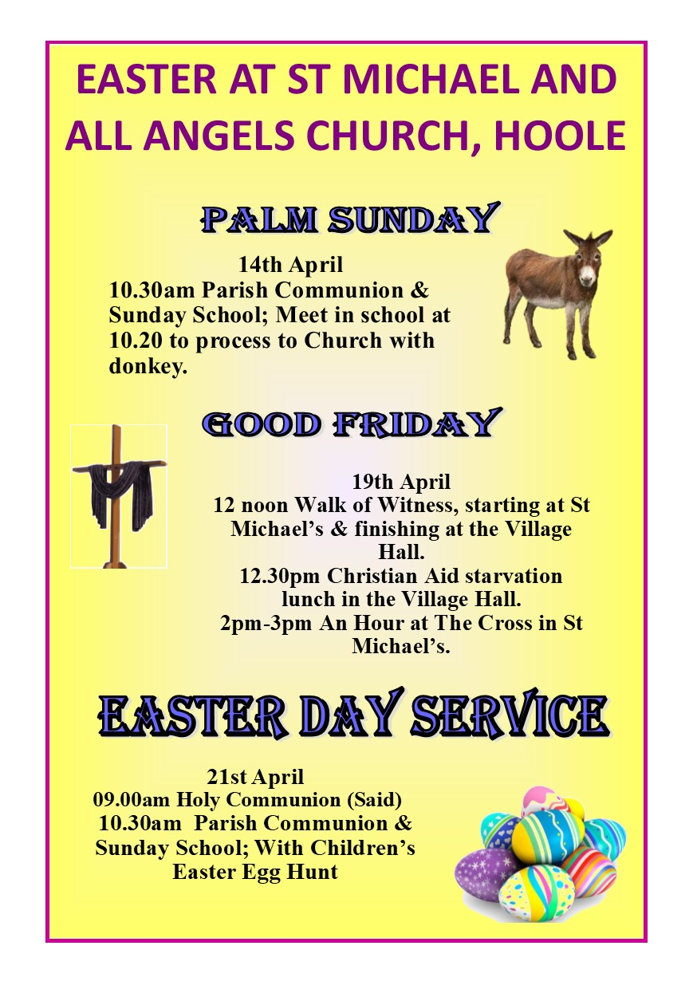

**CHURCH OFFICERS**

**Rector:** The Reverend Ann Templeman – Tel: 01772 448515 and mob: 07877 659156; E: anntempleman@live.co.uk

**Associate Minister:** The Reverend Peter Templeman

**Churchwarden**

Mr Jock Davidson – Tel: 617918; E: sgtmajor@talktalk.net

**Occasional Preacher**

Mrs Margaret Kirkman – Tel: 01772 379219. Mob: 07786543581.

E: margk1946@gmail.com

**Reader in Training**

Mr Alan Johnson – Tel: 01704 822179; E: alanmarie55@gmail.com

**Churchwarden Emeritus**

Mr William G Carr. Tel: 01772 615321. E: billcarr1935@btinternet.com

**PCC Secretary**

Mrs Andrea Susnik – Tel: 615336. E: familysusnik@live.co.uk

**PCC Treasurer**

Mrs Barbara Wood – Tel: 617679. E: bw12252@sky.com

**Deanery Synod Representatives:** Mrs Jane Elphick and Mrs Jean Dewhurst

**Magazine Editor**

Mrs Erika Penrose – Tel: 613816. E: jandepenrose@btinternet.com

**Magazine Secretary**

Mrs Elsie Kirkham – Tel: 615832.

**Magazine Advert Co-ordinator**

Mrs Margaret Clark – Tel: 616990. E: mic0802@live.co.uk

**Flower Secretaries**

Mrs Lisa Redshaw – Tel 614428 and Mrs Pearl Read – Tel: 614367.

**Electoral Roll Officers**

Mrs Jean Dewhurst, Tel: 616106 and Mrs Jane Elphick, Tel: 601495.

**Verger:** Mrs Irene Pickles – Tel: 615708

**Assistant Verger:** Mr Stuart Tighe – Tel: 612963

**Weekly Giving Envelopes:** Please contact the Churchwarden.

**Parish Administrator:** Mrs Amanda Gibson – Tel: 07735 961620.

**ORGANISATIONS**

**Sunday School**

Sunday School – St Michael’s Club – now begins at 10.30 in church and happens every Sunday.

Leader: Mrs Kathleen Leigh – Tel: 612196.  Email: katleigh@live.co.uk

**Hoole Church Ladies’ Group** – meets 7.30pm, 3rd Tuesday, in School. Leader: Mrs Erika Penrose.

Tel: 613816. E: jandepenrose@btinternet.com

**St Michael’s Men’s Fellowship** – meets 7.30pm, 2nd Tuesday, in Hoole Village Memorial Hall.

Secretary: Mr Stuart Tighe – Tel: 612963.

**Friends of St Michael** – Caring for the fabric of our ancient church.

Chair: Mrs Jane Elphick, Tel: 601495.

Secretary: Mr David Turner, Tel: 01772 383344.

**Social Committee** – Contact: Mrs Sheila Taylor, Tel: 616850

**Hoole St Michael C E Primary School**

Head Teacher: Mrs Juliet Price – Tel: 613219.

**1st St. Michael’s Hoole Scout & Guide Groups – Group Scout Leader:** Mandy Clark – Tel: 01772 305452; E:gmjbclark@yahoo.co.uk.

**Church Website:** Our new church website is now live; the address is

http://www.hooleparishchurch.com. WHY NOT TAKE A LOOK!

***Please note:***

***Church Rotas are to be found on pages 29 & 30.***

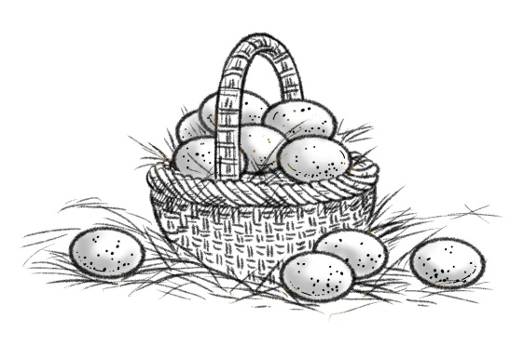

**FROM THE WORLD’S BEST-SELLER**

**DEAD**

**MAN**

**LIVES!**

**Jerusalem (Sunday) – This troubled city seethes with rumour and counter-rumour. What began as a routine execution on Friday has backfired on the Roman and Jewish authorities with report after report coming in of personal sightings of the dead man. His death was spectacular in the eerie darkness of a full solar eclipse, climaxed by heavy earth tremors, and the tearing of the Temple curtain shielding the holy of holies from the public. The officer on duty was heard to exclaim, “For sure, he was the SON of GOD”.**

**We have come to expect surprises of this man in the last few years. But this final miracle has set the city in an uproar. Jesus of Nazareth has come back from the dead! Read on for the full story.**

**OFFICIAL CONFUSION**

**Lord Caiphas**, the high priest, has issued a statement charging the followers of Jesus with stealing his body during a temporary “lapse” by the guards on sentry duty at the tomb. Usually reliable sources report bribery of the guards to make this story stick. His grace was unavailable for further comment.

**FRIENDS OF THE DECEASED**

**Mary Magdalene,** until recently a well-known personality in the red light quarter, became a follower of Jesus when he healed her of the demonic sickness that she says was tearing her apart. Since her dramatic cure she has followed Jesus everywhere, modelling her new lifestyle on his. **She was the first to see him alive.**

**DAWN GRAVE DRAMA**

“We were there at the tomb at first light after the Sabbath was over, to finish off anointing his corpse with ointments: sort of paying our last respects. Well, the big stone at the entrance was just lying pushed aside and the vault was empty. I panicked, and ran back to tell the others. Well, Peter and John raced back ahead of me and saw for themselves. The winding sheet and head wrapping were just lying there as though he had stepped out of them.

The men eventually went off in amazement, and I just stayed around. When I looked inside again there were two people inside in really bright clothes. By this time I was thoroughly confused. The gardener came up behind me just then, or at least I thought it was the gardener. I blurted out that if he had taken the body away to tell me where it was. Then he spoke my name. **It was JESUS.** My heart was beating wildly. It was really Jesus, alive again.

**FISHERMAN**

**John Zebedee,** a fisherman by trade, says that he believed Jesus was alive the moment he looked inside the tomb. “He often said that he would be arrested, killed and would rise up on the third day. But we never properly understood till now. Some people reckon it was just my imagination. Because I wanted him back so much, I gave myself hallucinations. But ten others saw and heard him at the same time. I’m sure we couldn’t all have the same hallucination!”

**PANIC**

“That night after we saw the empty grave, we were scared stiff, mainly because of what the authorities might do so us if they caught us. The doors were locked. Then, **Jesus just came and stood right in the middle of us.** He was real all right. He showed us his hands. They were all mangled from the nails and we could see the ugly gash in his side from the spear.

**SCEPTIC EX-FOLLOWER**

**Thomas Didymus, one of the inner cycle of a dozen or so who knew Jesus well, disagreed violently with the statements of the other disciples.** Back at his old job again, Didymus discounted the reports of Jesus as hysterical over-reaction to grief. **“He’s dead, finished”.**

**STOP PRESS LATE NEWS**

A late report from Thomas Didymus sheds new light on the resurrection story. A dumbfounded Didymus now says that he, too, had seen Jesus. Gathered in the familiar meeting room with his former associates, Jesus again mysteriously appeared, showing Didymus the crippling injuries that caused his death over a week before. Eye-witnesses said Didymus fell to his knees and exclaimed, “My Lord and My God”.

Jesus seemed unimpressed by this belated confession of faith. His reply was, “Do you believe because you see me? How happy are those who believe without seeing me!”

**EDITORIAL**

**The disturbing events you have been reading about are true.** Although they happened over two thousand years ago, they vitally affect our lives today. If Jesus in fact rose from the dead that first Easter Day, life can never be the same again.

This is the heart of the Christian “gospel” or “good news”. Jesus not only died for our sin, but rose again in tremendous power from the grave. **He is alive today.**

**The Resurrection of Jesus is not just a FACT: it can also be an EXPERIENCE.**

**Historian speaks.** Professor Edwin Judge says, “The historian will recognise that such a sensational and decisive tradition can hardly go back to mere imagination: something remarkable must be behind it. If this conception of God and the world limits his ability to accept the explanation the apostles gave, he is left with a baffling problem, **for no other account of the matter satisfies the historical evidence.**

**Journalist speaks.** A sceptical journalist, Frank Morrison, set out to write a book disproving the resurrection as a groundless myth. The gospel accounts so shook him that he became convinced of the fact of Jesus’s resurrection.

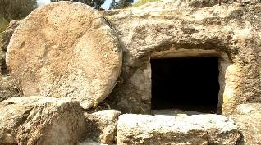

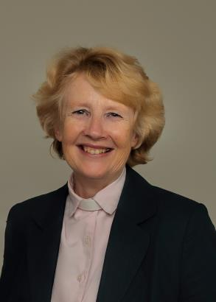**FROM THE RECTORY**

**Jesus said “I am the Resurrection and the Life. Those who believe in me, even though they die will live and everyone who lives and believes in me will never die”.**

Dear all

You hear these famous words of Jesus at the start of every Christian funeral service. It is a staggering claim but it is at the very heart of the Christian faith. Jesus Christ on the cross conquered sin and death and his glorious resurrection demonstrates the truth of that victory. It is the essence of the Christian Gospel – the greatest Good News of all time. Death, the final enemy, is conquered and for us we have the assurance that death is not the end but a glorious beginning – an entry into something far better.

And Jesus’ Resurrection changes everything now too in this life. The Alpha films have provided us with a number of inspirational glimpses of lives changed beyond recognition by the power of the risen Lord Jesus; an armed robber in a maximum security prison full of anger and hate tells of his transformation from violent criminal into faithful Christian minister and married father of 2 children.

I pray that you will experience something of the power and presence of the Risen Christ in your life this Easter. Please join us for worship on Easter Day.

**HE IS RISEN! ALLELUIA!**

Ann Templeman, Rector

anntempleman@live.co.uk

01772 448515

~~~~

**ST MICHAEL’S, HOOLE, PARISH DIARY**

March 31st to 12th May 2019

Sunday School – Michael’s Club for children (ages 3 to 12), every Sunday during the 10.30 service.

10.30am – Starts in church; children leave for their own teaching in the school after a children’s song and return after the sermon and prayers.

**Sunday 31st Mar** 9.00 Holy Communion (Book of Common Prayer)

**MOTHERING SUNDAY** 10.30 Parish Communion with flowers

4.00 Family Church in the Village Hall

**Monday 1st April** 7.30 Alpha film at the Rectory

**Tuesday 2nd April** 10.15 Holy Communion (said)

7.30 Alpha film at the Rectory

**Sunday 7th April** 9.00 Holy Communion (Book of Common Prayer)

10.30 Parish Communion with Sunday School

4.00 Holy Communion at Old Mill Court

**Monday 8th April** 7.30 Alpha film at the Rectory

**Tuesday 9th April** 10.15 Holy Communion (said)

7.30 Alpha film at the Rectory

**Thursday 11th April** 12.15 Locals’ Lunch at the Village Hall

**Sunday 14th April** **PALM SUNDAY**

9.00 Holy Communion (Book of Common Prayer)

10.20 Meet at the school to process to church with donkey for 10.30. Palm Sunday service with donkey rides.

Followed by Annual Church Meeting and Jacob’s Join Lunch in school

**Tuesday 16th April** 10.15 Holy Communion (said)

**Thursday 18th April MAUNDY THURSDAY**

7.00 **Passover meal** in the school for everyone, leading to informal Communion service.

**Friday 19th April** **GOOD FRIDAY**

12.00 Walk of Witness starting at church and

12.30 Christian Aid Starvation Lunch at Village Hall

**2.00 an Hour at the Cross at St Michael’s Church**

**Sunday 21st April EASTER SUNDAY**

9.00 Holy Communion

10.30 Parish Communion and Sunday School with children’s Easter Egg Hunt in the churchyard during the service

**Tuesday 23rd April** 9.00 Holy Communion (said)

**Sunday 28th April** 9.00 Holy Communion (Book of Common Prayer)

10.30 Morning Worship with Sunday School

**Tuesday 30th April** 10.15 Holy Communion (said)

**Sunday 5th May** 9.00 Holy Communion (Book of Common Prayer)

10.30 Parish Communion with Sunday School

**Tuesday 7th May** 10.15 Holy Communion (said)

7.30 House group/Bible Study at the Rectory

**Sunday 12th May** 9.00 Holy Communion (Book of Common Prayer)

10.30 Morning Worship with Sunday School

**KEY FUTURE DATES**

* **LEGO FAMILY CHURCH**

**Sunday 19th May** at 4.00pm in the Village Hall

* **LIFT OFF CHURCH**

**Sunday 9th** **June** at 4.00pm in the Village Hall

* **CREAM TEA CHURCH**

**Sunday 7th July** at 3.00pm in St Michael's School

* **HARVEST FESTIVAL**

**Sunday 6th October**



**The Easter Egg Hunt**

We seek them here, we seek them there,  
We seek those creme eggs everywhere!  
Within the church, within the ground  
Those hidden eggs which must be found!

The pulpit steps? The hymn book stand?  
The lectern we’ve already scanned  
Behind that pew? I’ll need a torch!  
Perhaps one’s hidden in the porch!

Aha! At last! I’m happy now!  
No more I search! No furrowed brow!  
I found my egg which tastes so good  
Within the Rector’s vestment hood!

*by Nigel Beeton*

**IS THERE MORE TO LIFE?** 

***Come and watch the ALPHA films during what’s left of the 5 weeks of Lent.***

***Each film lasts 30mins and will be followed by refreshments and a brief discussion. The films include many inspirational examples of people’s life-changing experience of the Jesus Christ. They are equally suitable for mature Christians or those wishing to explore the Christian faiths. Sessions will take place at the Rectory, 69 Liverpool Old Rd at 7.30pm.***

**Week 4: Monday 1st and Tuesday 2nd April – Why and how read the Bible**

**Week 5: Monday 8th and Tuesday 9th April – What about The Church?**

STOP PRESS!

Our new church website is now live; the address is http://www.hooleparishchurch.com

Why not take a look – the more “hits” we have, the better it will be for raising our profile!

**MAUNDY THURSDAY – THURSDAY 18th MARCH**

**PASSOVER MEAL**

**Experience the background to the Last Supper in 30AD.**

**Join in a Passover Meal leading into an informal service of Holy Communion -**

**an event suitable for the whole family.**

**7.00pm at St Michael’s Primary School**

**(there is no charge but donations will be invited to cover the cost of the food)**

**Please let Ann Templeman know that you are coming on 01772 448515 or anntempleman@live.co.uk**



**CHURCH OPENING TIMES**  
The church is open during the day as follows:

|  |  |  |
| --- | --- | --- |
| **Day** | **Open** | **Close** |
| Monday | 9.30am | 4.30pm |
| Tuesday | 9.30am | 4.30pm |
| Wednesday | 9.30am | 4.30pm |
| Thursday | 9.30am | 4.30pm |
| Friday | Closed | |
| Saturday | 9.30am | 4.30pm |
| Sunday | 8.00am | 4.30pm |

Jock Davidson, Churchwarden

~~~~

**Men’s Fellowship**

Our meeting this month is on Tuesday 9th April at 7.30pm at Hoole Village Hall. The talk is entitled “Rhapsody of Gershwin” by Harold Hoggarth.

~~~~

**Ladies’ Group**

Many thanks to the Men’s Fellowship for hosting last month, when we enjoyed the talk by Stephen Halliwell about Moses Holden, a Preston astronomer who was the first man to publish an inexpensive map of the heavens. Moses devoted the proceeds of one of his lectures to the erection of a monument in St Michael’s Church, Toxteth, to the memory of Jeremiah Horrocks, the famous astronomer linked to our St Michael’s. He was awarded the freedom of the Borough of Preston after establishing the Preston Institution for the Diffusion of Knowledge. Quite a man!

**April meeting:** *Please disregard the start time in your programme card – there will be no Lent service at church before our meeting this month; therefore the meeting will start at the usual time of* ***7.30pm.*** We’re looking forward to Nicola Sheard coming along to talk to us about “Tropic – more than just Skin Care”.

We’re starting to plan for the Summer Fete on **Saturday 8th June** and would be grateful if you could start to think about donating cakes for the cake stall, small cakes for refreshments, plants for the plant raffle, and raffle and tombola prizes. These latter can be brought to the April meeting or to the trip in May, and there will be the usual plastic box in church. All will be gratefully received.

Erika

~~~~

**ANNOUNCEMENT:**

**THE APCM WILL TAKE PLACE ON SUNDAY 14th APRIL 2019**

The Annual Parochial Council Meeting will take place after the 10.30 service on Palm Sunday starting at 12.00 noon and will be followed by a Jacob’s Join in school.

All are welcome and indeed actively encouraged to plan this into your day.

It is an important element of the Church Administrative year.

The Year End Reports & Accounts will be available for distribution and circulation no later than 14 days prior to the above date.

The Report will be circulated to the following:

* The Diocese & Charities Commission
* PCC Members
* Church Group Leaders
* The Congregation
* Church Website
* Church Porch Notice Board
* Copies in Church

Most of you will be emailed a copy if I have an email address for you. If you do not have email and you are a PCC or Church Group Leader, you will receive a printed copy.

If you do not receive a copy, and would like one, please do not hesitate to contact me.

Do you have any queries on the content?

Please submit in writing, IN ADVANCE of the APCM, I will then ensure the enquiry is addressed.

Many thanks.

Barbara Wood – Treasurer

**CHRISTIAN AID Sponsored Walk or Cycle:**

**Saturday April 6th – 9.30am-12.00 noon**

**Walk for Water or Cycle for a Bike**

The Longton Area Christian Aid Committee is again organising a Sponsored Walk and Cycle – a pleasant and healthy way of supporting Christian Aid! The Sponsored Walk is either approximately 2 miles from St Andrew’s Church Hall and around Longton Brickcroft or 4 miles from Much Hoole Methodist Church to New Longton Methodist Church via Longton. The Cycle is a 17 or 20 mile circuit from New Longton Methodist Church through Much Hoole, Bretherton, Croston and Midge Hall.

Proceeds from the Walk will go to help to provide water taps and toilets to areas of extreme poverty; from the Cycle the money will help to provide health care for remote areas where bicycles are often the only means of transport. A water pump and toilet cost approximately £50; a bicycle, £63.

NB **It is possible to do the walk or cycle on any other day or time if this is more convenient – and also to devise your own route**. (Several of the uniformed organisations have done a walk on their evening meeting in past years and members have earned a badge by taking part!)

Sponsor forms are available from the churches. For further information please contact Pauline Hopkins on 01772 617002 or Cath Greenlees: cathgreenlees@hotmail.co.uk; 01772 613500.

~~~~

**From the Parish Registers**

**Holy Baptism**

**“We welcome into the Lord’s Family”**

Joshua James Taylor, son of Jack and Lisa Taylor, of Much Hoole, was baptised on 10th March.

**Funerals**

We give thanks for the life of the Reverend Steven Hughes, MBE, aged 67 years, former Rector of this parish. Cremation followed at the West Lancashire Crematorium, Burscough.

We pray for his family and friends.

~~~~

**From the Register of Services**

|  |  |  |  |  |
| --- | --- | --- | --- | --- |
| Date |  | Attendance | Communicants | Amount |
| February | 24th | 77 | 24 | £254.85 |
| March | 3rd | 77 | 69 | £353.35 |
|  | 10th | 85 | 36 | £250.75 |
|  | 17th | 79 | 73 | £293.35 |
|  | 17th | Family service at village hall | | £32.55 |

Standing Order donations in lieu of donating via the envelope system – projected for March: £621.50.

Donations from Baptisms and Funerals: £133.72.

~~~~

**SUPPORTING WATER AID SINCE 2006 – AN UPDATE…**

This is just a reminder to everyone that the Water Aid collection has been running since Harvest and ends at Easter.

* If you have a jar filled with coins, please bring it in and hand it to Jock, me or just place on the window seat at the back of Church near to the font where it will be collected, counted and banked.
* If you haven’t got a jar, please feel free to pick one up – you will find them in a box in the porch together with the Water Aid Gift Aid form if you are a tax payer.
* If you have filled in a Water Aid Gift Aid Form in the past, you will need to do it again I am afraid as the official wording has had to change and without it, Water Aid cannot claim the Gift Aid back.

Thank you very much for your continued support.

The total raised is **£100.64** as at 20th March 2019.

Our average total over the past 12 years has been **£600**.

So get cracking folks!!  We have some catching up to do.

Many thanks.

Barbara Wood, Treasurer

**ELECTORAL ROLL 2019**

Every six years the electoral roll at Church has to be renewed, and 2019 is the year.

This has to be done before the Annual Meeting in April, so if you consider that St Michael’s is your church please complete a new form to be included on the Electoral Roll. Forms are available from Jane Elphick or Jean Dewhurst.

By enrolling you become a voting member of the Church of England.

You are entitled to attend the Annual Church Council Meeting and may raise any question of parochial or general church interest.



**Church Flowers**

This is an appropriate time to express the

appreciation of all the parishioners and friends

who enjoy the beautiful flower arrangements in

church throughout the year. Our flower ladies

undertake all this hard work, producing absolute

masterpieces, and we would like to express our grateful thanks.

**PANCAKE CHURCH - FAMILY CHURCH**

Well over 100 people of all ages crowded into the Village Hall on Sunday to celebrate Pancake Day, our first Family Church event. The children decorated pancakes and ate them, made their own craft frying pans and pancakes and enthusiastically took part in the pancake races, to the background of the Chariots of Fire music

We thought about St Paul’s picture of the Christian Life being like a race in an Olympic stadium and the need to fix our eyes on the goal –the Lord Jesus Christ.

We sang some well-known children’s songs including “He’s got the whole world in His hands” to the accompaniment of key board and flugelhorn. Pancake church ended as you might expect with eating lots of pancakes.

Do come and join us if you can for the other Family Events we have planned:

Sunday 31st March: **MOTHERING SUNDAY Family Church** 4.00pm in Village Hall – craft from 3.45pm

Sunday 14th April: 10.20am **PALM SUNDAY PROCESSION WITH DONKEY RIDES** from St Michael’s school to Church

Easter Sunday 10.30am **EASTER SUNDAY SERVICE WITH** 21st April: **EASTER EGG HUNT**

Sunday May 19th**: LEGO CHURCH** 4pm in the Village Hall

Sunday June 9th: PENTECOST: 4.00pm **LIFT OFF CHURCH WITH BALLOONS**

Sunday July 7th**: CREAM TEA CHURCH** 3pm in St Michael’s School grounds





**Ah, but St Michael’s can – and will!**

**THE REVEREND STEVEN HUGHES, M.B.E.**

Our parishioners are aware of the sad premature death of one of our past rectors, Steven Hughes, and many attended his funeral. The Funeral Service and Celebration of the Life of Steven was most touching, with many tributes. We thought people would like to read those by Steve’s wife, Mandy, and their friend, Fiona. (The tributes can also be found on the new church website, http://www.hooleparishchurch.com).

**Mandy’s Tribute**

Having read all the other wonderful tributes, which you are all about to hear, we realised that a big part of Steve’s life and Ministry was missing. How could we miss out the Much Hoole bit!

Having moved as a child to the village where his dad Phil was the local bobby, Steve was involved in the Church here at St Michael’s from a young age. He was a member of the PCC at 17, helped with Sunday School, and the Cubs football team and started his training for ordained Ministry from Hoole. I remember him telling me that when he decided to become a Vicar he told the then Bishop of Blackburn that he was a beer drinking, smoking dart/snooker player but felt he would make a good Priest. He had no clue how you did that.

He took himself off to Durham University, leaving a good job as a finger print expert with Lancashire Constabulary to study for his theology degree and then to Cambridge to train as a Priest. Hoole was always home, St Michael’s his Church, no matter where we travelled. Eventually, following our return from Romania he became Rector and the Church thrived. He was Governor and chair of Governors at St Michael’s Church School and Little Hoole School and had a real gift for engaging the children, who would stop him in the street and at school to say “hello Rev Steve”. This gift left a legacy so that following the tragic events in May 2017 when the Manchester arena was bombed, one of the children who he had impressed – Georgina Callander – was killed. He played a big part in her funeral as her parents had remembered her talking about him. This affected him deeply.

Our daughter and her friends set up a successful youth club that ran until they left for university, and the church was full of children especially at Christmas and other big occasions, but also for assemblies and church trails. Steve had been part of the community for years and as you can see today – still is and always will be.

Steve was a good non-traditional, out of the mould Vicar. He was passionate about Unity in the Church, the place of children, young people and families, and making it all relate to real life. In the words of many “he preached a damn good sermon” stayed true to his convictions, was never stuffy or pious, and brought people into the Church who might never have otherwise. He stopped the smoking but never the beer, and never expected me to be the Vicar’s Wife!! I provided him with much sermon material over the years.

Well Steve, we hope we have done you proud today, I know you would have wanted to organise this yourself! You always made people laugh and cry at funerals and that’s what we will do for sure. Thank you for your work, friendship and love for us all.

Rest in Peace and Rise in Glory!

**This tribute is written by Steve and Mandy’s friend, Fiona and has been précised**

I first met Steve and Mandy in Birmingham shortly after leaving university in 1988 and taking up my job as a teacher. We were all involved in the church life of Kings Norton and the nearby parish of Hawkesley and together joined a local ecumenical project.

In the summer of 1989 Steve and Mandy were married and then on Christmas day of the same year Nicolae Ceaușescu and his wife Elena were executed in Romania. Then came the horrific tales of poverty and abandoned children in orphanages… the plight was on our TV screens. All was set to change.

Initially the Hawkesley Christian Romania Trust was formed and, in later years, became SHARE. Fund raising began in earnest and soon a convoy of 11 trucks and vans were making their way to Romania with donated items for the orphanages. A good supply of Easter eggs helped facilitate the passage across border crossings! Another innovative fund raising event took place at the Alexander Athletics stadium in Birmingham when school children from the area tried to break the world record for the longest line of coins. The record was not broken but many bucket loads of coins raised much needed funds. I was thrilled that my pupils also ran auctions for the trust and raised several hundred pounds.

Easter 1990 saw a group of 6th Formers travel with their teacher, a friend and myself in a minibus stacked with tins of paint. Over the holiday we painted the waiting room of the children's hospital in Timisoara (on the west side of the country). The poverty was an eye opener for all of us who were visiting Romania for the first time.

Steve and Mandy moved out full time to Romania in 1991 and I and my friend Julie travelled out by road in the summer of 1992 to help them over the holiday. By this time Mandy was pregnant with Ben. Mandy was building links with hospitals in the world of ante natal in particular and Steve was working hard at building church links. One of our key tasks that week was delivering wheelchairs around the community with Steve.

The summer of 1994 saw us travelling to a recently purchased house in the village of Cisnădiaora (central Romania) which was to become a centre for reconciliation. We worked hard clearing the grounds which had been neglected for a long time. The scope of the work been undertaken by SHARE continued to grow and the network of supporting charities also expanded. Steve also at this time worked very hard to build close ties between the congregations and ministers of the orthodox and the unofficial churches. It was in the latter part of the decade that his influence on the spiritual life of those around him gathered momentum.

I didn’t see much of this, but news came through newsletters and at our trustee meetings.

There is so much more that could be shared about the work of Steve and Mandy in Romania. They were a team with a shared passion. Without them, and those with a calling to Romania, none of this would have happened.

Steve, your legacy lives on. I felt privileged to have collated the hundreds of messages that came flooding in when I was pulling together the application for the MBE back in 2000 and all those who endorsed the wonderful work carried out by Steve and Mandy will mourn his death.

****Thank you, Steve for your friendship. May you rest in peace.

**Steve’s Prayer for Christian Unity**

Father don’t make us like them,

Don’t make them like us,

Make us more like you.

~~~~

**FOMO Malawi**

Friends of Mulanje Orphans, (Malawi)

UK Charity No 1090727

**FOMO Malawi Weekly Lottery**

Friends of Mulanje Orphans now has its own lottery raising funds to help the orphaned children in its care in Malawi and giving you the chance to win £1,000 every week.

The weekly Friday draw has a top prize of £1,000 as well as other cash prizes.

It costs just £1 a week to enter and you get 10 chances in the draw. You can take out more than one entry.  Lucky winners will receive their cheques in the post.

FOMO Malawi is a beneficiary of the Heartbeat Lottery. After deduction of prizes and reasonable expenses, the good cause money of your ticket will be used to fund FOMO'S work in Malawi.

You can pay by Direct Debit, credit or debit card or cheque.  
For an application form please contact Liz Henfield (612951) or Chris Coxhead (617245).

~~~~

**Not too late – some suggestions for Lent…**

Fast from judging others;

Feast on Christ dwelling in them.

Fast from emphasis on differences;

Feast on the unit of all life.

Fast from thoughts of illness;

Feast on the healing power of God.

Fast from anger;

Feast on patience.

Fast from pessimism;

Feast on optimism.

Fast from complaining;

Feast on appreciation.

Fast from bitterness;

Feast on forgiveness.

Fast from self-concern;

Feast on compassion for others.

Fast from lethargy;

Feast on enthusiasm.

Fast from suspicion;

Feast on truth.

Fast from shadows of sorrow;

Feast on the sunlight of serenity.

Fast from idle gossip;

Feast on purposeful silence.

Fast from problems that overwhelm;

Feast on prayer that sustains.

Anon

~~~~

**Hymn No: 474 Now Thank We All Our God Author: Martin Rinkart (1586-1649)**

**Translated by Catherine Winkworth**

Upon hearing the hymn, one would never realize that this song of praise was forged during times of tragic experiences. From some of the most severe human hardships imaginable during the Thirty Years' War (1618-1648) came this stately hymn, often called the national hymn of Germany because it has been sung on many occasions of national rejoicing. I have my own personal reasons for wanting to sing this hymn to God, but that is another story.

**Martin Rinkart,** born in the city of Eilenberg, Saxony, Germany, was the son of a poor coppersmith. He was for a time a boy chorister in the famous St. Thomas Church of Leipzig, Germany, where J.S. Bach was later to become musical director.

At the age of thirty-one he was called to be the pastor of Eilenberg. He arrived there just when the dreadful bloodshed was starting. Because Eilenberg was a walled city it became a frightfully overcrowded refuge for political and military fugitives from far and near. Throughout these war years several waves of deadly pestilence and famine swept the city as the various armies marched through the town, leaving death and destruction in their wake. The Rinkart home served as a refuge for the afflicted victims, even though it is said that Martin Rinkart often had difficulty in providing food and clothing for his own family. The plague of 1637 was particularly severe. At its height Rinkart was the only remaining minister, often taking as many as forty to fifty funeral services daily.

**Now Thank We All Our God**

***Now thank we all our God, with hearts and hands and voices, who wondrous things hath done, in whom His world rejoices; Who, from our mothers' arms, hath blest us on our way With countless gifts of love, and still is ours today.***

***O may this bounteous God through all our life be near us, With ever joyful hearts and blessed peace to cheer us; And keep us in His grace, and guide us when perplexed, And free us from all ills in this world and the next.***

***All praise and thanks to God the Father now be given, The Son, and Him who reigns with them in highest heaven, The one eternal God, whom heav'n and earth adore, For thus it was, is now, and shall be evermore.***

**Bill Carr, Church Warden Emeritus**

~~~~

**Our Prayer Circle**

As Christians we know that one of the main things that Jesus taught us was the words of The Lord’s Prayer and very often in the Bible we are told that He went to a quiet place and prayed.  Our hymns tell us to “Take it to the Lord in prayer” and that “the voice of prayer is never silent”.  There is no doubt of the need for prayer  for our own spiritual needs as well as the knowledge of the comfort and support that it gives to both the person praying and the people being prayed for.

To that end we have set up a Prayer Circle at St Michael’s.... ‘What’s one of those then?’ you may ask.  It is simply a group of people who when called upon will pray at home separately and quietly for whatever you ask.

If you have a concern of any sort that you want us to pray for all you need to do is to ring any of the numbers and simply say what or who is in need of prayer, and whilst a minimum of explanation might be an advantage for us to focus the prayer,

you don’t even have to say who you are! The person taking

the call will pass it round the circle and you will know that we, on behalf of the church, are taking your worry to the Lord. If you would like your particular concern added into the intercessions on a Sunday morning then we can do that too.

We are happy to welcome others into the circle, just let us know and you will be added on.

Prayer is an essential part of our Christian life to keep us walking in the footsteps of our Saviour... so... the lines are open right now, we are waiting to take your call which is very important to us because it matters to you... just ring and your prayer will be increased seven-fold (at least).

Our circle consists of Ted (01772 617002), Margaret (01772 379219), Carole Bamber (01772 610670 or mobile 07989 145963), Gill Slinger (07729 121248), Barbara Wood (07745 208617) and Bill Carr (01772 615321).

*Ted, Margaret, Carole, Gill, Barbara and Bill*

**St James the Least of All**

*Parish Pump Editor: The Rev Dr Gary Bowness continues his tongue-in-cheek letters from ‘Uncle Eustace’…*

**On why a vicar should avoid wedding receptions**

The Rectory

St James the Least

My dear Nephew Darren

My generous offer to take last week’s marriage service for you in your church, so that you could attend your weekend plumbing course, proved most unwise. You may now be qualified to unblock church hall kitchen sinks, but I will not be taking another marriage ceremony for you again, no matter how much you have set your heart on that electrician’s course next year, so that you can re-wire the vestry.

At first, I was delighted when the bride’s mother called, inviting me to the reception. I assumed that somewhere called Charnley Hall would be a most fitting location, full of oak floors and waiters bearing sherry to guests. I did not realise until too late that it is only the rather dubious pub next door to your church.

At least I had been placed with the happy couple and both sets of parents. Then it slowly dawned on me: I was there to stop the bride’s mother from attacking her newly-acquired son-in-law. My presence may have kept an uneasy peace at our table, but it had no such effect on some of the others.

Well before the speeches, bride’s and groom’s supporters were exchanging snide remarks and bitter looks. Then all hell broke loose: a bridesmaid slapped an usher and burst into tears.

That was the starting signal for the liveliest wedding reception I have ever attended: chairs were knocked about, plates broken, wedding cake thrown, flowers snapped in two, and memorable insults exchanged. Of course, I could cope with all that, but then someone snatched the bottle of champagne that had been placed in front of me. They were going to waste it by breaking it on someone’s head. I knew then that things had gone far enough.

It took but an instant for me to leap to my feet, lean over the table, and try and grab my bottle back. Unfortunately, that was when the police arrived. Were our churchwarden, Lord Jelleby, to have been on the bench that day, matters could have been settled quite amicably. It was not to be: you may enthusiastically pass the peace in your church; I am now bound over to keep it.

Your loving uncle,

Eustace

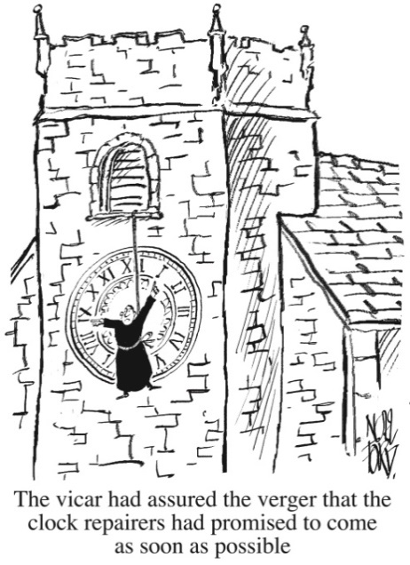

CHURCH ROTAS FOR APRIL

**Flower Arrangers**

No flowers during Lent.

**Tea/Coffee Rota following our 10.30 Service**

Apr 7th Carole & Gill

14th Beryl & Rona

21st Pauline & Barbara

28th Carole & Gill

May 5th Erika

If you’re not available on the date allocated or wish to change the date assigned to you, please find a replacement or arrange a swap.

*We’re rather short of helpers, so if you feel you could give an hour at this service every few weeks, have a word with Erika or call on 613816.*

**Sidespersons’ Rota**

Apr 7th 9.00 Ken Bishop

10.30 Jean Aughton and Churchwarden

14th 9.00 Rob McMurray

10.30 Norman Skellorn, Tom Wignall and Geoff Demack

21st 9.00 Jeremy Leigh

10.30 Bill Carr, Scott Eckersley and Beryl Blakeley

3.00 Peter Smallwood

28th 9.00 John Simpson

10.30 Ted Hopkins and Robert Hawthornthwaite

May 5th 9.00 Mike Redshaw

10.30 Jean Aughton and Churchwarden

**Readers’ Rota**

*If you cannot read as specified on this rota, please find a substitute and inform a churchwarden of any changes.*

April 7th 9.00 Joan Wilson

 10.30 Alan Johnson and Peter Templeman

April 14th 9.00 Mike Redshaw

10.30 Carole Bamber and Gill Slinger

April 21st – Easter Day

9.00 Peter Templeman

10.30 Barbara Wood and Scott Eckersley

April 28th 9.00 Kathleen Leigh

10.30 Jane Elphick and Ted Hopkins

May 5th 9.00 Joan Wilson

10.30 Margaret Kirkman and Jean Dewhurst

May 12th 9.00 Mike Redshaw

10.30 Emma Cairns and Lillie Eaves-Holmes

Peter Templeman will contact each reader by email by the preceding Tuesday. Please will readers ensure Peter has their contact email.

