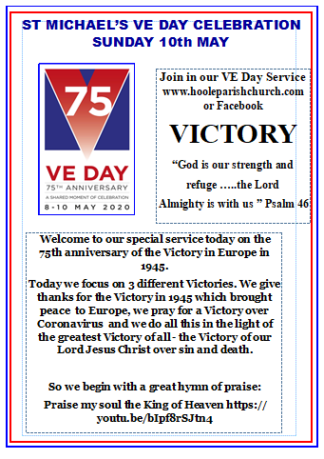

1 Praise, my soul, the King of heaven;
to his feet your tribute bring.
Ransomed, healed, restored, forgiven,
evermore his praises sing.
Alleluia, alleluia!
Praise the everlasting King!

2 Praise him for his grace and favour
to his people in distress.
Praise him, still the same as ever,
slow to chide, and swift to bless.
Alleluia, alleluia!
Glorious in his faithfulness!

3 Father-like he tends and spares us;
well our feeble frame he knows.
In his hand he gently bears us,
rescues us from all our foes.
Alleluia, alleluia!
Widely yet his mercy flows!

4 Angels, help us to adore him;
you behold him face to face.
Sun and moon, bow down before him,
dwellers all in time and space.
Alleluia, alleluia!
Praise with us the God of grace!

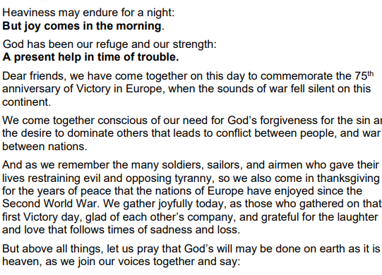

Our Father who art in heaven
Hallowed be thy name
Thy kingdom come, thy will be done
On earth as it is in heaven.
Give us this day our daily bread and forgive us our trespasses
As we forgive those who trespass against us
And lead us not into temptation
But deliver us from evil
For thine is the kingdom, the power and the glory, for ever and ever. Amen

BIBLE READING 1: 2 Corinthians 5: 19 and 20.

God was reconciling the world to himself in Christ, not counting people’s sins against them. And he has committed to us the message of reconciliation. We are therefore Christ’s ambassadors, as though God were making his appeal through us. We implore you on Christ’s behalf: be reconciled to God.

BIBLE READING 2: Psalm 46.
¹ God is our refuge and strength,
an ever-present help in trouble.
² Therefore we will not fear, though the earth give way
and the mountains fall into the heart of the sea,
³ though its waters roar and foam
and the mountains quake with their surging.^{[c]}
⁴ There is a river whose streams make glad the city of God,
the holy place where the Most High dwells.
⁵ God is within her, she will not fall;
God will help her at break of day.
⁶ Nations are in uproar, kingdoms fall;
he lifts his voice, the earth melts.
⁷ The Lord Almighty is with us;
the God of Jacob is our fortress.
⁸ Come and see what the Lord has done,
the desolations he has brought on the earth.
⁹ He makes wars cease
to the ends of the earth.
He breaks the bow and shatters the spear;
he burns the shields^{[d]} with fire.
¹⁰ He says, ‘Be still, and know that I am God;
I will be exalted among the nations,
I will be exalted in the earth.’
¹¹ The Lord Almighty is with us;
the God of Jacob is our fortress.

SERMON
Let us pray:
Lord Jesus conqueror of sin and death, fill our hearts this morning with thankfulness and praise, help us to trust you now and show us how to bring your peace to others.

We think first of that first great victory which brought peace to Europe after 5 and a half long years of a devastating war. It has been intensely moving to watch all the footage of the national celebrations in London with huge excited crowds outside Buckingham Palace and in the Mall wearing red white and blue, cheering, hugging, waving flags doing the conger and cheering with an unutterable relief and joy

But what about Hoole - what was going on here in Hoole? How did we celebrate ?
Let me introduce you to Betty who was born in Town Lane on a farm in 1929. These are her memories of VE Day in Hoole in May 1945.Betty was 15

“On VE Day, I was working on the farm with my father and brother. We were quite a way from the house. I went back to get the bagin (which is a drink) and I was met by Alice, my stepmother, who was very excited. She told me she’d been listening to the Churchill on the radio. He said the war was over. So I dashed back to the field and to father and my brother and he threw his cap up in the air and we were so, so excited. Upset really, with tears and laughter. So emotional.
Soon after, the church bells started ringing and the hooters from the ships on the river, the River Ribble, started hooting and we came home. We finished the work and we wanted to listen to the king who was speaking at 9:00. So, we all gathered round the radio, well the wireless we called it, and there were 6 of us in the family, and we listened to the king’s speech. We were drained really, so emotional we was. We put the flag out; we had a Union Jack, we put it through the window: we had a sash window, and we put it through the window. We didn’t have any street parties because we lived too far from the neighbours in those days.
We had a party, but it was in the Methodist School in Walmer Bridge, and we had a really, really good party. Then we went to the recreation field for sports and there was all sorts of sport and entertainment and a fun fair. The highlight of the afternoon was a challenge between Tommy Horrod, who was a very lively and vivacious chap, and Dick Wignall, who was more sedate and they undertook a 100 yards race. Well, Tommy set off like a house on fire, but his legs wouldn’t keep up with his body and he fell flat on his face and Dick just strolled past! Talk about the tortoise and the hare, that’s a typical example! We had a really good time; everybody was in such a good mood, and excited. But we were still very sad at the news coming on the radio about the Concentration Camps: they had just found out about them. We couldn’t believe it. It was all very emotional.

Thank you so much Betty for helping us to capture something of what you experienced on that glorious but very emotional day.

But where does God come in? He is our strength and refuge an ever-present help in times of trouble says Psalm 46 which we have just read.. The Christian knows that ultimately there is no need to fear whatever happens- the Lord Almighty is with us.

So sing along with these great words set to the Dambuster theme:
God is our strength and refuge...

HYMN God is our strength and refuge

God is Sovereign ; this is his world. He is in control. The original context of this Psalm was some notable deliverance of Jerusalem from the attack of heathen invaders. But the deeper central meaning works for every age and situation. It is a sublime expression of quiet confidence in God's Sovereignty amid the upheavals of nature and history . So it is supremely relevant in the midst of a global pandemic. We all long for a Victory against this terrible virus. There are signs of hope but the Victory is certainly not yet complete; people are still suffering and dying. We all have a responsibility to play our part whatever that is. All of us can make a big difference here: let's make sure we keep looking out for one another as life gradually we hope returns to normal, let's keep offering to get shopping for each other where needed, let's keep donating to the food bank, let's keep enjoying and giving thanks for the glorious countryside round here, let's keep chatting and making new friends in the street and lets’ keep sharing -speaking personally I am hugely grateful to all those who have been sharing surplus books and supplying me with new thrillers and crime novels. Above all else let's keep turning to our sovereign God for help.

God is here with us; He created us and loves each of us more than we can imagine. He sent His Son to save us. And now He is suffering with us, comforting, giving us strength to serve Him and others through it all.

So let me finish with the greatest Victory of all - the Victory of our Lord Jesus Christ over sin and death. Psalm 46 ends with a celebration of God's Victory and power. God's protection of Jerusalem is seen as a pledge and foretaste of the day when God will end all war and establish His kingdom of peace.
As Christians we know that through the cross and His glorious resurrection the greatest Victory has been won. As CS Lewis remarked we are still living in enemy occupied territory -there is still evil in our world- and there are still minor skirmishes to be fought. But the War is over; we are on the winning side and we have immediate access as Christians to High Command through prayer.

So what is our task now? In our brief second reading we are told that God has entrusted us with the message of reconciliation; we are Christ's ambassadors bringing that message of peace to all those around us. Start with the personal: now is the time to mend that broken relationship – try taking the initiative and saying sorry. And now outwards to your wider circle of friends and neighbours and share with them the message of reconciliation and the most crucial reconciliation of all – ‘Be reconciled to God’ A truly awesome task but one we can take up with joy in the sure and certain hope of the resurrection to eternal life.

And so we too with Christians down the ages that can say, "We will not fear; God is with us."

Let us pray
Lord God as we rejoice now in your power, your love and your presence,
help us to be channels of your peace.

Our next hymn is a prayer for peace and that we will be instruments of that peace
HYMN Make me a channel of thy peace:

Let us pray

Thanks be to God, who gives us the victory, through our Lord Jesus Christ.
Lord we thank you for the victory that we celebrate today. We thank you for the joy of that day May 8 1945, as crowds gathered to celebrate victory in Europe, cessation from hostilities and peace throughout the continent. We thank you that today in Berlin, Germans are celebrating freedom from the Nazi regime. We pay tribute to the servicemen and women who sacrificed for and committed to the freedoms that we now enjoy. And we praise you for the stories of inspiration that we have heard from Captain/Colonel Tom Moore, and many others who contributed to that victory 75 years ago.
Lord, in your mercy, hear our prayer.

Thanks be to God, who gives us the victory through our Lord Jesus Christ.
Father, we are engaged in a battle and pursuing victory over the corona virus, and we commit our situation to you now. We praise you for the work of medical staff, carers, hospital staff, doctors, nurses and consultants, and for those continuing work in the essential services. We pray for your help and guidance for all who are involved in finding a vaccine to combat this virus. And we pray for the families of those who have lost loved ones to this disease, often not being able to be present at their last moments. Please bless and help our endeavours to find a way forward, and may we continue to put the needs of our neighbour before our own.

Lord, in your mercy, hear our prayer.
Father, we thank you most of all for the victory of your Son, our Lord Jesus Christ, over sin and death. Thank you that, by tasting death, He defeated death, and offered the fruits of His victory to each one of us.
We pray at this time for those known to us who are sick and unwell, and we particularly commit to you Pearl Read, who was taken into hospital on Thursday. We give thanks for the lives of those known to us and who have meant so much to us, especially praising you for the life of Mike Redshaw, for his service to the nation in the Royal Engineers, and to the Church and community here in Hoole. We thank you for his love of family, and we pray for Lisa and the family, in their time of mourning and grief.
Lord, in your mercy, hear our prayer.
Lord, we praise you that your victory has opened for us the gate of Heaven, the way into eternal life, and the joy of one day seeing you Face to face. Encourage us we pray, as we remember the words of the hymn
Yours is the battle
Yours shall be the praise.
Merciful Father, accept these prayers for the sake of your Son, our Saviour Jesus Christ.

We sing our final hymn:
HYMN - Lord for the Years, your love has kept and guided

After the final blessing, please join in the national anthem

BLESSING
May the Love of the Lord Jesus draw you to Himself
May the Power of the Lord Jesus strengthen you to serve Him
And may the Joy of the Lord Jesus fill your hearts on this day of celebration
And so may the blessing of God Almighty, the Father, the Son and the Holy Spirit be with you and all those whom you love, now and for evermore. Amen.
THE NATIONAL ANTHEM.

