GGOD FRIDAY SERVICE 2020
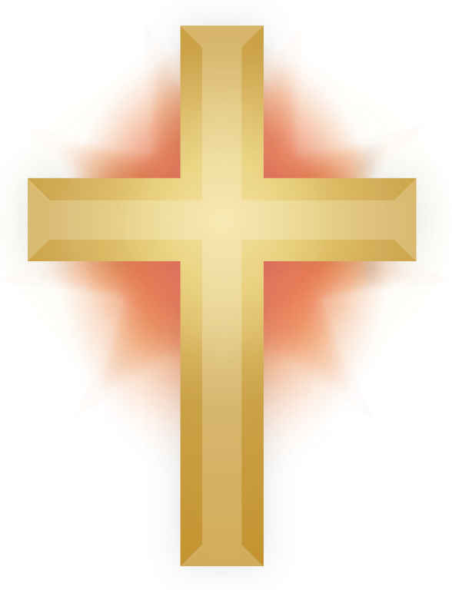

ST MICHAEL’S CHURCH HOOLE
The Death of Jesus
“Surely He was the Son of God”. Matthew 27 v 54
Today we remember Jesus’ death on the cross which brought about our salvation. We can‘t worship together in our beautiful church building but we can still worship together in spirit in our homes. We can thank God for his great love for us in sending His Son to die for us; we can read His Word and be encouraged and strengthened, and we can pray for our families, our community, our world and ourselves.

We begin with a great Good Friday hymn: There is a Green Hill far away https://www.youtube.com/watch?v=d0ybUpuLn8M:
1. There is a green hill far away,
outside a city wall,
where our dear Lord was crucified,
who died to save us all.
2. We may not know, we cannot tell
what pains he had to bear;
but we believe it was for us
he hung and suffered there.
3. He died that we might be forgiven,
he died to make us good,
that we might go at last to heaven,
saved by his precious blood.
4. There was no other good enough,
to pay the price of sin;
he, only, could unlock the gate
of heaven and let us in.
5. Lord Jesus, dearly you have loved,
and we must love you too;
and trust in your redeeming blood,
and live our lives for you.

Let us pray:

PRAYER FOR GOOD FRIDAY:

Eternal God, in the cross of Jesus we see the cost of sin and the depth of your love: in humble hope and fear may we place at His feet all that we have and all that we are,
through Jesus Christ our Lord. Amen.

BIBLE READING:

1. Matthew 27: v 32-44.

The Crucifixion of Jesus
As they were going out, they met a man from Cyrene, named Simon, and they forced him to carry the cross. They came to a place called Golgotha (which means “the place of the skull”). There they offered Jesus wine to drink, mixed with gall; but after tasting it, he refused to drink it. When they had crucified him, they divided up his clothes by casting lots. And sitting down, they kept watch over him there. Above his head they placed the written charge against him: this is jesus, the king of the jews.
Two robbers were crucified with him, one on his right and one on his left. Those who passed by hurled insults at him, shaking their heads and saying, “You who are going to destroy the temple and build it in three days, save yourself! Come down from the cross, if you are the Son of God!” In the same way the chief priests, the teachers of the law and the elders mocked him. “He saved others,” they said, “but he can’t save himself! He’s the king of Israel! Let him come down now from the cross, and we will believe in him. He trusts in God. Let God rescue him now if he wants him, for he said, ‘I am the Son of God.’” In the same way the robbers who were crucified with him also heaped insults on him.
Talk 1
THE CRUCIFIXION Matthew 27 v 32 - 44.

We join the account of Good Friday at Matthew 27 v 32. Jesus has just been flogged and scourged - a procedure that in some cases would result in the death of an accused. This explains why Jesus was unable to carry His cross all the way from Pilate's residence to Golgotha. As the soldiers lead Jesus away from the trial to execution, with a board with the written charge displayed for all to see "This is Jesus, the King of the Jews", Jesus stumbles, falls and drops the cross.

The Roman centurion, in charge of the whole process, is now in a dilemma. He can't ask a Roman to carry a cross - that was totally beneath any Roman's dignity. And he couldn't ask a Jew, as that would have made the Jew unclean, and therefore unfit to celebrate Passover, and might well have resulted in a riot among the Jews. So he looks round the crowd, and sees a face of darker skin than most. He finds out that the man is called Simon, and is from Africa; so this man from Cyrene is compelled to carry Jesus' cross.

In Mark's gospel, Simon is identified as the father of Alexander and Rufus, and it seems that the whole family became Christians, almost certainly beginning from this moment. Simon reappears in Acts, and Rufus in Romans.

Finally the procession arrives at Golgotha, Calvary, the Place of the Skull. They offer Jesus a drink, wine mixed with vinegar. Jesus refuses, partly because He had said at the Last Supper that He would not drink wine again until He had come into the Kingdom of Heaven; and partly because it would have drugged Him, deadening His senses, and Jesus seems to have been determined to drink the cup of suffering to the full.

And then we are given the reactions of those present:-
1) The soldiers
They are more interested in the clothes of Jesus, than in Jesus Himself. So as Jesus suffers on the cross, they sit down and throw dice, to see who will get the clothes of the victim. The time will come, the day will come, when these soldiers will wish that their focus had been on Jesus, rather than on Jesus' clothes. Having said that, it looks from v 54, later on in the chapter, that the soldiers, as well as the centurion, were convinced that Jesus was the Son of God.
2) Secondly the crowd, shouting insults and abuse, and throwing down the challenge to Jesus to come down from the cross.
3) Similarly the religious authorities also challenge Jesus to come down from the cross, to prove Himself. The irony is of course that Jesus could have come down from the cross, if He had chosen to do so. He had already said at His arrest that He had twelve legions of angels at His disposal, if He wanted.
But Jesus knew that He had to stay on the cross,
to pay for the sins of the world,
to take on himself the burden of the world's wrongdoing,
to give His life as a ransom for many.
4) There were also the robbers who insulted Jesus, although we know from Luke's gospel that one robber turned from invective to penitence, from insults to dependence, from opposition to allying himself to Jesus for eternity.

We will see, in the next section of verses, some of the implications of Jesus' death. But for now, let us notice two things:-
a) Freedom. From where we are, at the moment, inhibited by lockdown, we long for freedom. Freedom of movement, freedom to go outside when and where we want. Freedom to come and go as we please - and all that is natural.
But Jesus stayed on the cross, Jesus died on the cross, to win us a far greater freedom. Freedom from sin, freedom from the power of sin, from the penalty of sin, from the presence of sin. A freedom more wonderful than any other known to human beings, described in one of our prayers as "whose service is perfect freedom."

b) Community. In a similar vein, we long to be restored to community, to meet people, to chat, to shake hands, to embrace.
But Jesus stayed on the cross, Jesus died on the cross, to form a community for Himself; an eternal community, a community so glorious and wonderful that no one can number it. A community that will for eternity sing the praise of Him who is truly the King of Israel, the Son of God.

Listen now to the beautiful hymn How Deep the Father’s love for us and use it as a prayer :
https://youtu.be/dLDGVl8D5UU
How deep the Father's love for us
How vast beyond all measure
That He should give His only Son
To make a wretch His treasure
How great the pain of searing loss
The Father turns His face away
As wounds which mar the Chosen One
Bring many sons to glory
Behold the man upon a cross
My sin upon His shoulders
Ashamed, I hear my mocking voice
Call out among the scoffers
It was my sin that held Him there
Until it was accomplished
His dying breath has brought me life
I know that it is finished
I will not boast in anything
No gifts, no power, no wisdom
But I will boast in Jesus Christ
His death and…

BIBLE READING;

Matthew 27: v 45-54.

The Death of Jesus …

From noon until three in the afternoon darkness came over all the land. About three in the afternoon Jesus cried out in a loud voice, “Eloi, Eloi, lama sabachthani?” (which means “My God, my God, why have you forsaken me?”).
When some of those standing there heard this, they said, “He’s calling Elijah.”
Immediately one of them ran and got a sponge. He filled it with wine vinegar, put it on a staff, and offered it to Jesus to drink. The rest said, “Now leave him alone. Let’s see if Elijah comes to save him.”
And when Jesus had cried out again in a loud voice, he gave up his spirit.
At that moment the curtain of the temple was torn in two from top to bottom. The earth shook, the rocks split and the tombs broke open. The bodies of many holy people who had died were raised to life. They came out of the tombs after Jesus’ resurrection and went into the holy city and appeared to many people.
When the centurion and those with him who were guarding Jesus saw the earthquake and all that had happened, they were terrified, and exclaimed, “Surely he was the Son of God!”

Talk 2
THE DEATH OF JESUS Matthew 27 v 45-54
Self isolation is one of the new phrases that’s on everyone's lips. We will always think of Coronavirus whenever we hear the word isolation. This second Bible reading in our Good Friday service begins with the most terrible self isolation of all. Our Lord hanging on the cross in agony shouted out what is often called the cry of dereliction- the cry of self isolation; ‘My God, my God why have you forsaken me?’ He is quoting Psalm 22. Here of His own free will, Jesus is cutting Himself off from the core relationship of His being - His relationship with His Father God- something that had never happened before in all eternity. And He did it for us. There was simply no other way to deal with the sin of the world, your sin and my sin. At that very moment Jesus was taking upon Himself the sins of all humanity, for you and for me; He who was totally without sin became sin for us, voluntarily cutting Himself off from God the Father.
It was a cataclysmic event. The sky became dark even though it was midday and remained so while Jesus hung in agony on the cross, dying to pay the price of sin, of all our sins. And then He died crying out with a loud voice. John’s Gospel tells us what He shouted – ‘It is finished’. But this was not a cry of defeat but of victory. The Greek word is ‘tetelestai’ which means it has been accomplished- I have done what I came to do. Jesus has been in total control of all the events leading up to this moment. He came to die for us and this is what He has done.
He came to die that we might live; remember the most famous verse in the bible; God so loved the world that He gave His only Son that whoever believes in Him should not perish but have eternal life. And on that cross in 30AD in Roman occupied Palestine, the victim of a gross miscarriage of justice, the Lord of the Universe gave Himself up to an agonising death for us.
That He did indeed accomplish what He came to do is set out dramatically in the next paragraph. At the very moment of His death we read the curtain of the temple was torn in two from top to bottom. (Not notice from bottom to top, as any human being would do it, but from top to bottom- this was a supernatural event.) This curtain was huge, 30 feet high and very heavy; it separated off the Holy of Holies the sacred centre of the great Temple from all the rest. This was where it was believed God dwelt; only the High Priest could enter and that only once a year. But now Jesus, God’s only Son, has died – He has shattered the barrier between God and humanity made by our sin. All of us whatever our age our sex our race can enter freely into God’s presence because of Jesus’ death. Jesus the Saviour has indeed accomplished His great rescue operation.
And this great rescue operation goes way beyond what our wonderful careworkers and our own efforts at self isolation can do. We hope and pray that together with God's help in this crisis we can defeat Coronavirus. But we of ourselves can never conquer death ; that comes eventually to us all.
But here on the cross because of Jesus’ death we can know for sure that the greatest enemy of all time has once and for all been conquered. At the time it took a foreigner, a Roman centurion who saw all that had happened; he watched Jesus die and he saw the dramatic effects of His death. “Surely” he said “He was the Son of God."
Jesus was indeed the Son of God. Our self isolation at the moment is costly as many voluntarily cut themselves off from their loved ones to protect themselves and others. We fervently hope it will work. Jesus’ self isolation was more costly than we can possibly imagine as he endured the spiritual agony of being cut off from his Father. But we can know for certain that His self isolation was a hundred per cent effective; Easter Day is the glorious proof that the worst disease of all - death has been vanquished once and for all.
Alleluia!
Let us pray:
1. Blessed are you, O God of our salvation,
To you be glory and praise for ever.
As we behold Your Son, enthroned on the cross,
Stir up in us the fire of your love, that we may be cleansed from all our sins,
And walk with you in newness of life,
Singing the praise of Him who died
For us and our salvation.
Blessed be God, Father, Son and Holy Spirit
Blessed be God for ever. Amen
2. Keep us, good Lord,
under the shadow of your mercy in this time of uncertainty and distress.
Sustain and support the anxious and fearful,
and lift up all who are brought low; that we may rejoice in your comfort,
knowing that nothing can separate us from your love in Christ Jesus our Lord. Amen.

A moment of silence as we bring our personal prayers to God: …….
We join now in the prayer Jesus taught his followers to pray:
Our Father who art in heaven
Hallowed be thy name
Thy kingdom come, thy will be done
On earth as it is in heaven.
Give us this day our daily bread and forgive us our trespasses
As we forgive those who trespass against us
And lead us not into temptation
But deliver us from evil
For thine is the kingdom, the power and the glory, for ever and ever. Amen

Our final hymn focuses on the depth of Jesus’ love for us which demands from us total commitment to Him;
When I survey the wondrous cross https://www.youtube.com/watch?v=Z9eCUqz_x5A
- When I survey the wondrous cross
On which the Prince of glory died,
My richest gain I count but loss,
And pour contempt on all my pride.
- Forbid it, Lord, that I should boast,
Save in the death of Christ my God!
All the vain things that charm me most,
I sacrifice them to His blood.
- See from His head, His hands, His feet,
Sorrow and love flow mingled down!
Did e’er such love and sorrow meet,
Or thorns compose so rich a crown?
- Were the whole realm of nature mine,
That were a present far too small;
Love so amazing, so divine,
Demands my soul, my life, my all.
BLESSING
Jesus said, ‘Peace I leave with you; my peace I give you. I do not give as the world gives. Do not let your hearts be troubled and do not be afraid’.
And so may the blessing of God Almighty, the Father, the Son and the Holy Spirit be with you and all those whom you love, now and for evermore. Amen

Rev Ann Templeman 01772448515 or 07877659156, anntempleman@live.co.uk

