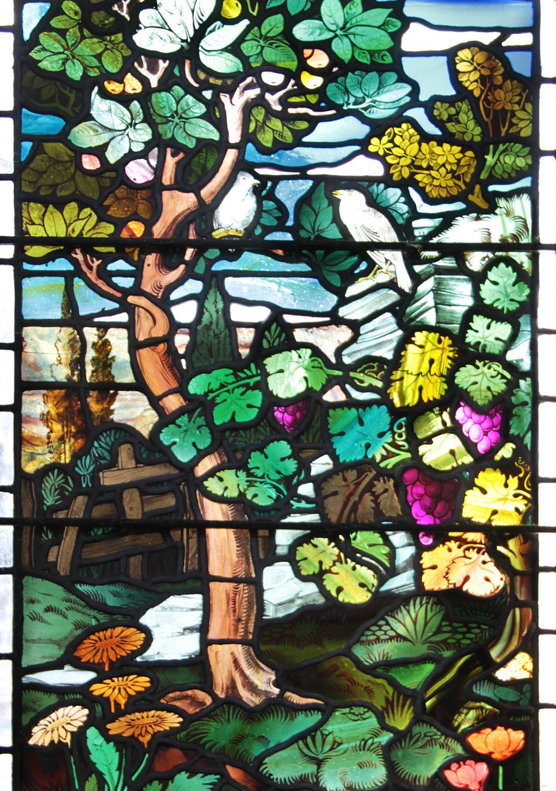
Photo by Paul Judson, from a redundant church near Sedburgh, Yorkshire
CHURCH OFFICERS
Rector: The Reverend Ann Templeman
The Rectory, 69 Liverpool Road, Much Hoole, PR4 4RB
Tel: 01772 448515 and mob: 07877 659156;
E: anntempleman@live.co.uk
Associate Minister: The Reverend Peter Templeman
Churchwarden:
Mr Jock Davidson – Tel: 617918; E: sgtmajor@talktalk.net
Occasional Preacher:
Mrs Margaret Kirkman – Tel: 01772 379219. Mob: 07786543581.
E: margk1946@gmail.com
Reader in Training:
Mr Alan Johnson – Tel: 01704 822179; E: alanmarie55@gmail.com
Churchwarden Emeritus:
Mr William G Carr. Tel: 01772 615321. E: billcarr1935@btinternet.com
PCC Secretary:
Mrs Andrea Susnik – Tel: 615336. E: familysusnik@live.co.uk
PCC Treasurer:
Mrs Barbara Wood – Tel: 617679. E: bw12252@sky.com
Deanery Synod Representatives: Mrs Jane Elphick, Mrs Jean Dewhurst and Mrs Kathleen Leigh.
Parish Safeguarding Officer: Mrs Jean Dewhurst, Tel: 616106.
Magazine Editor
Mrs Erika Penrose – Tel: 613816. E: jandepenrose@btinternet.com
Magazine Secretary:
Mrs Elsie Kirkham – Tel: 615832.
Magazine Advert Co-ordinator:
Position vacant
Flower Secretaries:
Mrs Lisa Redshaw – Tel 614428 and Mrs Pearl Read – Tel: 614367.
Electoral Roll Officers:
Mrs Jean Dewhurst, Tel: 616106 and Mrs Jane Elphick, Tel: 601495.
Verger: Mrs Irene Pickles – Tel: 615708
Assistant Verger: Mr Stuart Tighe – Tel: 612963
Weekly Giving Envelopes: Please contact the Treasurer or Churchwarden.
Parish Administrator: Mrs Amanda Gibson – Tel: 07735 961620.
ORGANISATIONS
Sunday School
Sunday School – St Michael’s Club – begins at 10.30 in church and usually happens every Sunday.
Leader: Mrs Kathleen Leigh – Tel: 612196. Email: katleigh@live.co.uk
Hoole Church Ladies’ Group – meets 7.30pm, 3rd Tuesday, in School. Leader: Mrs Erika Penrose.
Tel: 613816. E: jandepenrose@btinternet.com
St Michael’s Men’s Fellowship – meets 7.30pm, 2nd Tuesday, in Hoole Village Memorial Hall.
Secretary: Mr Stuart Tighe – Tel: 612963.
Friends of St Michael – Caring for the fabric of our ancient church.
Chair: Mrs Jane Elphick, Tel: 601495.
Secretary: Mr David Turner, Tel: 01772 383344.
Social Committee – Contact: Mrs Sheila Taylor, Tel: 616850
Hoole St Michael C E Primary School
Head Teacher: Mrs Juliet Price – Tel: 613219.
1st St. Michael’s Hoole Scout & Guide Groups – Contact:
Rebecca Catterall
Church Website: http://www.hooleparishchurch.com.

CHURCH OPENING TIMES
St Michael’s Church is open every day. Opening times are:
Monday to Saturday inclusive: 9.30am to 4.30pm.
Sunday: 8.00am to 4.30pm.
Jock Davidson, Churchwarden

Do take a look at our church website – http://www.hooleparishchurch.com

Please note: All adverts are at the back of the magazine.
Church Rotas are on pages 25 & 26.

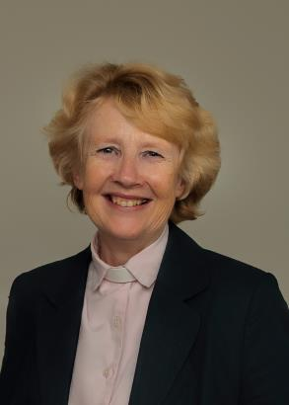
FROM THE RECTORY
'The Heavens declare the Glory of God' Psalm 19
We are 'fearfully and wonderfully made'. Psalm 139
Dear all
It was a fabulous cake, a large bright yellow square with cute yellow chicks perched on the icing. It was perfect for Farm Church and we thought at the beginning how a scientist would be able to discover what it was made of and when, but never why - only its creator would know that. What was true of our cake is true of our universe. How ever we approach it, our world is awe inspiring in its beauty and complexity and the way it is 'tailor-made' to support the possibility of human life. This is what is known as the Goldilocks effect – just like in the story where baby bear's chair, porridge and bed were 'just right' for Goldilocks, so against all the odds - like hitting a square inch target the other side of the known universe – it seems that our world had exactly the right conditions to support us humans.
Scientists now have some idea how they think our world and perhaps our universe came into being but they could never tell us why it was made – only God the Creator can do that. It is a very important truth that God and Science are not in conflict; quite the reverse: as Einstein said “Science without religion is lame and religion without science is blind”. Many of the very top scientists in the world of every discipline are committed Christians. Science and faith could never be incompatible -they are asking and answering different questions.
The red and brown and orange and yellow colours of autumn and harvest – the stunning beauty of our world – give us reason to pause and wonder and praise God. The Psalms are wonderful vehicles to praise our Creator God – try Psalm 8 or 19 for starters.
And at the same time look smaller at the wonder of new life. Read Psalm 139 where the psalmist ponders about how the Great God of the whole Universe can and does care for each individual person: “Before I formed you in the womb I knew you. I am fearfully and wonderfully made”. At Farm Church we had some new-born chicks to delight in and handle. But a baby is infinitely more special; those of you in the Ladies’ Group will remember the talk about being a midwife and the joy and privilege our speaker of delivering babies our speaker describes. Before we were born God knows everything about us – that is huge. There is an excellent children's song which has become very popular – Great Big God. It talks of God’s transcendence and His imminence – He made the universe yet He knows me and He loves me since before the world began. Hold on to that this autumn and as we thank God for the Harvest this Harvest Festival, thank Him too for His great personal love for you and resolve to know Him better.
Ann Templeman (Rector) August 2019
~~~~

GOING DEEPER – GROWTH GROUPS
No relationship remains static and communication is the key to ensuring relationships flourish. That is true of all our human relationships and it is equally true of our relationship with God. The Bible is the chief way he speaks to us and prayer the chief way we speak to him.
So let me encourage you to join one of our Growth groups (another name for Bible study or Housegroups) this autumn which are regarded as one of the best ways to grow in faith. We have held four fortnightly sessions on Mondays and Tuesdays in September, and will be continuing in October and November (see the Parish Diary). We are using a course called God’s Big Picture which gives a broad brush insight into the themes of the whole Bible beginning with the book of Genesis. It assumes no prior knowledge and is accessible for everyone. Each session (lasting about an hour with refreshments) will begin with a 10min clip given by a gifted Bible teacher and then there will be questions and discussion. There is no pressure to join in the discussion unless you wish to.
After a break we will have a short series on preparing for Christmas; we will look at some of the key Bible passages about the coming of Jesus into our world.
We hope to make one session geared to those who have little or no experience of Bible study. It would be very helpful if you could let me know if you see yourself in this category and when you are available.
Please see dates list for full dates of Growth groups.
~~~~
ST MICHAEL AND ALL ANGELS CHURCH, HOOLE
SUNDAY SCHOOL – Michael’s Club for children (ages 3 to 12), usually every Sunday during the 10.30 service.
10.30am – Starts in church; children leave for their own teaching in the school after a children’s song and return after the sermon and prayers.

Parish Diary up to November
Friday 27th Sept 7.00 Harvest Supper/Quiz night in Village Hall
Sunday 29th Sept 9.00 Holy Communion (Book of Common Prayer)
10.30 Parish Communion with Sunday School
12.00 Baptism of Ethan Peterson
Monday 30th Sept 7.30 Growth Group at the Rectory
GOD’S BIG PICTURE SESSION 3
Tuesday 1st October 10.15 Holy Communion (said)
Friday 4th October St Michael’s School Harvest Festival
Sunday 6th October 09.00 Holy Communion (Book of Common Prayer)
10.30 HARVEST FESTIVAL
4.00 Holy Communion at Old Mill Court
Tuesday 8th October 10.15 Holy Communion (said)
7.30 Growth Group at the Rectory:
GOD’S BIG PICTURE SESSION 3
Sunday 13th October 09.00 Holy Communion (Book of Common Prayer)
10.30 Morning Worship
3.45 SUPERHEROES’ FAMILY CHURCH IN ST MICHAEL’S SCHOOL
Monday 14th Oct 7.30 Growth Group at the Rectory
GOD’S BIG PICTURE SESSION 4
Tuesday 15th Oct 10.15 Holy Communion (said)
7.30 Joint Ladies’ Group & Men’s Fellowship in the Village Hall
Saturday 19th Oct 1.00 Wedding of Ben Hughes & Rosie Tattersall
Sunday 20th Oct 09.00 Holy Communion (Book of Common Prayer)
10.30 Parish Communion with Sunday School
Tuesday 22nd Oct 10.15 Holy Communion (said)
7.30 Growth Group at the Rectory
GOD’S BIG PICTURE SESSION 4
Sunday 27th Oct 09.00 Holy Communion (Book of Common Prayer)
10.30 Morning Worship with Sunday School
Tuesday 29th Oct 10.15 Holy Communion (said)
Sunday 3rd Nov 09.00 Holy Communion (Book of Common Prayer)
10.30 Parish Communion with Sunday School
4.00 SERVICE OF THANKSGIVING FOR LOVED ONES
Monday 4th Nov 7.30 PCC meets at the Rectory
Tuesday 5th Nov 10.15 Holy Communion (said)
7.30 Growth Groups restart
PREPARING FOR CHRISTMAS SESSION 1
Sunday 10th Nov 09.00 Holy Communion (Book of Common Prayer)
10.10 REMEMBRANCE SUNDAY SERVICE
Tuesday 12th Nov 10.15 Holy Communion (said)
7.30 Men’s Fellowship meeting at Much Hoole Village Hall
Saturday 16th Nov 10.00am-2.00pm PCC/PARISH QUIET MORNING AT WHALLEY ABBEY LED BY ARCHDEACON MARK
Sunday 17th Nov 09.00 Holy Communion (Book of Common Prayer)
10.30 Parish Communion
3.45 STAR WARS FAMILY CHURCH IN THE VILLAGE HALL

KEY FUTURE DATES
- HARVEST SUPPER
Friday 27th September at 7.00 for 7.30pm in the Village Hall

- ST MICHAEL’S SCHOOL HARVEST FESTIVAL
Friday 4th October

- HARVEST FESTIVAL
Sunday 6th October

- SUPERHEROES FAMILY CHURCH
Sunday 13th October at 3.45pm in St Michael’s School

- TOY & CHRISTINGLE SERVICE IN ST MICHAEL’S CHURCH
Sunday 8th December at 4.00pm

- CAROLS BY CANDLELIGHT IN ST MICHAEL’S CHURCH
Sunday 15th December at 6.00pm

- CHRISTMAS EVE CRIB SERVICE
Sunday 24th December at 4.00pm

- MIDNIGHT COMMUNION IN ST MICHAEL’S CHURCH
Sunday 24th December at 11.30pm

- CHRISTMAS DAY FAMILY SERVICE WITH COMMUNION
Monday 25th December at 10.30am

Intercessions: Please let the Rector or Margaret Kirkman know of anyone you would like including on our prayer list, by text or 07786 543581.

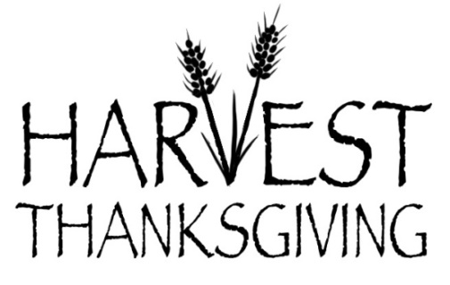
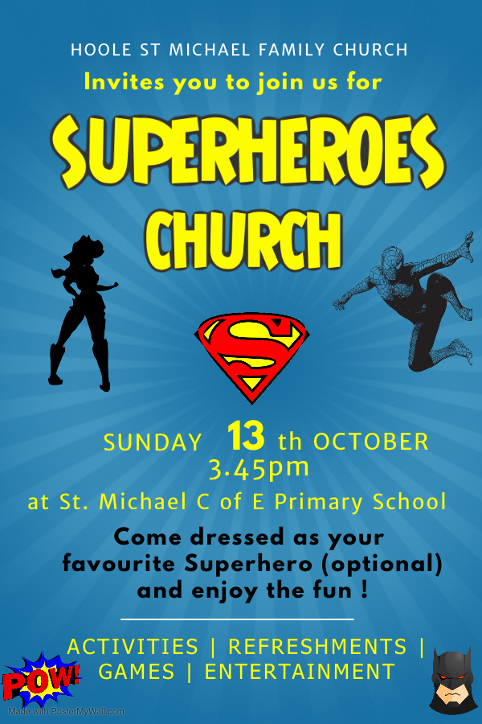
Report on Farm Sunday Church
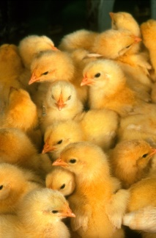
Over 100 members of our local community came together to celebrate Farm Church which was held at the Village Hall on Sunday 15th September, led by Rev Ann Templeman. Although the day was a little drizzly all enjoyed sitting on farm vehicles, handling baby chicks, Welly Wanging, and participating in some fabulous farm craft. It was very enjoyable to meet lots of new people to our Family Church and the day was a great success.
"I loved Farm Church because of the delicious cakes and fun craft" (Eve).
"Welly throwing was lots of fun!" (Beth)
"I loved holding the baby chicks" (John)
Ladies’ Group
We all enjoyed David Tomlinson’s visit from Warburton’s Bakery who came along with a free raffle of bread-related gifts in August. He also gave a most interesting and amusing talk about the history of the company which is still a family-run concern.
Equally, in quite a different way, our September meeting was most enjoyable, with Janet Edwards telling us about some of the memorable events in her life as a midwife.
This month, on Tuesday 15th October at 7.30pm at Hoole Village Hall, we invite the Men’s Fellowship to join us for Harold Hoggarth’s talk about “The Way Things used to be”. It could be a nostalgic evening! All new members are welcome.
Erika
~~~~

From the Parish Registers
Holy Baptism
“We welcome into the Lord’s Family”
Arthur John Cairns was baptised on 25th August.
Emily Grace Goodwin was baptised on 8th September.
Joseph Mason Carruthers and Roman Daniel Carruthers were baptised on 20th September.
Weddings
“Those whom God has joined together”
Nathan Pow and Joanne Irene Bamber, both of Carlisle, were married on 6th August.
Thomas Henry Sutton and Karina Sokolova, both of Little Hoole, were married on 9th August.
Jonathan Stuart Whittle and Katie Louise Tyrer, both of Fulwood, were married on 14th September.

Funerals
We give thanks for the life of Sylvia Mary Evans, aged 83 years, of Walmer Bridge, whose funeral took place on 22nd August. Interment followed in the churchyard.
We give thanks for the life of William Frederick (Bill) Dewhurst, aged 86 years, of Walmer Bridge, whose funeral took place on 2nd September. Interment followed in the churchyard.
We give thanks for the life of William James Colman, aged 76 years, of Walmer Bridge, whose funeral took place on 16th September. Interment followed in St Andrew’s churchyard, Longton.
~~~~
From the Register of Services
Date |  | Attendance | Communicants | Amount
August | 4th | 73 | 66 | £272.21
 | 11th | 62 | 22 | £193.35
 | 18th | 55 | 55 | £362.00
 | 25th | 75 | 29 | £353.40
September | 1st | 95 | 74 | £218.94
Note: the attendance on Sept 1st includes the Family Farm Church
 | 8th | 87 | 31 | £322.48
 | 15th | 159 | 48 | £197.35
Standing Order donations in lieu of donating via the envelope system for August (actual): £4,681.50. September (projected): £586.50.
Donations from Baptisms: £255.63. Donations from Weddings: £76.00.

DOES THIS APPEAL TO YOU?
Mr Les Hodgson makes these candle silhouettes by hand and the proceeds go to the Royal British Legion – more details on his website.
I have just ordered two, based on a recommendation by my sister and her husband who know him personally. The time of year seems appropriate.
I have ordered the Royal Marine and the Wren.
Barbara Wood
~~~~

PARISH JOB OPPORTUNITY
Advertisement Co-ordinator
We need a volunteer for the above. Margaret Clark, who has taken on this role for the past few years, has recently resigned after having done a sterling job.
Ideally, I don’t really want the job back again so… if you have basic Word and Excel skills you could do this.
Training will be provided and full support throughout.
Brief Job Description:
- It is a once a year activity on or around October/November of each year.
- It involves contacting all the advertisers in the magazine inviting them to renew plus follow up as necessary
- Collate the payments that come in/liaise with the treasurer for BACs payments
- Late Nov/early December, check and edit the adverts and forward them to the printer (details will be available) to be included in the January Magazine.
- Do a bit of marketing to find new advertisers if we have any blanks.
- Keep a record of all the advertisers and relevant details.

Many thanks.
Barbara Wood
Treasurer
Tel: 617679. Email: bw12252@sky.com

WATER AID LAUNCH 2019-2020
Another year starts…………Harvest 2019 through to Easter 2020.
For those of you who may be new readers or new church attendees this is the background:
For well over 10 years now our Church has been collecting for this charity – we save our loose change in empty jam jars (or any type of jar really – we don’t mind). Some people fill one jar others fill multiple jars. You choose.
It is really really easy – pick up a jar AND FILL IT with your loose change.
You won’t miss it – I promise.
- You will find empty jars with the Water Aid label on in various places in Church – at the end of your pew, in the porch or at the back of Church beside the font – depending on what is going on in Church that week. Or you can provide your own and pick up a Water Aid label and Gift Aid Form available in Church, probably in the box of jars in the porch.
- If you are a tax payer, please complete the Water Aid Gift Aid declaration form to be found in the jar.
- If you have filled in their new form (2018), please can you indicate this as it will be on record.
- If in doubt – fill it in anyway.
- If you are not a tax payer, please remove the form when you hand in your jar.
- When your jar is full, bring it into Church and hand it to our trusty churchwarden or a sides-person who will pass them to me and I will make sure it gets to the volunteer(s) who are doing the counting. Alternatively, you can leave your jar on the seat behind the font on a Sunday morning and it will be collected that same afternoon.
If you are at Church on Harvest Sunday – then do please consider picking up a jar there and then.
If you are not, the jars will be around for some considerable time for you to pick up at your leisure.
Many, many thanks in anticipation.
Barbara Wood (Treasurer)

Make your donation worth more with Gift Aid – so it can do more
From the Water Aid Website…
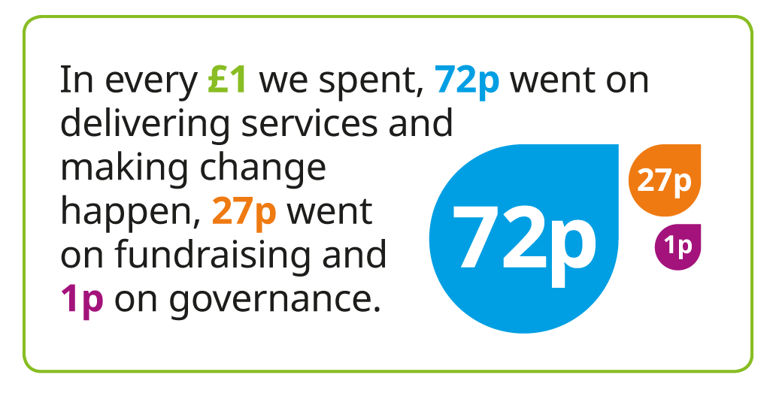

HYMN OF THE MONTH
BE STILL FOR THE PRESENCE OF THE LORD
Words and Music: David J. Evans
Hymn No. 67

Tell Out My Soul Hymn No: 631 Author: Timothy-Dudley Smith Born 1926
Timothy Dudley-Smith wrote this hymn in May 1961 when he and his wife had just moved into their first house in Blackheath. He was inspired to write the text when he was reading a modern paraphrase of the Magnificat in Luke 1:46-55 which begins with the phrase, "Tell out, my soul, the greatness of the Lord". This song in its original form is the song that Mary the mother of Jesus sings when she is pregnant. It is usually said or sung every evening in Anglican cathedrals. This modern version is written by the contemporary hymn-writer Bishop Timothy Dudley-Smith. His father influenced his love of poetry, and his first and most widely sung hymn, "Tell Out, My Soul," was written while he was at Cambridge. He says of its conception, "I did not think of myself as having in any way the gifts of a hymn-writer when in May 1961 I jotted down a set of verses, beginning Tell out, my soul, the greatness of the Lord.
Tell out, my soul, the greatness of the Lord!
Unnumbered blessings give my spirit voice;
Tender to me the promise of his word;
In God my Saviour shall my heart rejoice.
Tell out, my soul, the greatness of his name!
Make known his might, the deeds his arm has done;
His mercy sure, from age to age the same;
His holy name, the Lord, the mighty One.

Tell out, my soul, the greatness of his might!
Powers and dominions lay their glory by;
Proud hearts and stubborn wills are put to flight,
The hungry fed, the humble lifted high.
Tell out, my soul, the glories of his word!
Firm is his promise, and his mercy sure.
Tell out, my soul, the greatness of the Lord
To children's children and forever more!
My soul doth magnify the Lord: and my spirit hath rejoiced in God my Saviour. When I was a choir boy, the Magnificat was said or chanted at every evening service.
Bill Carr, Church Warden Emeritus

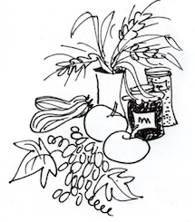

Our Prayer Circle
As Christians we know that one of the main things that Jesus taught us was the words of The Lord’s Prayer and very often in the Bible we are told that He went to a quiet place and prayed. Our hymns tell us to “Take it to the Lord in prayer” and that “the voice of prayer is never silent”. There is no doubt of the need for prayer for our own spiritual needs as well as the knowledge of the comfort and support that it gives to both the person praying and the people being prayed for.
To that end we have set up a Prayer Circle at St Michael’s.... ‘What’s one of those then?’ you may ask. It is simply a group of people who when called upon will pray at home separately and quietly for whatever you ask.
If you have a concern of any sort that you want us to pray for all you need to do is to ring any of the numbers and simply say what or who is in need of prayer, and whilst a minimum of explanation might be an advantage for us to focus the prayer, ou don’t even have to say who you are! The person taking the call will pass it round the circle and you will know that we, on behalf of the church, are taking your worry to the Lord. If you would like your particular concern added into the intercessions on a Sunday morning then we can do that too.
We are happy to welcome others into the circle, just let us know and you will be added on.
Prayer is an essential part of our Christian life to keep us walking in the footsteps of our Saviour... so... the lines are open right now, we are waiting to take your call which is very important to us because it matters to you... just ring and your prayer will be increased seven-fold (at least).
Our circle consists of Ted (01772 617002), Margaret (01772 379219), Carole Bamber (01772 610670 or mobile 07989 145963), Gill Slinger (07729 121248), Barbara Wood (07745 208617) and Bill Carr (01772 615321).
Ted, Margaret, Carole, Gill, Barbara and Bill

St James the Least of All
Parish Pump Editor: The Rev Dr Gary Bowness continues his tongue-in-cheek letters from ‘Uncle Eustace’…

On what to do when some of the PCC ‘goes green’

The Rectory
St James the Least of All

My dear Nephew Darren
Our Lord said that we will always have some poor with us; were He to have been speaking to the clergy that day, I suspect He may well have said that we will always have some awkward parishioners with us.
My cross at present is Mr and Mrs Wartleby, our resident ‘greens’, who have adopted ecological attitudes with evangelical fervour.
They do not possess a car and travel everywhere on bicycles, have installed a wind turbine, knit their own muesli and I suspect use the village stream for washing. I can picture Mrs W bashing her husband’s shirts on stones on the riverbank while singing a native African folk-song. Everything they wear is home-made; one has a beard and smokes a pipe – possibly Mrs Wartleby.
Their helpful suggestions for church life have been legion: the organ uses electricity unnecessarily and should be replaced by a piano; the Rectory should be sold and the money given away while I board with parishioners on monthly rotation; we should only use home-brewed alcoholic drinks at social functions – clearly they have yet to sample Colonel Tewksbury’s elderberry wine, which our ladies have discovered is ideal for cleaning the brass in church.
Unfortunately, I made a deeply regrettable mistake last month in not cancelling our church council meeting when I was away at my annual college re-union. In my absence the Wartlebys seized the opportunity. The parish of St James the Least of All is now a deep green, ecologically committed, nuclear-free zone and I am to report back to the next meeting about what steps we will take to save the planet.
I may have made one error of judgement, but I will not make another. My list of suggestions is now complete:
1. To save paper, no minutes of meetings will be printed; I will simply tell people at the subsequent meeting what was decided at the previous one.
2. To save electricity, no lights will be used at Evensong (the Wartlebys attend Evensong), although parishioners may bring their own candles – which must first be checked by our health and safety committee (two can play at their game).
3. To economise on fuel, the church heating will only be turned on when the temperature reaches minus five degrees.
4. To reduce the use of unnecessary electronic equipment, the Rectory telephone will be disconnected.
5. A monthly relocation of the Rector will be too disruptive, so I will stay at each house for one year at a time; my first place of residence will be with the Wartlebys.
I anticipate that the original resolution will be overturned at the next PCC meeting – most probably by the Wartlebys.
Your loving uncle
Eustace

Jokes from the Edinburgh Fringe
A cowboy asked me if I could help him round up 18 cows. I said, “Yes, of course. That’s 20 cows”. Jake Lambert
A thesaurus is great. There’s no other word for it. Ross Smith
Sleep is my favourite thing in the world. It’s the reason I get up in the morning. Ross Smith
I accidentally booked myself on to an escapology course. I’m really struggling to get out of it. Adele Cliff
After learning six hours of basic semaphore, I was flagging. Richard Pulsford
To be or not to be a horse rider, that is equestrian. Mark Simmons

Sudoku – Easy
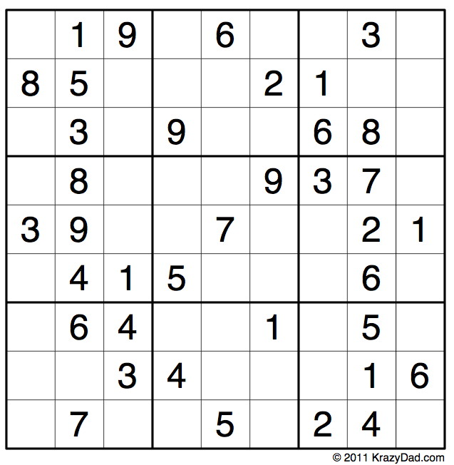
Sudoku – Medium
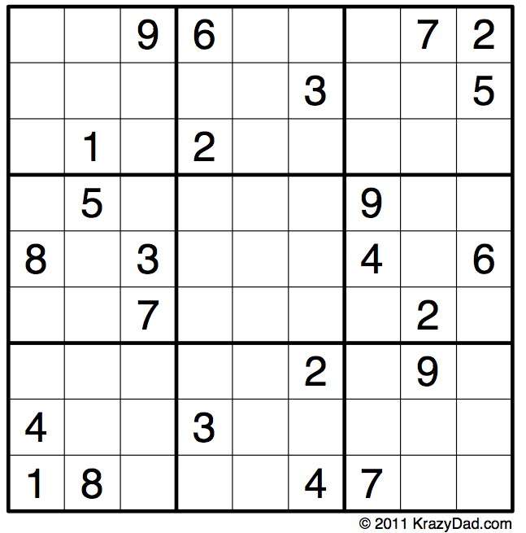
Word-search
October brings us Harvest, and Psalm 65 expresses it perfectly: “You care for the land and water it; you enrich it abundantly. The streams of God are filled with water to provide the people with corn, for so you have ordained it... You crown the year with your bounty, and your carts overflow with abundance... the hills are clothed with gladness, the meadows are covered with flock and the valleys are mantled with corn; they shout for joy and sing.”
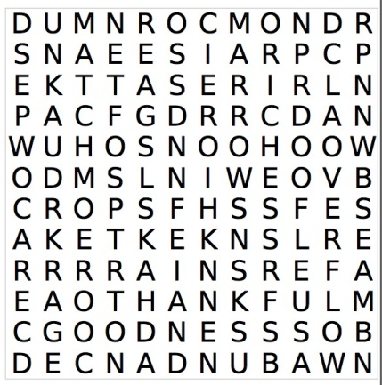
Corn
Rain
Mud
Wheat

Abundance
Goodness
Riches
Pumpkins

Marrows
Water
Thankful
Food

Crops
Soften
Carts
Overflow

Praise
Care
Blessing
Meadows
flocks

CHURCH ROTAS FOR OCTOBER

Tea/Coffee Rota following our 10.30 Service
Oct 6th Pauline & Barbara
13th Carole & Gill
20th Erika
27th Pauline & Barbara
Nov 3rd Beryl & Rona

If you’re not available on the date allocated or wish to change the date assigned to you, please find a replacement or arrange a swap.
We’re rather short of helpers, so if you feel you could give an hour at this service every few weeks, have a word with Erika at church or call 613816, or just come along and help!

Sidespersons’ Rota
Oct 6th 9.00 Rob McMurray
10.30 Jean Aughton, Colin Brown & Julia Brown
13th 9.00 Jeremy Leigh
10.30 Ted Hopkins & Robert Hawthornthwaite
20th 9.00 John Simpson
10.30 Norman Skellorn, Geoff Demack & Eunice Houghton
27th 9.00 Mike Redshaw
10.30 Bill Carr, Scott Eckersley & Beryl Blakeley
Nov 3rd 9.00 Ken Bishop
10.30 Jean Aughton, Colin Brown & Julia Brown

Readers’ Rota
If you cannot read as specified on this rota, please find a substitute and inform a churchwarden of any changes.

October 6th 9.00 Val Simpson
10.30 Margaret Kirkman and Jean Dewhurst
13th 9.00 Mike Redshaw
10.30 Ted Hopkins and Carole Bamber
20th 9.00 Kathleen Leigh
10.30 Emma Cairns and Lillie Eaves-Holmes
27th 9.00 Val Simpson
10.30 Scott Eckersley and Jane Elphick
Nov 3rd 9.00 Peter Templeman
10.30 Lynn Smith and Gill Slinger
Peter Templeman will contact each reader by email by the preceding Tuesday. Please will readers ensure Peter has their contact email.

