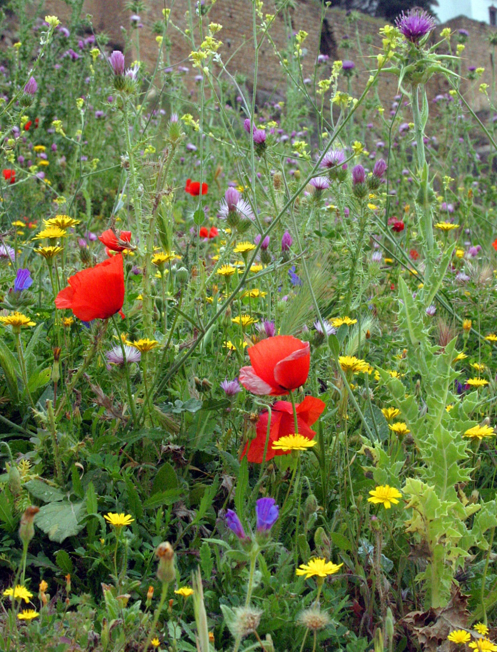
CHURCH OFFICERS
Rector: The Reverend Ann Templeman
The Rectory, 69 Liverpool Road, Much Hoole, PR4 4RB
Tel: 01772 448515 and mob: 07877 659156; E: anntempleman@live.co.uk
Associate Minister: The Reverend Peter Templeman
Churchwarden:
Mr Jock Davidson – Tel: 617918; E: sgtmajor@talktalk.net
Occasional Preacher:
Mrs Margaret Kirkman – Tel: 01772 379219. Mob: 07786543581.
E: margk1946@gmail.com
Reader in Training:
Mr Alan Johnson – Tel: 01704 822179; E: alanmarie55@gmail.com
Churchwarden Emeritus:
Mr William G Carr. Tel: 01772 615321. E: billcarr1935@btinternet.com
PCC Secretary:
Mrs Andrea Susnik – Tel: 615336. E: familysusnik@live.co.uk
PCC Treasurer:
Mrs Barbara Wood – Tel: 617679. E: bw12252@sky.com
Deanery Synod Representatives: Mrs Jane Elphick, Mrs Jean Dewhurst and Mrs Kathleen Leigh.
Parish Safeguarding Officer: Mrs Jean Dewhurst, Tel: 616106.
Magazine Editor
Mrs Erika Penrose – Tel: 613816. E: jandepenrose@btinternet.com
Magazine Secretary:
Mrs Elsie Kirkham – Tel: 615832.
Magazine Advert Co-ordinator:
Position vacant
Flower Secretaries:
Mrs Lisa Redshaw – Tel 614428 and Mrs Pearl Read – Tel: 614367.
Electoral Roll Officers:
Mrs Jean Dewhurst, Tel: 616106 and Mrs Jane Elphick, Tel: 601495.
Verger: Mrs Irene Pickles – Tel: 615708
Assistant Verger: Mr Stuart Tighe – Tel: 612963
Weekly Giving Envelopes: Please contact the Treasurer or Churchwarden.
Parish Administrator: Mrs Amanda Gibson – Tel: 07735 961620.
ORGANISATIONS
Sunday School
Sunday School – St Michael’s Club – now begins at 10.30 in church and happens every Sunday.
Leader: Mrs Kathleen Leigh – Tel: 612196. Email: katleigh@live.co.uk
Hoole Church Ladies’ Group – meets 7.30pm, 3rd Tuesday, in School. Leader: Mrs Erika Penrose.
Tel: 613816. E: jandepenrose@btinternet.com
St Michael’s Men’s Fellowship – meets 7.30pm, 2nd Tuesday, in Hoole Village Memorial Hall.
Secretary: Mr Stuart Tighe – Tel: 612963.
Friends of St Michael – Caring for the fabric of our ancient church.
Chair: Mrs Jane Elphick, Tel: 601495.
Secretary: Mr David Turner, Tel: 01772 383344.
Social Committee – Contact: Mrs Sheila Taylor, Tel: 616850
Hoole St Michael C E Primary School
Head Teacher: Mrs Juliet Price – Tel: 613219.
1st St. Michael’s Hoole Scout & Guide Groups – Group Scout Leader: Mandy Clark – Tel: 01772 305452; E:gmjbclark@yahoo.co.uk.
Church Website: http://www.hooleparishchurch.com.

Please note: All adverts are at the back of the magazine.
Church Rotas are on pages 26& 27.

Do take a look at our church website – http://www.hooleparishchurch.com

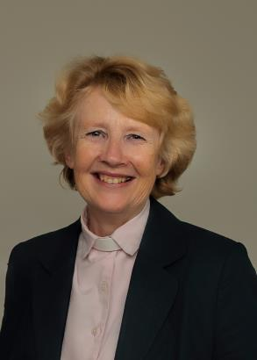
From the Rectory
Jesus said "I came that you may have life – life in all its fullness" – John 10 v 10.
At the countdown from 20, 60 large red helium balloons soared into the gloriously blue sky outside Hoole Village Hall (see pics on page 7). It was 9th June, the Feast of Pentecost when an excited crowd of children at Lift Off Church sent off their balloons with wonderful messages of Good News tied on the strings - "Jesus loves you" and "Jesus is alive" and "Jesus is risen". At the time of writing 3 balloons have been found – the furthest at Waddington near Clitheroe.
On that first Pentecost in 30 AD when the Holy Spirit came upon the apprehensive group of Jesus' disciples with wind and fire and enormous power, human history changed for ever. It was the birthday of the Christian Church. 3000 lives were transformed that very day when people heard the great message of Jesus' death for the sins of the world and his resurrection from the dead and committed their lives to following him.
And so the Good News remains as powerful and relevant as ever. Have you experienced something of the joy and excitement of knowing that death is not the end, that your sins are forgiven, that you are loved more than you can imagine? In fact look back at the verse at the top of this article: Jesus said "I came that you might have abundant life". What that looks like in practice will be different for all of us: some 50 years ago a famous Christian minister wrote a small book called "My God is real"; God is real, He changes people and situations today; He can and will change us if we let Him, though the results are in His control not ours. It's like the passage in one of the Narnia books when Lucy says of Aslan (=Jesus) "He is not a tame lion." We can't predict what our Lord will do in us and through us but if we let Him He promises Life in all its fullness. Give Him the opportunity this summer to show you His plans for your life and the life of His body the church here in Hoole.
Ann Templeman. June 2019.

ST MICHAEL AND ALL ANGELS CHURCH, HOOLE
SUNDAY SCHOOL – Michael’s Club for children (ages 3 to 12), every Sunday during the 10.30 service.
10.30am – Starts in church; children leave for their own teaching in the school after a children’s song and return after the sermon and prayers.

PARISH DIARY
THY KINGDOM COME
NATIONAL CALL TO PRAYER: ASCENSION DAY TO PENTECOST
Sunday 30th June 9.00 Holy Communion (Book of Common Prayer)
10.30 Parish Communion with Sunday School
10.30 Confirmation Service at St James’ Church, Leyland
12.00 Baptism of Joshua Thomas John Bradley
Monday 1st July 7.30 Bible Study Group at the Rectory – John (No 4)
Tuesday 2nd July 10.15 Holy Communion (said)
Sunday 7th July 9.00 Holy Communion (Book of Common Prayer)
10.30 Parish Communion with Sunday School
3.00 CREAM TEA FAMILY CHURCH at St Michael’s School
Monday 8th July 2.00 Funeral of Freda Webb
7.30 PCC meeting at the Rectory
Tuesday 9th July 10.15 Holy Communion (said)
7.30 Bible Study Group at the Rectory – John (No 5)
Thursday 11th July 12.15 Locals’ Lunch at Hoole Village Hall
Friday 12th July 7.00 Summer evening cruise on the Lancaster Canal. Starting from Barton Grange Garden Centre: Please park in the Flower Bowl car park as it is open until late. Be on the boat at 7.00pm.
Sunday 14th July 9.00 Holy Communion (Book of Common Prayer)
10.30 Morning Worship with Sunday School
12.00 Baptism of Jake Robert Fitzell
4.00 Holy Communion at Old Mill Court
Monday 15th July 7.30 Bible Study Group at the Rector – John (No 5)
Tuesday 16th July 10.15 Holy Communion (said)

Sunday 21st July 9.00 Holy Communion (Book of Common Prayer)
10.30 Parish Communion with Sunday School
Tuesday 23rd July 10.15 Holy Communion (said)
7.30 Bible Study Group at the Rectory – John (No 6)
Thursday 25th July 12.15 Locals’ Lunch at the Village Hall
Sunday 28th July 9.00 Holy Communion (Book of Common Prayer)
10.30 Morning Worship with Sunday School
Monday 29th July 7.30 Bible Study Group at the Rectory – John (No 6)
Tuesday 30th July 10.15 Holy Communion (said)
Sunday 4th August 9.00 Holy Communion (Book of Common Prayer)
10.30 Parish Communion with Sunday School
Intercessions: Please let the Rector or Margaret Kirkman know of anyone you would like including on our prayer list, by text or 07786 543581.

KEY FUTURE DATES
- CREAM TEA CHURCH
Sunday 7th July at 3.00pm in St Michael's School
`
- FARM FAMILY CHURCH
Sunday 15th September at 3.45 in the Village Hall

- HARVEST SUPPER
Friday 27th September at 7.00 for 7.30 in the Village Hall

- ST MICHAEL’S SCHOOL HARVEST FESTIVAL

- HARVEST FESTIVAL
Sunday 6th October

- SUPERHEROES FAMILY CHURCH
Sunday 13th October at 3.45 in St Michael’s School

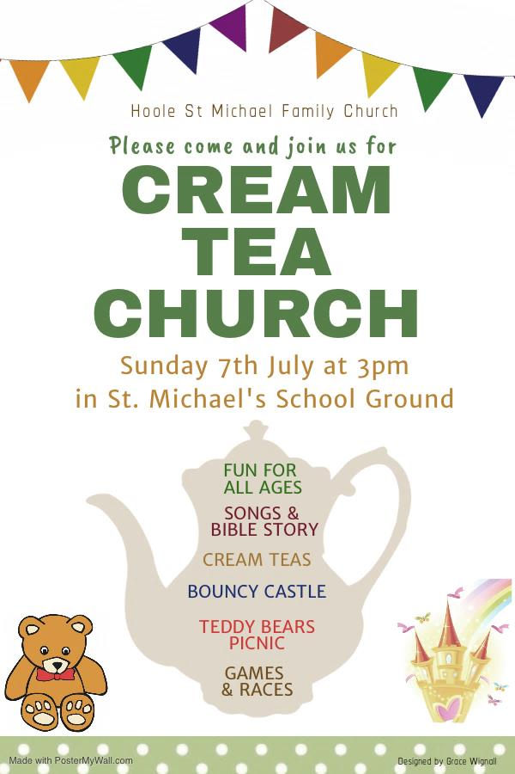
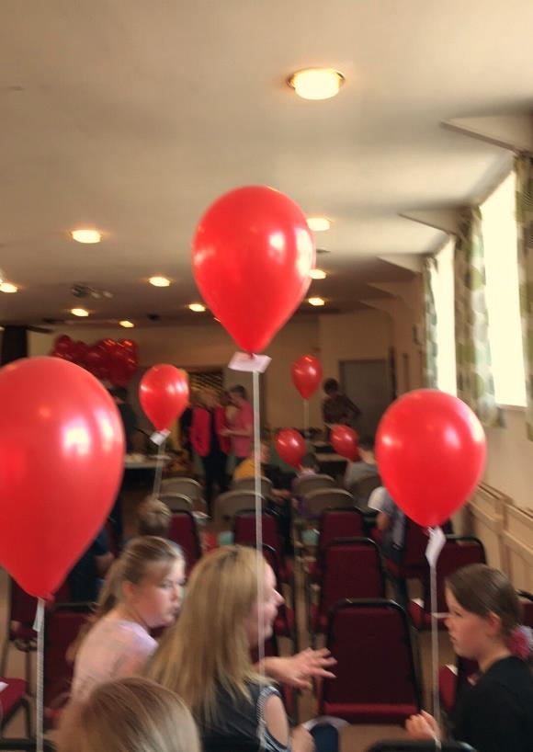
Excitement at the Village Hall on Lift Off Sunday!

Ladies’ Group
There was a jolly atmosphere at our Summer Fete despite the awful weather and plenty of people came along to enjoy themselves, helping to make it a very successful event financially as well as socially. Tracy Taylor and her young pupils presented their best ever exhibition of dancing! The committee would like to say a special thank-you to everyone who helped at the fete in any way, whether by setting up the stalls, baking cakes, providing prizes, manning the stalls, and the myriad other ways which contributed towards our latest fund raising effort.
At our June meeting Pam Roberts spoke about the Lancashire Witch Trials of 1612 which was fascinating. It was certainly a tough life in those days, especially if you were at all eccentric.
The committee has been debating whether to change the venue of our meetings, mainly due to problems with heating in the school hall. We decided to throw the matter open at the June meeting and, after discussion and despite the fact that we would have to increase the annual subscription, there was a unanimous vote to move to Hoole Village Hall and thus to the new Village Hall when it is built. Therefore, all being well, we intend to move premises as from our September meeting. Comments from members who weren’t able to be at the meeting are welcome; please contact our secretary, Rose Brown, on 614750 or email: tomb4u@outlook.com.
There’s no meeting in July and we look forward to seeing you all again on Tuesday 20th August, when David Tomlinson of Warburton’s Bakery will be speaking on “The Staff of Life”. This is to be an Open Evening so please do invite your friends and relations to come along. Rumour has it that there will be free samples available!
Erika
NEXT EDITION OF THE PARISH MAGAZINE
Please note that there is a change of plan for the next Parish Magazine: there will not be an August magazine as such this year but we hope to publish the next one for August/September around mid-August.
Contributors please note that the deadline will be Friday 2nd August. You will receive a reminder by email in good time.

CHURCH OPENING TIMES
The church is open during the day as follows:

Day | Open | Close
Monday | 9.30am | 4.30pm
Tuesday | 9.30am | 4.30pm
Wednesday | 9.30am | 4.30pm
Thursday | 9.30am | 4.30pm
Friday | Closed
Saturday | 9.30am | 4.30pm
Sunday | 8.00am | 4.30pm

Jock Davidson, Churchwarden

~~~~
From the Parish Registers
Holy Baptism
“We welcome into the Lord’s Family”
Elsie Louise Williams was baptised on 26th May.
Rory George Thomas was baptised on 2nd June.
Benjamin Toby Alan Wheatley was baptised on 9th June.
Weddings
“Those whom God hath joined together”
Andrew William Thomas Crabtree and Donna Marie Harrison were married on 25th May.
Funerals
We give thanks for the life of Jean Mary Spalding, aged 95, of Penwortham, whose funeral took place on 28th May. Interment followed in the Churchyard.
Jean was the widow of The Revd Wilfrid Spalding, a former rector of this parish. Turn to page 13 for the eulogy made by her son, Richard.
~~~~
From the Register of Services
Date |  | Attendance | Communicants | Amount
May | 26th | 79 | 32 | £293.07
June | 2nd | 95 | 85 | £291.25
 | 9th | 168 | 25 | £282.00
 | 16th | 91 | 73 | £239.78
Standing Order donations in lieu of donating via the envelope system for June: £876.50. Donations from Baptisms: £126.19.
~~~~
THE ST MICHAEL’S UNIFORMED SCOUT GROUPS
Our Church supports this organisation and this is an update on their activities as at 6th June 2019.
The scout group is doing very well.
We do have a few spaces for Beavers and Cubs at present.

Beavers | Thursday 6.15-7.30pm for 6-8 year olds
Cubs | Monday 6.30-8.00pm for 8-10½ year olds
Scouts | Wednesday 7.00-9.00pm for 10½-14 year olds

We would always welcome anyone interested in volunteering as a leader or helper or even someone who has an interesting skill or activity that we could cover in a section meeting.
The group are about to embark on the South Ribble District Group camp on 21st June and the church’s donations have been used to purchase five new tents to ensure we have enough accommodation for the 48 who are attending across all the section. We recently put on axe throwing activities as part of the village Spring fair and are supporting a number of other scout groups by providing this activity for their scouts.
Steven Catterall is attending the World Scout Jamboree in America over the summer and is on the service team providing climbing activities for the participants. We try to encourage our members to partake in an international camp - of which there are many offered.
To contact us please email: Hoolebeaverscouts@yahoo.com or ring 07761 728400.
Jacqui Sherrington

WATER AID
THE FINAL TOTAL IS £515.35
PROJECTED GIFT AIDED IS £79.64
THANK YOU ONE AND ALL

VACANCY FOR AN ADVERTISEMENT CO-ORDINATOR
We need a volunteer for the above – please?
Margaret Clark, who has taken on this role for the past few years, has recently resigned after having done a sterling job.
Ideally, I don’t really want the job back again so… if you have basic Word and Excel skills you could do this.
Training will be provided and full support throughout.
Brief Job Description:
- It is a once a year activity on or around October/November of each year.
- It involves contacting all the advertisers in the magazine inviting them to renew plus follow up as necessary
- Collate the payments that come in/liaise with the treasurer for BACs payments
- Late Nov/early December, check and edit the adverts and forward them to the printer (details will be available) to be included in the January Magazine.
- Do a bit of marketing to find new advertisers if we have any blanks.
- Keep a record of all the advertisers and relevant details.

Many thanks
Barbara Wood
Treasurer – contact details in front of the mag.
~~~~
A LETTER FROM OKOROM
ST MICHAEL ANGLICAN
CHURCH OF UGANDA-OKOROM
C/O MARGARET ARIONGET LIMA
P.O BOX 127, NGORA
margaretariongetlima@gmail.com
07/06/2019
To St Michael Hoole, c/o Elizabeth Swarbrick, UK.
Greetings to you in the name of our Lord Jesus Christ. Thank you for the Easter celebrations which, do believe it, were marvellous. We at St Michael-Okorom similarly enjoyed it with joy and happiness as we treasure the resurrection of our Lord Jesus Christ. Above all God has blessed us with rains which have enabled Christians to do agriculture activities to support their families.
We would like to thank you very much for your financial contributions towards church construction. The money altogether received is worth 3,450,000 UGX (three million four hundred and fifty thousand shillings only). However, this money is being used to build the church veranda, painting, and stabling the church side flow. We have attached some pictures for you to see and we request that at your convenient time, please pay us a visit.
Thank you so much and may God reward you abundantly.
God bless you
Denis Olei
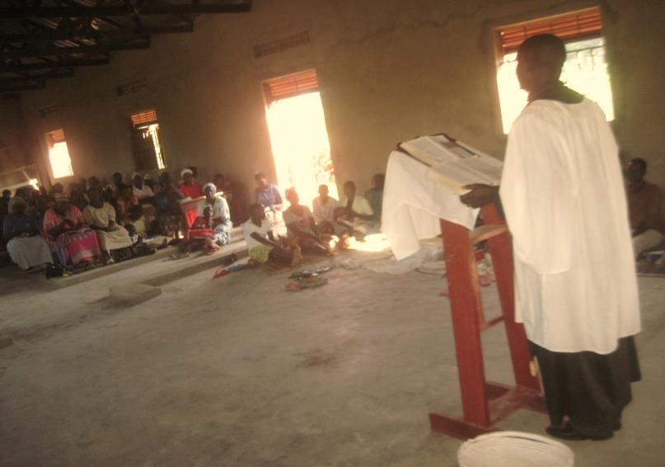
Lay leader

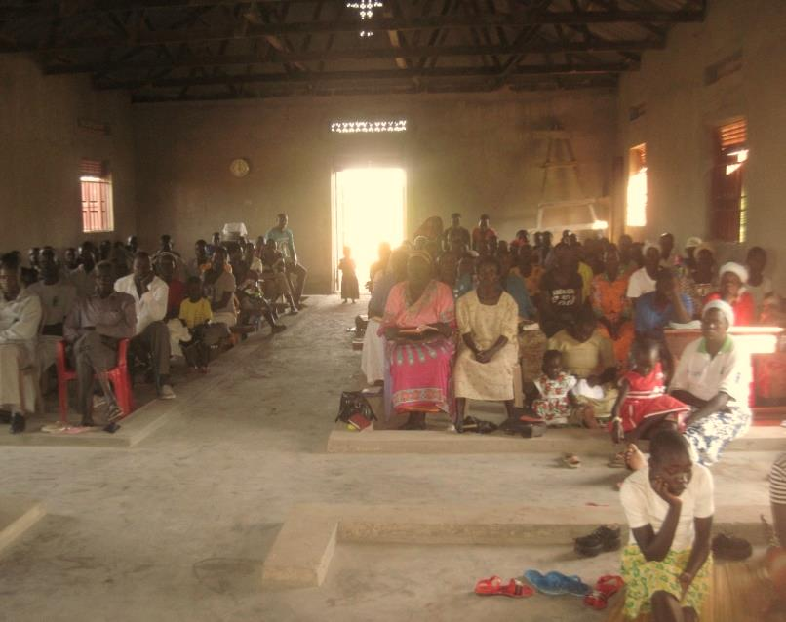

~~~~

RICHARD SPALDING’S “MEMORIES OF MUM” – JEAN SPALDING, at her funeral on 28th May 2019. Jean was the widow of the Revd Wilfrid Spalding, a former Rector of St Michael’s, Hoole.
(This article has been précised for the parish magazine).
I suppose we all take Mothers for granted. They are always there to wash behind our ears, feed us, or give us a plaster when we graze our knees!
For most of my life I think I took my mother Jean for granted – she was always just there in the background. But after I retired from work, and as she became more ill, I spent more time with her. And as I got to know her better, I think we became good friends. She was not quite herself of course, because of her Alzheimer’s and depression. However, I learnt more of her character in those last 8 years, and I am grateful for that time, and grateful to the carers who looked after her. So I wanted to share some of what I learnt about her with you all today.
Mum’s father Fred was a market gardener in Frome, and her mother Cicely did the flowers for a big church there, so she inherited a love of flowers. She always had a flower garden: in her cottage in Frome, in her houses in Clitheroe and Accrington, and especially in the Rectory in Hoole and at her bungalow in Fulwood. She loved the flower festival here at St Michael’s, and decorating this church at Christmas and Easter. She was basically a country girl, and maybe that’s why she and Dad fitted in so well in Hoole. Mum always said she couldn’t arrange flowers herself, but she seemed to do well enough to me! Fiona reminded me that when she came home from hospital with our first son Alistair, Mum had picked loads of flowers from our garden and put them in vases around the house to welcome her. Mum had also prepared a running buffet lunch, so she and Fiona could sit and watch Charles and Dianna’s wedding all that afternoon. Mum was also a super caterer and many a time would prepare buffets for family gatherings, even though she said she couldn’t cook!
Another thing I remember from Frome is that Jean was an Organiser, and very organised herself. She went away to secretarial college when she was in her teens, and learnt bookkeeping and shorthand, and she used that all her life. My father wooed her (when he was posted to Frome in the army) by asking her to teach him shorthand. When Dad went off to theological college Mum kept us afloat financially by working as an Auctioneer’s Clerk. After Dad was ordained, we were not much better off, and Mum worked as a Secretary in Clitheroe, and in Accrington, to supplement our income. At Hoole, she was the School Secretary, and in retirement ran St Catherine’s Hospice shop in Preston. Not having much money, she kept detailed accounts of her personal income and expenditure, and reconciled them every week right up until she left her bungalow in Fulwood. In retirement, I know Mum gave Dad an allowance for his pipe tobacco and hobbies!
As well as being organised, Mum was a worker herself, and especially a worker for St Michael’s. When we were visiting Mum and Dad on holiday, on Sundays Mum would go to the morning service at 10.00, give us all a roast lunch with all the trimmings about 1.00, go off to teach Young People’s Church at 2.00 in the afternoon, and then be back to provide
A collage of photos of the Revd Wilfrid and Mrs Jean Spalding. The Revd Spalding was Rector of St Michael’s from 1969 to 1985.

afternoon tea at 4.00, often outside in the old Rectory Garden. Many of you here will remember the Garden Parties, Flower Festivals, Autumn Fairs and Walking Days Jean had a hand in, as well as the Sewing group, the Ladies Group and the PCC. I was looking at her the day she died: she was so thin, and I thought ‘she has used up her body, living life and serving to the full’. She and Dad did all this because they believed the church was there to ‘hold out the word of life’ to the world, and they wanted the church to reach out to the whole village. I think they were very successful. At Mum’s baptism as a baby the vicar would have prayed that she would be ‘Christ’s faithful soldier and servant to her life’s end’. Mum was certainly an answer to that prayer.
In preparing this talk I realised that you can’t sum up a person in a few words. But I think the main thing is this – she loved the places she lived: especially the cottage in Frome, the old Rectory at Hoole, and her bungalow in Fulwood, and she made them into homes: for her family, and for many of us here.

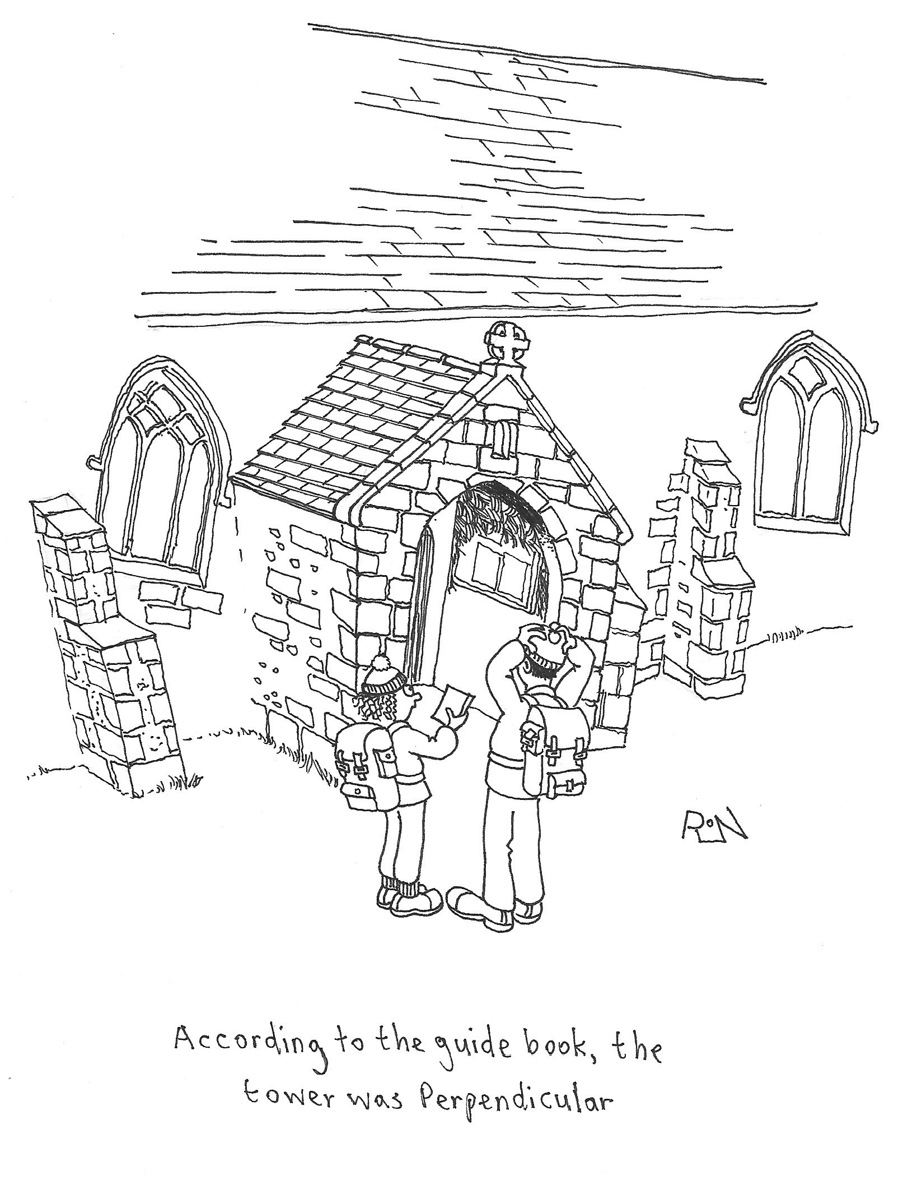
HYMN OF THE MONTH
DEAR LORD AND FATHER OF MANKIND Hymn No. 144
Words and music: John Greenleaf Whittier (1807-1892)
Music: Charles Hubert Hastings Parry (1848-1918): Repton

Dear Lord and Father of mankind,
Forgive our foolish ways!
Re-clothe us in our rightful mind,
In purer lives thy service find,
In deeper rev’rence praise,
In deeper rev’rence praise.

In simple trust like theirs who heard,
beside the Syrian sea, the gracious calling of the Lord,
let us, like them, without a word, rise up and follow thee,
rise up and follow thee.

Breathe through the heats of our desire
thy coolness and thy balm; let sense be dumb, let flesh retire;
speak through the earthquake, wind and fire, O still small voice of calm!
O still small voice of calm.

Who would have thought that this great hymn was extracted from a poem all about a hallucinogenic drug made from an Indian plant called SOMA mixed in a drink and used in early religious rituals to create a state of frenzy. John Greenleaf Whittier was not a follower of these practices; in fact he was an American Quaker who wrote a poem called “The Brewing of Soma” to show his dislike of over enthusiastic Christianity, with its use of incense and music to bring on a trance-like state. The words of the poem (which can be found on the internet) which follow “Dear Lord and Father of mankind, forgive our foolish ways” are as follows:
In sensual transports wild as vain We brew in many a Christian fane The heathen Soma still!
Written by a Quaker who was used to worshipping God in the calm silence of the meeting house, his writing of the poem “The Brewing of Soma” was a direct plea to “forgive our foolish ways and re-clothe us in our rightful mind”. He was calling Christians back to simple pure worship.
Whittier was brought up as a Quaker and was a descendant of the “Pilgrim Fathers”. The son of a farmer, he made his living as a journalist who wrote poetry and was a passionate abolitionist all through his adult life. He was credited as being a fine hymn writer but never wrote a hymn though many hymns have been drawn from his poetry. The great hymn writer, William Garrett Horder, saw the potential of the verses of the poem and adapted them into the hymn we have come to love so much and included it into his 1884 Congregational Hymn Book.
In the 2007 film Atonement which was based on a novel by Ian McKewan, a choir of exhausted soldiers in a bandstand on the beach at Dunkirk sang the hymn ‘Dear Lord and Father of Mankind’ and won an Academy Award for “best score”.
There is so much light and shade in this hymn which takes us from Galilee to the Syrian sea and to the beauty of His peace, and the still small voice of calm. What a wonderful hymn to sing.
Bill Carr, Church Warden Emeritus

Our Prayer Circle
As Christians we know that one of the main things that Jesus taught us was the words of The Lord’s Prayer and very often in the Bible we are told that He went to a quiet place and prayed. Our hymns tell us to “Take it to the Lord in prayer” and that “the voice of prayer is never silent”. There is no doubt of the need for prayer for our own spiritual needs as well as the knowledge of the comfort and support that it gives to both the person praying and the people being prayed for.
To that end we have set up a Prayer Circle at St Michael’s.... ‘What’s one of those then?’ you may ask. It is simply a group of people who when called upon will pray at home separately and quietly for whatever you ask.
If you have a concern of any sort that you want us to pray for all you need to do is to ring any of the numbers and simply say what or who is in need of prayer, and whilst a minimum of explanation might be an advantage for us to focus the prayer, ou don’t even have to say who you are! The person taking the call will pass it round the circle and you will know that we, on behalf of the church, are taking your worry to the Lord. If you would like your particular concern added into the intercessions on a Sunday morning then we can do that too.
We are happy to welcome others into the circle, just let us know and you will be added on.
Prayer is an essential part of our Christian life to keep us walking in the footsteps of our Saviour... so... the lines are open right now, we are waiting to take your call which is very important to us because it matters to you... just ring and your prayer will be increased seven-fold (at least).
Our circle consists of Ted (01772 617002), Margaret (01772 379219), Carole Bamber (01772 610670 or mobile 07989 145963), Gill Slinger (07729 121248), Barbara Wood (07745 208617) and Bill Carr (01772 615321).
Ted, Margaret, Carole, Gill, Barbara and Bill

St James the Least of All
Parish Pump Editor: The Rev Dr Gary Bowness continues his tongue-in-cheek letters from ‘Uncle Eustace’…

On the delights of the parish jumble sale
The Rectory
St James the Least
My dear Nephew Darren
The estimate for re-hanging the bells in our church tower came as a great shock. The church council discussed fund-raising at length. Someone suggested selling part of the Rectory garden for building, another for getting 200 parishioners to loan £1,000 each, interest-free. Then Mrs Ffrench suggested holding a jumble sale. The jumble sale won – mainly because it was achievable without a great fight, and also gave everyone an opportunity to see what their neighbours think of as junk.
Expensive articles were brought with an ostentatious show of modesty when everyone was sorting donations. Genuine jumble, such as odd plates, old blankets and mysterious kitchen gadgets, were left at the church door in the dead of night.
On the day of the jumble sale, our helpers were ready behind wobbly tables stacked high with stuff. Had the tables collapsed, half the congregation would have been smothered. Little Miss Faversham was having a wonderful time flitting from table to table like a woolly bumble bee, kitting herself out for another year.
When the doors opened and the customers poured in, I realised how the Italians must have felt when they saw Hannibal with his elephants pouring down the sides of the Alps. That is when the mettle of our ladies really showed. They were tremendous - haggling at great length over whether something worth £10 should go for 10p or 11p. I noticed that those who are used to riding with hounds seem best able to control the crowds – even if they occasionally tended to regard the customers as the fox.
As it happened, the youth club were going pot-holing that day, so most of the teenagers bought complete sets of clothing for 10p which could then be discarded afterwards. But I wondered what their caving instructor would think of teenagers arriving dressed in dinner jackets and tweed skirts.
Two days of preparation yielded a battle that was over in less than an hour. We emerged bloodied but unbowed, with only scraps of jumble left. Then it was home for a bath and a strong restorative, in the knowledge that the first step to saving the bells has been taken. Only another 2,500 jumble sales and we shall have reached our target. Indeed, the only jarring note of the day was to discover someone with a peculiar sense of humour had put a note on my car: “Sold – to be collected later”.
Your loving uncle,
Eustace
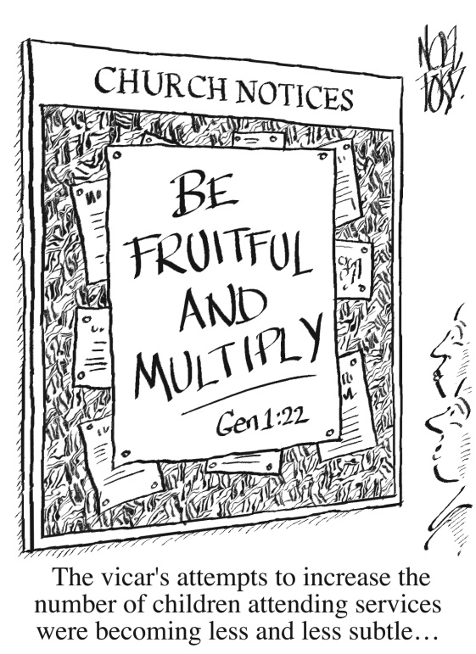
Crossword Clues

Across
1 ‘I pray that out of his glorious — he may strengthen you with power through his Spirit in your inner being’ (Ephesians 3:16) (6)
4 ‘Saul’s father Kish and — father Ner were sons of Abiel’ (1 Samuel 14:51) (6)
7 ‘Praise the Lord, O my — ’ (Psalm 103:1) (4)
8 See 5 Down
9 Laws (1 Kings 11:33) (8)
13 ‘Who of you by worrying can — a single hour to his life?’ (Luke 12:25) (3)
16 Artistry (Exodus 31:5) (13)
17 ‘Your young men will see visions, your — men will dream dreams’ (Acts 2:17) (3)
19 How David described his Lord (Psalm 19:14) (8)
24 ‘If this city is built and its — — restored, you will be left with nothing in Trans-Euphrates’ (Ezra 4:16) (5,3)
25 ‘The holy Scriptures, which are able to make you — for salvation through faith in Christ Jesus’ (2 Timothy 3:15) (4)
26 Intended destination of arrows (Lamentations 3:12) (6)
27 Eve hit (anag.) (6)

Down
1 ‘For I am gentle and humble in heart, and you will find — for your souls’ (Matthew 11:29) (4)
2 Where Peter was when he denied Christ three times (Luke 22:55) (9)
3 Remarkable early 20th-century Indian evangelist, a convert from Hinduism, — Sundar Singh (5)
4 ‘Now the king had put the officer on whose — — leaned in charge of the gate’ (2 Kings 7:17) (3,2)
5 and 8 Across The Lover describes this facial feature of the Beloved thus: ‘Your — is like the tower of Lebanon looking towards — ’ (Song of Songs 7:4) (4,8)
6 ‘Stand firm then, with the belt of truth buckled — your waist’ (Ephesians 6:14) (5)
10 Trout (anag.) (5)
11 Easily frightened (1 Thessalonians 5:14) (5)
12 The ability to perceive (Ecclesiastes 10:3) (5)
13 One of the clans descended from Benjamin (Numbers 26:38) (9)
14 “It is one of the Twelve,” he replied, “one who — bread into the bowl with me”’ (Mark 14:20) (4)
15 Resound (Zephaniah 2:14) (4)
18 Traditional seat of the Dalai Lama (5)
20 Precise (John 4:53) (5)
21 Build (Ezekiel 4:2) (5)
22 Beat harshly (Acts 22:25) (4)
23 Darius, who succeeded Belshazzar as king of the Babylonians, was one (Daniel 5:31) (4)
Answers on page 25
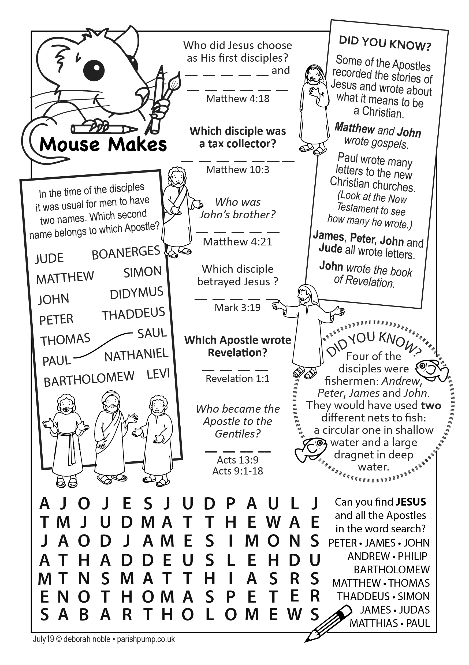
SUDOKU (Easy)
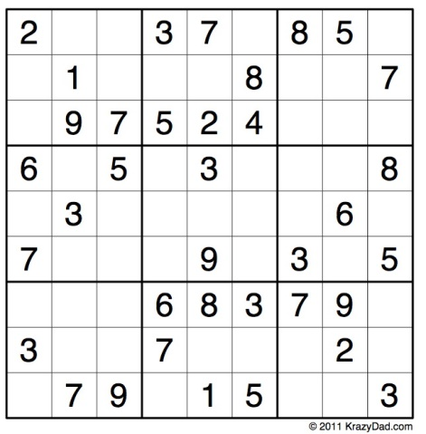
SUDOKU (Medium)
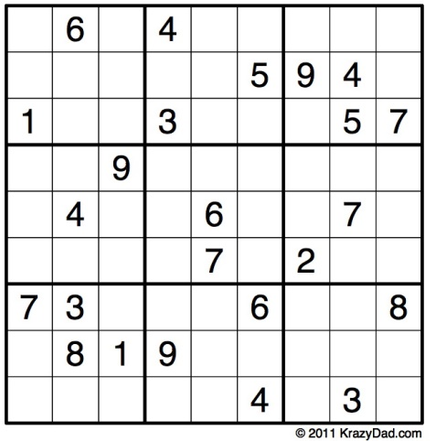
ANSWERS TO CROSSWORD CLUES
ACROSS: 1, Riches. 4, Abner’s. 7, Soul. 8, Damascus. 9, Statutes. 13, Add. 16, Craftsmanship. 17, Old. 19, Redeemer. 24, Walls are. 25, Wise. 26, Target. 27, Thieve.
DOWN: 1, Rest. 2, Courtyard. 3, Sadhu. 4, Arm he. 5, Nose. 6, Round. 10, Tutor. 11, Timid. 12, Sense. 13, Ashbelite. 14, Dips. 15, Echo. 18, Lhasa. 20, Exact. 21, Erect. 22, Flog. 23, Mede.
CHURCH ROTAS FOR JULY/AUGUST

Flower Arrangers
Date Arranger(s) Sponsor(s):
July 7th Althea & Lesley Mrs A Slater
14th Jean & Joan Mr & Mrs S Taylor
21st Averil & Betty Mr & Mrs Leigh
28th Julie Church Ladies’ Group
Aug 4th Jean & Sue Mrs S Westell
11th Pearl & Claire -
18th Althea & Elsie Mrs Clark
~~~~
Tea/Coffee Rota following our 10.30 Service
July 7th Pauline & Barbara
14th Carole & Gill
21st Beryl & Rona
28th Pauline & Barbara
Aug 4th Carole & Gill
11th Beryl & Rona
18th Pauline & Barbara

If you’re not available on the date allocated or wish to change the date assigned to you, please find a replacement or arrange a swap.
We’re rather short of helpers, so if you feel you could give an hour at this service every few weeks, have a word with Erika at church or call 613816.
~~~~
Sidespersons’ Rota
July 7th 9.00 John Simpson
10.30 Jean Aughton and Churchwarden
14th 9.00 Mike Redshaw
10.30 Bill Carr, Scott Eckersley and Beryl Blakeley
21st 9.00 Ken Bishop
10.30 Ted Hopkins and Robert Hawthornthwaite
28th 9.00 Rob McMurray
10.30 Norman Skellorn, Tom Wignall and Geoff Demack
Aug 4th 9.00 Jeremy Leigh
10.30 Jean Aughton and Churchwarden
Readers’ Rota
If you cannot read as specified on this rota, please find a substitute and inform a churchwarden of any changes.

July 7th 9.00 Ann Templeman
10.30 Peter Templeman and Gill Slinger
14th 9.00 Peter Templeman
10.30 Margaret Kirkman and Jean Dewhurst
21st 9.00 Mike Redshaw
10.30 Jane Elphick and Ted Hopkins
28th 9.00 Kathleen Leigh
10.30 Carole Bamber and Scott Eckersley
August 4th 9.00 Ann Templeman
10.30 Emma Cairns and Lillie Eaves-Holmes

Peter Templeman will contact each reader by email by the preceding Tuesday. Please will readers ensure Peter has their contact email.

